PuRest: A WEB Application SERVER & REST Framework For the lua language

project Report

University of Ulster

*Supervised by Giuseppe Trombino*

Matthew Snoddy – B00563554

BSc Hons Computing Science

Abstract

Distributed and interconnected systems are becoming the de facto standard for information interchange, with the internet and HTTP being at the forefront providing a middleware layer and message passing protocol. Personal applications such as smartphone apps communicate with web services to manipulate and search across data. Enterprise services such as software as a service rely on the internet and intranets to deliver ever more sophisticated content.

The technology used to produce services like the above are evolving to allow software engineers to concisely write code to preform data lookups and respond to communication requests, creating powerful and flexible applications. Many tools have been chosen as hosts for this task including C#, Java and PHP.

Scripting languages khave, in recent years, provided even more shorthand and lithe methods for fully fletched web services. Examples of this are Python, Ruby and Perl.

The Lua programming language, with its dynamic and extensible characteristics, is a scripting language that offers the potential to expand the trend of writing succinct web applications, free from the chains of type checking and imposed programming paradigms.

According to W3Techs web technology surveys the use of Lua as a server side programming language is extremely low at 0.1%, as of March 2015 (w3techs, Usage statistics and market share of Lua for websites, 2015). This means that there is evidence of strong under-utilisation of Lua for web programming, providing room for growth.

This project focuses on producing an application web server that can be used to develop and host web services and dynamic websites. The server, codenamed Purest (Pure Rest), will be coded using Lua, which will also serve as the primary development language for writing web applications and scripts.

Work will be done in alignment with an agile software development lifecycle approach. The end goal of this project is to release the server as a whole to the open source Lua community for use, adaptation and study.

Acknowledgments

I would like to take this opportunity to thank my friends and family for being so supportive during the project and putting up with me being so busy during this time. A special and very heartfelt thanks goes to my University colleagues: Scott, Sam, Patrick and Megann; they have sat through many long days and nights working together.

Finally, my project supervisor for taking on the project in the first place and encouraging me to do my best throughout the project.

*Table of Contents*

Abstract i

Acknowledgments i

1. Introduction 1

1.1 Project Background 1

1.2 Project Definition 1

1.2.1 Project Objectives 1

1.3 Dissertation Overview 1

2. Literature Review 2

2.1 Introduction 2

2.2 Distributed Systems 2

2.3 Web Servers 3

2.3.1 Lua Centric Web Servers 3

2.4 Developer Rollout 5

2.5 Technologies 6

2.6 Networking 6

2.6.1 TCP/IP 6

2.6.2 DNS 7

2.7 Security 7

2.7.1 HTTP Authentication 7

2.7.2 HTTPS 8

2.8 Concurrency 8

2.9 File Systems 10

2.10 Relational Databases 10

2.11 Regular Expressions (Regex) 11

2.12 HTTP 11

2.12.1 Routing & URIs 11

2.12.2 HTTP 1.1 12

2.12.2.1 Messages 12

2.12.2.2 Status Codes 13

2.12.2.3 Methods 14

2.12.2.4 Headers 14

2.12.2.5 Content & MIME Types 14

2.12.2.6 Compression (GZIP) 15

2.12.7 RESTful Services 16

2.13 Web Applications 17

2.13.1 Server Side Scripts 17

2.13.2 Sessions 17

2.13.3 Model View Controller 17

2.13.4 JSON 18

2.13.5 XML 19

2.13.6 HTML 19

2.13.8 PHP 19

2.14 Logging 20

2.15 Lua 20

2.15.1 Programming Paradigms 21

2.15.2 Core Language 22

2.15.3 C Extensions 22

2.15.4 LuaRocks 22

2.16 Source Control 23

2.17 Linux 23

3. Requirements Engineering Process 25

3.1 Elicitation & Analysis 25

3.1.1 Formal Interviews with Client/Stakeholders 25

3.1.2 JAD Session 25

3.1.3 System Analysis 26

3.2 Specification 26

3.2.1 Functional Requirements 26

3.2.1.1 Volere Shells 27

3.2.2 Non-Functional Requirements 28

3.2.3 MoSCoW 29

3.3 System Modelling 29

3.3.1 Use Case Model 29

3.3.2 System Context Diagram 30

3.4 Requirement Validation 30

3.5 Requirements Management 30

3.5.1 Change Management 31

3.6 Software Development Life Cycle 31

3.6.1 Staged Delivery 31

3.6.2 Waterfall 31

3.6.3 Agile 31

3.6.4 Conclusion 32

3.7 Project Constraints 33

3.7.1 Constraints 33

3.7.2 Assumptions 33

4. Project Management 34

4.1 Project Plan 34

4.1.1 Contingency Plans 34

4.1.2 Resources 34

4.1.3 Risks 35

4.2 Epics & User Stories 35

4.2.2 Taiga 36

4.2.4 Change Control and Issue Tracking 37

4.3 Source Control 37

4.3.1 BitBucket 37

4.3.2 TortoiseHG 38

5. Design 39

5.1 High Level System Architecture 39

5.2 System Events and Processes 42

5.2.1 Server Start-Up 42

5.2.2 Accepting New Client Connections 43

5.2.3 HTTP Request Received 43

5.2.4 Router Resolving Resource 44

5.3 Class Diagram 45

5.4 Admin Web Application Design 46

5.4.1 Web Service 46

5.4.2 UI Mock-ups 47

5.4.2.1 Web Application Listings 47

5.4.2.2 Server Logs 47

5.4.2.3 Web Server Performance 48

5.4.3 Developer Documentation 48

6. Implementation 49

6.1 Lua Libraries 49

6.1.1 Apache Portable Runtime 49

6.1.2 LuaSec 49

6.1.3 LrexLib 49

6.1.4 LuaLogging 49

6.1.5 lzlib 49

6.1.6 JSON.lua 49

6.1.7 RapidXML Parser 50

6.1.8 Alien 50

6.2 Gradle 50

6.3 IntelliJ IDEA 50

6.4 Sprints 50

6.4.1 Sprint 1 Retrospective: 14th – 28th November 2014 51

6.4.1.1 Epics 53

6.4.1.2 Unscheduled Activities 54

6.4.2 Sprint 2 Retrospective: 12th – 23rd December 2014 54

6.4.2.1 Epics 57

6.4.2.2 Issues/Bugs Raised 57

6.4.3 Sprint 3 Retrospective: 19th – 30th January 2015 57

6.4.3.1 Epics 59

6.4.3.2 Issues/Bugs Raised 59

6.4.4 Sprint 4 Retrospective: 2nd – 13th February 2015 60

6.4.4.1 Epics 61

6.4.4.2 Issues/Bugs Raised 61

6.4.4.3 Unscheduled Activities 62

6.4.5 Sprint 5 Retrospective: 16th – 27th February 2015 63

6.4.5.1 Epics 66

6.4.5.2 Issues/Bugs Raised 66

6.4.5.3 Unscheduled Activities 67

6.4.6 Sprint 6 Retrospective: 2nd – 13th March 2015 67

6.4.6.1 Epics 67

6.4.7 Sprint 7 Retrospective: 16th – 27th March 2015 67

7. Testing 68

7.1 Testing Suite 68

7.1.1 Test Web Application 68

7.1.1.1 Functionality Tested 68

7.1.1.2 Launch Script 68

7.1.1.3 PHP Tests 68

7.1.2 Employees Web Application 68

7.1.2.1 MySQL Sample Database 69

7.1.2.2 MVC Site 69

7.1.2.3 REST Service 70

7.1.2.4 Bootstrap 71

7.1.2.5 Knockout 71

7.2 Web Browsers 71

7.3 HTTP Client - Postman 72

7.4 Blackbox Testing 73

7.5 Continuous Integration 73

7.5.1 JUnit 74

7.5.2 Selenium Web Driver 74

7.5.3 Apache HTTP Client 74

7.5.4 Tests Developed 74

7.6 Manual Testing 75

7.6.1 Error Handling 75

7.6.2 Profiling Code 75

7.6.3 Logging 75

8. Evaluation 76

8.1 Requirements Evaluation 76

8.2 Technologies Evaluation 77

8.2.1 Lua 77

8.2.2 Apache Portable Runtime 78

8.2.3 Automated Testing 78

8.2.4 IntelliJ IDEA 78

8.2.5 Source Control 78

8.3 Software Methodology Evaluation 79

8.5 End Users Evaluation 79

8.5.1 Positive Aspects 79

8.5.2 Negative Aspects 79

8.5.3 Desired Aspects 79

8.6 System Evaluation 80

9. Conclusion 81

9.1 Project Reflection 81

9.2 Future Development 81

9.3 Learning Outcomes 82

Bibliography 83

Appendix A: MoSCoW Requirements Listing 87

Appendix B: Project Journal 89

Week Beginning 19th January 89

Week Beginning 2nd February 90

Week Beginning 9th February 92

Week Beginning 16th February 95

Week Beginning 23rd February 97

Week Beginning 2nd March 100

Week Beginning 9th March 100

Week Beginning 16th March 100

Appendix C: End User Documentation 102

Appendix D: Epics & User Stories 117

Appendix E: Source Repositories 127

Purest Repository; the main server source code and configuration. 127

Purest Web Apps Repository; web applications and test sites. 148

Purest Tests Repository; automated Junit tests. 153

Appendix F: Integration Tests 155

Appendix G: Employees Sample MySQL Database Schema 156

Appendix H: Project Gantt Chart 157

Appendix I: Design – Activity Diagrams 158

Session Retrieve/Update 158

Route Protected by HTTP Authentication 158

Launch Script Loading 159

Run PHP File 159

List Directory 160

File Cache 160

Appendix J: Requirements Engineering – Volere Shells 161

Appendix K: SonicAgile Software 168

**Table of Figures**

Figure 1 - TCP three way handshake process. (Cisco, n.d.) 6

Figure 2 - Overview of the general HTTP authentication process. (Gourley, Totty, Sayer, Aggarwal, & Reddy, 2002) 8

Figure 3 - Classic operation of a thread pool. (Burnett, 2007) 9

Figure 4 - The HTTP request in the top left denotes the site in the location, underlined in red, and this is matched to the 'site_a' directory, also underlined. 10

Figure 5 - Sample exchange of HTTP messages. (Gourley, Totty, Sayer, Aggarwal, & Reddy, 2002) 13

Figure 6 - Example of HTTP compression and associated headers. 16

Figure 7 - The process of using MVC to process HTTP requests. (j2mesalsa, 2009) 18

Figure 8 - Example snippet from a server log file. 20

Figure 9 - Use Case Model of the Web Application Server and Clients 29

Figure 10 - System Context Diagram for the Web Application Sever 30

Figure 11 - The Taiga Dashboard, showing the banner with project story points with sprints on the right hand side. 36

Figure 12 - An Epic (seen as a user story in Taiga) with realted tasks, note the story point estimation on the right hand side. 37

Figure 13 - Source Code Repositories Hosted on BitBucket 38

Figure 14 - Tortoise HG User Interface 38

Figure 15 - An overview of the web application server's high level architecture, the grey filled box contains the components of the web server and the blue filled box contains external libraries. 39

Figure 16 - Activity Diagram: Server Start-Up 42

Figure 17 - Activity Diagram: Accepting New Client Connections 43

Figure 18 - Activity Diagram: HTTP Request Received 43

Figure 19 - Activity Diagram: Router Resolving Resource 44

Figure 20 - Activity Diagram: Processing a View 44

Figure 21 - Complete System Class Diagram 45

Figure 22 - Admin Application: Web App Listings 47

Figure 23 - Admin Application: Server Logs 47

Figure 24 - Logic to accept a new client connection in the ‘startServer’ method of the Server Class. 51

Figure 25 - Extracting the components of the inital line from a HTTP request; this method is present in the HttpDataPipe class, see section 5.1 for more information. 51

Figure 26 - The HTTP request object modelled in the HttpState class. 52

Figure 27 - The HTTP response modelled in the HttpState class. 52

Figure 28 - Initial HTTP response line being constructed in the ‘getFormattedHeadersAndContent’ method of the response object in the HttpState class. 52

Figure 29 - Creating a Route that will match when a GET request is recieved for the method resource. The ‘methodTest’ parameter is a function that is called to handle the route when requested by a client. 53

Figure 30 - A route designed to capture a URL parameter after a '/params/' location starting string; this would match '/params/one' but not '/params/one/two'. 53

Figure 31 - Logic to load the launch script from the file system and checking return value; from the ‘tryExecutingLaunchScript’ method in the Site class. 55

Figure 32 - Logic to validate the return values from the Launch script; from the ‘tryExecutingLaunchScript’ method in the Site class. 56

Figure 33 - Logic in the Server class that uses the thread pool (or thread slots) to get a new thread and start it, passing the client socket to the new thread using the thread queue on the last line. 56

Figure 34 - A JUnit Test Created for the Project, using the Apache HTTP Client to Request a Resource and Inspecting the HTTP Status Code. 57

Figure 35 - Requesting the Process ID of the Server from the Windows OS using Alien. 59

Figure 36 - Building the Command Line Call and Executing using the Lua I/O Library. 59

Figure 37 - The Try Catch used to Run Logic and Report Errors. 60

Figure 38 - The LuaSocket emulation class, showing the setmetatable function providing the __index method which handles index calls and redirects them based on the value of the key used. 62

Figure 39 - The restAction API function used to add an employee to a database, note the clean up call in the second handler function passed to restAction. 63

Figure 40 - Method name pattern matching in the database interface class. 64

Figure 41 - An example LHTML file, with a printer snippet in the title element and an executor snippet in the body element. 65

Figure 42 - A PHP script that output the request parameters passed in by the web server. 66

Figure 43 - Employees Index Page, Showing Search Results. 69

Figure 44 - The Employee Editor Web Form. 70

Figure 45 - Desktop Browser Market Share as of April 2015. (Applications.com, Desktop Browser Version Market Share, 2015) 71

Figure 46 - Mobile/Table Browser Market Share. (Applications.com, Mobile/Tablet Browser Version Market Share, 2015) 72

Figure 47 - Employees REST API In Postman. 72

Figure 48 - Authoring a HTTP request in Postman. 73

Figure 49 - Schema for the MySQL Sample Employees Database. (Employees Structure, 2008) 156

Figure 50 - Activity Diagram: Loading/Saving Sessions 158

Figure 51 - Activity Diagram: Route Protected by HTTP Authentication 158

Figure 52 - Activity Diagram: Launch Script loading 159

Figure 53 - Activity Diagram: Run PHP File 159

Figure 54 - Activity Diagram: List Directory 160

Figure 55 - Activity Diagram: File Cache 160

1. Introduction

1.1 Project Background

The project spawns from the project developers’ assorted work with distributed systems and the Lua scripting language in recent years. From this exposure to available Lua libraries and applications, specifically web server solutions, came a desire to attempt to implement a complete web application server from scratch both for experimental purposes and the desire to fill the gap for a fully featured, heavyweight Lua web server.

While some initial research and very brief exploratory development was carried out prior to the final year project commencement in October 2014, the main body of comprehensive research and design was carried out at the beginning of this projects life cycle. The wealth of experience in managing agile projects and working with industry standard technologies such as integration testing and version control are seen as key indicators that the project will be lead in an intelligent, knowledgeable and successful way.

1.2 Project Definition

Release a web application server for the Lua language which provides the ability to host dynamic web sites and web services, specifically allowing the creation of RESTful services and Model View Controller style web sites.

1.2.1 Project Objectives

* Follow the development methodology outlined in the requirements section
* Produce a functioning piece of software that meets the high level requirements
* Conduct appropriate research into the technologies, design patterns and paradigms that are key to the project
* Design and implement tests which will give a measure of the quality and completeness of the solution
* Provide detailed documentation and guidance on the software’s use

1.3 Dissertation Overview

Below is a description of the chapters that make up this dissertation.

1. This chapter provides a brief background and definition of the project.
2. Presents research into various technologies and subject areas that concern the project, also contains an existing systems evaluation.
3. Covers the requirements gathering, analysis and system modelling which feeds into the design of the project. The software development lifecycle used is introduced and how this works with requirements is discussed.
4. Gives an overview of the techniques and tools used to plan, track and audit the management of the project.
5. Contains a detailed design of the web application server, demonstrating the architecture, data structures, algorithms and design patterns used.
6. Covers in detail the implementation, with information on specific libraries and tools used followed by a log of work undertaken, covering project issues and unscheduled activities affecting development.
7. Deals with testing techniques and tools applied to the project.
8. Provides an evaluation of the work carried out and the experience gained, with a section on the potential future of the project.
9. Concludes the report with project achievements and outcomes.

2. Literature Review

2.1 Introduction

This chapter details what areas of computer science the project touches and relies upon, with a brief overview of existing web application server solutions that provide generic and Lua specific based development environments. Section 2.4 – ‘developer rollout’ deals with exemplars of other products whose end users are also developers and server administrators, laying out what documentation and other release materials need to be provided to allow quick uptake of an application programming interface and the associated web server environment.

The remaining sections in this chapter give a comprehensive technical foundation necessary to design and implement a web application server and add desirable features to the project, the relationships between the technologies presented are explained more fully in the fifth chapter – ‘design’; however each item will describe its generic role in a server and/or web oriented application.

2.2 Distributed Systems

A distributed system is one that is defined by the use of software/hardware connected by a network to communicate and co-ordinate actions by passing messages between various entities. (Coulouis, Dollimore, & Kindberg, 2005) The network such systems rely on can scale from a personal area network within 10 meters of concerned parties to links between continents and planets.

Distributed systems can enable the sharing of resources; these are usually very abstract units such as CPU processing time, file systems and databases. The largest system of this type in operation today is the internet, allowing clients and servers to work together globally across a vast collection of public networks; intranets are the private cousins of the internet, emulating its operation on a smaller, more private, scale via local area networks.

The most popular application that utilises the Internet is the World Wide Web, this uses the hypertext transport protocol to provide information interchange between web servers and clients. Servers operating on the World Wide Web, or via an intranet, can be interconnected to build sophisticated modular systems which have a high fault tolerance.

These qualities and the ability to distribute access to a system with only a URL and appropriate credentials are a key driver in the evolution of development platforms that allow projects to create services in a simple and maintainable manner.

2.3 Web Servers

Below is a review of the most widely used servers and the primary language they support to code server side logic/scripts; as of March 2015.

|  |  |  |  |  |  |
| --- | --- | --- | --- | --- | --- |
| Name | Description | Usage % | Used by High Traffic Sites? | Large number of Sites? | Development  Language |
| Apache | Generic HTTP server | 58.3 | N | Y | PHP |
| IIS | Microsoft’s premier web application server | 13.2 | Y | Y | .NET  (C#, Visual Basic) |
| Tomcat | Java based application server | 0.4 | Y | N | Java |

(w3techs, Usage statistics and market share of Apache for websites, 2015), (w3tech, 2015), (w3techs, Usage statistics and market share of Tomcat for websites, 2015)

The servers selected represent over 70% of the market and a broad variety of programming languages. All the servers discussed share a set of core features that they all implement in their own way, these are listed below (Foundation, 2007) (Microsoft, 2009) (Thakur, 2010):

* Security (Authentication)
* Content Delivery (Static Files)
* Response Compression
* Resource Caching
* Logging
* Server-Side Programming
* HTTPS (Secure HTTP)
* Routing (custom URL handling)
* Multi-threaded Architecture

In order to present a web application server to the end user that is familiar and useful it would be desirable to research and implement each of the high level features listed above, and to make the server stand out also choose extra functionality that could enhance a developers experience while making web applications; such as very simple and concise APIs and easy to understand configuration.

2.3.1 Lua Centric Web Servers

Web application servers for the Lua language do currently exist and this section will try to evidence some research into this and how it has influenced in the planning of this project. A key influence on the server’s features and design is simplicity, with a view that many Lua based projects rely too much upon the generally accepted idiom of write once compile anywhere.

While this statement many sound like a paradox considering the Lua language is interpreted, therefore cross platform by its very nature, most of the more powerful libraries for networking and other services related to web servers are coded in C based modules that can be loaded and used in Lua scripts.

These modules are fast and powerful but require you to build them before use, and this is the core of the issue. Distribution of the server will ‘just work’ and require no extra steps bar downloading, installing dependencies and running. An added benefit of coding the server from scratch means the project team can bring in the best elements from every web platform they have researched and worked with in the past.

Research into existing software took the form of finding Lua based servers reading their documentation and comparing features. The goal of this is to gain a detailed view of what features are popular and commonly implemented. Below you can find the research findings.

|  |  |  |  |
| --- | --- | --- | --- |
| Features | Mako (Logic, 2014) | Tir (Shaw, 2011) | Luvit (Luvit, 2014) |
| URL Mapping (Routing) | ✔ | ✔ | ✔ |
| Virtual file system | ✔ | ✘ | ✘ |
| Security | ✔ | ✘ | ✘ |
| HTTPS/SSL | ✔ | ✘ | ✘ |
| Dynamic pages | ✔ | ✘ | ✘ |
| Web Sockets | ✔ | ✘ | ✘ |
| Database API | ✔ | ✘ | ✘ |
| OOTB Distribution | ✔ | ✘ | ✔ |
| Automatic Content Parsing | ✔ | ✔ | ✘ |
| REST web services | ✘ | ✔ | ✘ |
| MVC API | ✔ | ✘ | ✘ |
| Lua-JIT Optimisation (Building the source code into byte code) | ✔ | ✔ | ✘ |
| Asynchronous Requests | ✘ | ✘ | ✔ |
| Supported Feature Count | 11 | 4 | 3 |

As is evident, Mako server stands head and shoulders above the others. In studying its feature guide and documentation the team have not only got a feel what areas they should strive to cover, but the stark difference in quality when discussing web application servers for the Lua platform.

Modern highlights such as web sockets, a virtualised file system and Lua-JIT optimisation are very desirable in attracting developers looking to utilise the most up-to-date tech. However Mako does not abandon more traditional techniques such as dynamic pages and the MVC design pattern.

Tir seems none to special and relies on a separate web core to do much of the heavy lifting, while this is a more conservative approach it ties the fate of this platform directly into a specific version and feature set provided by the underlying server software. Of note is that it is the only server seen to explicitly support REST web services out of the box.

Luvit is more of a niche project as it attempts to replicate the design pattern of the up and coming node.js web server; focusing on asynchronous communications and URL routing. The performance quoted in main promotional text is quite high and the project shows great promise, but this is not the direction the team wish to take the project server in, and again the feature count is quite low.

In review of the research the developer will definitely aim to install and study the Mako server as an archetype of server design for the Lua platform that is both performant and featureful. The broad range of desirable capabilities to build into the project server matches Mako and even goes beyond to provide more APIs and features, and definitely surpasses the less impressive Tir and Luvit servers.

2.4 Developer Rollout

As the end users of this project will be developers looking to create new web applications using the server it is prudent to take an overview of the qualities that are desirable for the application development environment. The key tasks end users will undertake are developing and deploying code.

Developing code concerns the Language being used and the libraries available, in the context of this project this means the API presented to the user to allow them to build web services and dynamic pages. Below is a list of the appropriate assets for the web server APIs:

* Well Documented – The classes and functions must have their parameters and behaviours documented completely, along with tutorials on how to complete common tasks with the API.
* Logical – All data structures and procedures should be connected to the next logical step in a task.
* Flexible – End users should be able use classes in multiple scenarios, such as being able to use error handling routines in both a full application and script embedded in HTML for a dynamic web page.
* Predictable – Closely linked to the first criteria in this list, the developer should be made aware of all errors procedures can throw, the expected outputs, inputs and types required.
* Abstract – The API should never be too closely linked with how the server is structured in the back end, allowing these to be decoupled in the developers eyes, a change to the server should not change the API in any way.
* Depreciate not change – Any functionality that is to be implemented in a better way or facilities that are obsolete should not be changed or deleted, the new functionality should be added separately and the old kept until the majority of developers are no longer using the old features/logic.
* Familiar – Terms and phrases should not deviate greatly from similar platforms and they should also adhere to standards, this means developers will recognise class and parameter names allowing them to more rapidly learn how to make applications for the server.

Deploying any code developed should not involve any elaborate steps, merely consisting of copying files to the proper directory and checking some key filenames. For web servers it can be ensuring the files are in the root web directory; this is a directory web servers use to look for resources. Checking file names can be similar to making sure the main file is labelled something appropriate like ‘index.html’.

No complicated tool chains should need to be used or preparations necessary bar the above paragraph and checking the server configuration.

2.5 Technologies

The remaining sections in this chapter deal with the high level technologies researched that are required to implement a web server application, as well as other areas that are key to desirable functionality. Note that the specific libraries and tools used to utilise these technologies are discussed at the beginning of the sixth chapter, implementation.

2.6 Networking

Underlying network technologies are key to the communication systems that enable the HTTP communication necessary to build a web server that can allow clients to connect in a compatible and standards compliant manner. Below the features are outlined of the two technologies researched that are key to working with hosts on a network and providing web server functionality.

2.6.1 TCP/IP

The transport control protocol and the internet protocol are at the heart of making reliable connections between nodes on the internet, it’s simple but reliable methods are key to ensuring high level text messages arrive intact and uncorrupted. HTTP is implemented on top of TCP/IP, as it uses formatted text to communicate with clients.

Initial connections between clients using TCP is staggered in stages and verified before allowing either party to transmit messages, ensuring a reliable channel has been established. This is done through the use of a three way handshake, sending a connection request, request acknowledgement then connection acknowledgement.

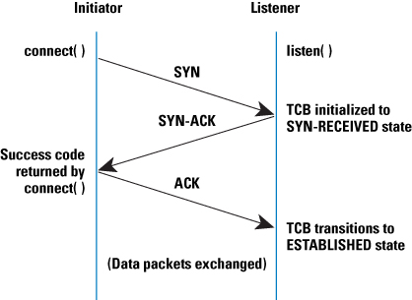

Figure - TCP three way handshake process. (Cisco, n.d.)

Error detection is a high priority for TCP, this is achieved through the use of CRC checks. If the CRC check comes back ok the receiver then sends an acknowledgement that it has received the data correctly, otherwise the data is sent again until the connection times out or an acknowledgment is received by the sender. In terms of web servers, as stated before, this ensures that all messages passed are intact and correct.

Transmitting/receiving data is done through the use of streams, these are abstract sources of text or binary data that can be read or written to. This makes it simple to incrementally read in a request and write out a text based response, such as HTTP requests and responses.

When sending and receiving HTML specifically it is key that transmission is correct as the presentation or behaviour of the web page when rendered in browser could be adversely affected. All modern operating systems such as Windows and UNIX like systems all provide support for TCP sockets built into the operating system.

2.6.2 DNS

The domain name system enables computer to lookup a node on a network by a host name rather than an IP address, thereby allowing for more user friendly and meaningful identifiers to be allocated. A web server must deal with DNS for host validation, which is making sure that a site is only accessible via a specific host name.

Validation is often done to make sure that resources are not requested using incorrect or deliberately renamed hosts; which is often done to dupe users into believing that the site they are accessing is genuine or to try and circumvent security that relies on a correct host name, HTTPS is an example of this where a certificate is often issued to only a very specific hostname.

The use of DNS for validation can take two forms, looking up the IP address for a host name or the reverse, using a host name to resolve to an IP. This functionality is often provided by a third party networking library that uses the underlying OS’s network software to communicate with the configured DNS server.

2.7 Security

Certain web applications require a degree of security to protect sensitive information from being accessed by inappropriate or malicious parties. Additionally when a user or server is transmitting data it must be unreadable by any node intercepting the message; a classic man in the middle attack which sniffs information and uses it to compromise security systems and/or steal data.

2.7.1 HTTP Authentication

This section describes part of the Hyper Text Transport Protocol, so it recommended to read section 2.12 if you are unfamiliar with HTTP.

HTTP authentication is a technique of using HTTP headers to provide a layer of access security using user names and passwords. There are two versions available, namely Basic and Digest, both handle authentication in a fundamentally different way but still use HTTP headers.

All requests for authentication in HTTP follow a pattern of a standard request with no authentication data and a response signalling you are unauthorized to request the resource. This loop repeats until a request with appropriate authentication information in the HTTP headers, in that case the resource is served normally.

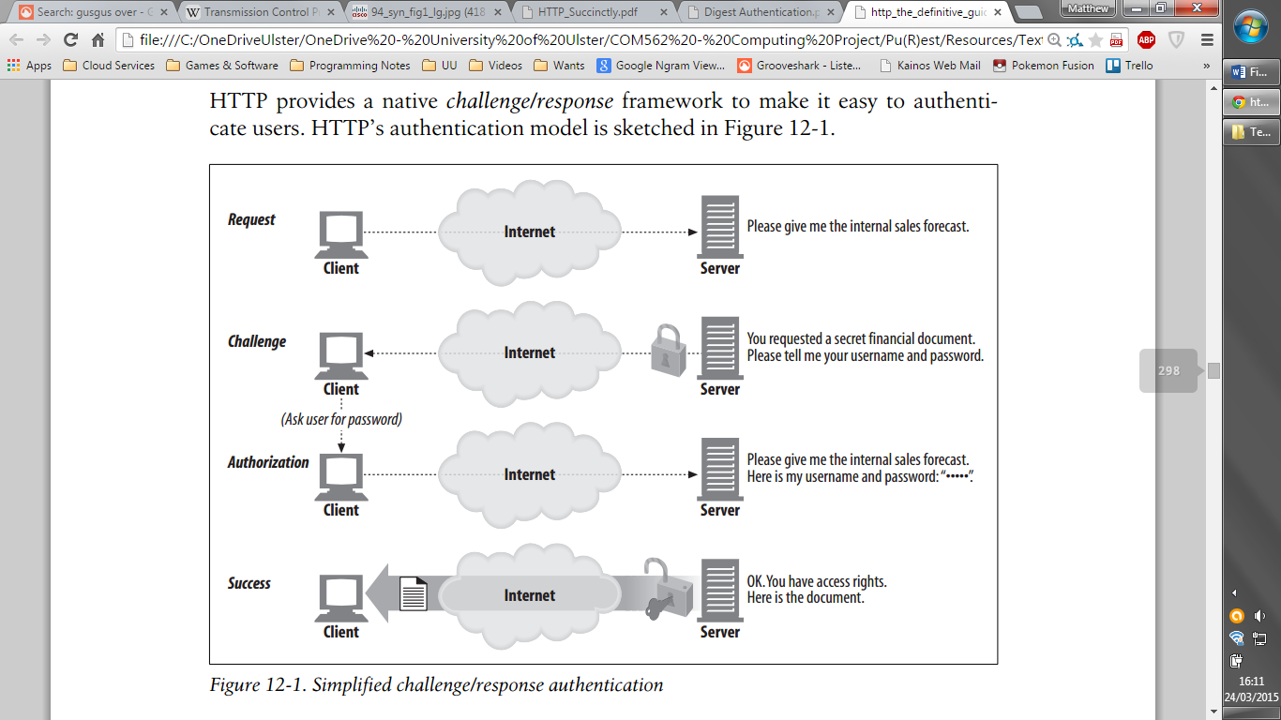

Figure - Overview of the general HTTP authentication process. (Gourley, Totty, Sayer, Aggarwal, & Reddy, 2002)

Basic authentication works by having the client format a string that contains the username and password and encode it using BASE64 encoding, this is a two way encoding scheme used to transmit binary data as ASCII text. The simplistic nature of this method makes it simple to implement, and if the sender knows that the resources need authentication then the HTTP headers can contain the authentication data without having to go through the process in fig. 2, making it efficient for a well-established system.

The fact that you can get the username and password from the information sent to the server makes this method inherently insecure, it is recommended to only use Basic authentication over HTTPS.

Digest authentication is a more sophisticated and secure method, and never transmits the password in authentication information. Using MD5 hashing to produce unique finger prints made up of the request information and user details, the Digest method matches the finger print sent by the client to the one produced server-side using the correct user name and password; this is why the password is never directly transmitted.

Unlike Basic authentication, Digest requires more complex logic server side to compute the user fingerprints, as a side effect this also makes requests take a longer amount of time due to the fact hashes must be calculated and compared; instead of a direct user lookup and verification.

The above forms of authentication will be implemented on the web server as they are both well documented and compatible with all HTTP compliant browsers.

2.7.2 HTTPS

While HTTP authentication aims to protect resources from being served it makes no attempt to conceal the contents of HTTP requests or responses, which themselves often contain sensitive information, such as credit card details being used to pay of a transaction.

HTTPS solves this security issue by encrypting the entire communication channel between the client and the server, meaning that not only is the content of messages hidden but no person intercepting the data could tell what messages were being sent; i.e. what resources were being requested and by whom.

An added benefit of HTTPS is that it uses a certificate system to validate the identity of servers, allowing users to browse sites in the confidence that the site is genuine and the encryption can be trusted; these certificates are maintained by authorities which can be trusted, this means a third party can be queried if the validity of a certificate is in doubt.

Additionally HTTPS can protect certificates with keys to prevent unauthorized people from communicating with the server entirely if necessary. The underlying encryption used for HTTPS is variable, using either SSL (Secure Socket Layer) or TLS (Transport Layer Security). SSL is outdated as it is no longer secure, however TLS is still in widespread use and has not been proven to be as insecure as SSL yet.

One of the most popular ways to implement HTTPS is to use the OpenSSL library to encrypt any TCP sockets that you use to communicate with clients; this allows the OpenSSL software to deal with setting up the secure connection and then using the socket in the normal manner to receive and send HTTP messages, which are now encrypted.

2.8 Concurrency

Concurrency in modern applications is a quite vast topic, and for the purposes of this dissertation only areas that are key to the project will be discussed here. The three main topics are lightweight processes/multi-threading, thread pools and message passing. Benefits of taking a multi-threaded approach to the web server architecture are as follows:

* Scalability, ability to handle requests from many different clients asynchronously. Also modern browsers often open multiple connections to servers to download separate resources in parallel, this needs the server to deal with requests in parallel for this to work.
* Error isolation, one request that generates a runtime error will be contained in its own thread.
* Multiple server sockets, to run technologies such as HTTPS the server must provide a second port for clients to connect to (usually port number 443), this can be done efficiently if two server instances ran in separate threads; one to handle HTTP requests and another to handle HTTPS requests.

Multi-threading is the act of having a process which has many ‘child’ threads that can interact with each other to work towards a common goal. This is divided in two types, fork and join and fork and continue. Fork and join uses the main thread (originating process) to start threads and then wait until all threads have processed to continue execution in the main thread.

Fork and continue simply makes an effort to start the child threads and then continues execution straight away; this is the behaviour most suitable for the web server as it must deal with HTTP requests in parallel, therefore the main thread should be able to continue to accept connections after spawning a new child thread to serve a request.

Thread pools are abstract data structures that allow a program to schedule tasks for completion asynchronously in a queue. This means there is always a promise that the system will process the task, and the pool can be scaled or set to a fixed size to optimize performance if you are familiar with the maximum problem size at given point in the execution.

Once a thread finishes, its slot in the queue can be freed and the results stored for retrieval or if the thread produces no useful result, it can be simply discarded. As thread queues can be represented as a class in an object oriented language, they can be shared amongst threads themselves, so the two server instances handling HTTP and HTTPS can share a thread pool and co-ordinate their use of this to allow uniform handling of threads across all server instances.

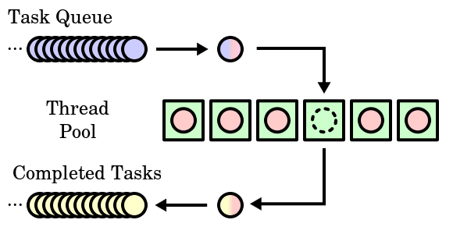

Figure - Classic operation of a thread pool. (Burnett, 2007)

Passing messages between threads is fundamental to co-ordination of actions in a multi-threaded system. Messages can be simple signals to flag processes as complete or resources freed, but can also be more complex such as sharing atomic access to a variable across threads.

An example of this, in the web server domain, would be sharing server side sessions amongst a collection of threads that are dealing with requests from the same client. The access needs to atomic because a session should always reflect the changes made to it during the logic executed when handling a request, and the data needs to be shared between these threads as every request should maintain the same session for a single unique client.

While message passing is useful it needs to be managed with care as incorrect access constrictions can lead to data corruption and runtime errors as programs overwrite data and assign different types to properties in objects.

2.9 File Systems

Serving static resources from a web server requires an understanding of the underlying file system and an ability read directory structures and file contents. All modern operating systems provide facilities to query files and directories for properties which would not be available through standard I/O; these are things such as create/modify times and exact file sizes.

To accelerate resource serving it is often useful to build a cache of frequently modified files in memory, only updating the cache when the file properties indicate that a modification has occurred or the file is no longer present, i.e. it has been deleted or moved.

Defining individual sites that are hosted on a web server is often done by inspecting the child directories of a given directory. The site that has been requested can be inferred by the location specified in the HTTP request, the ability to iterate over directories to find one with a matching name is also a feature a web server would avail of.

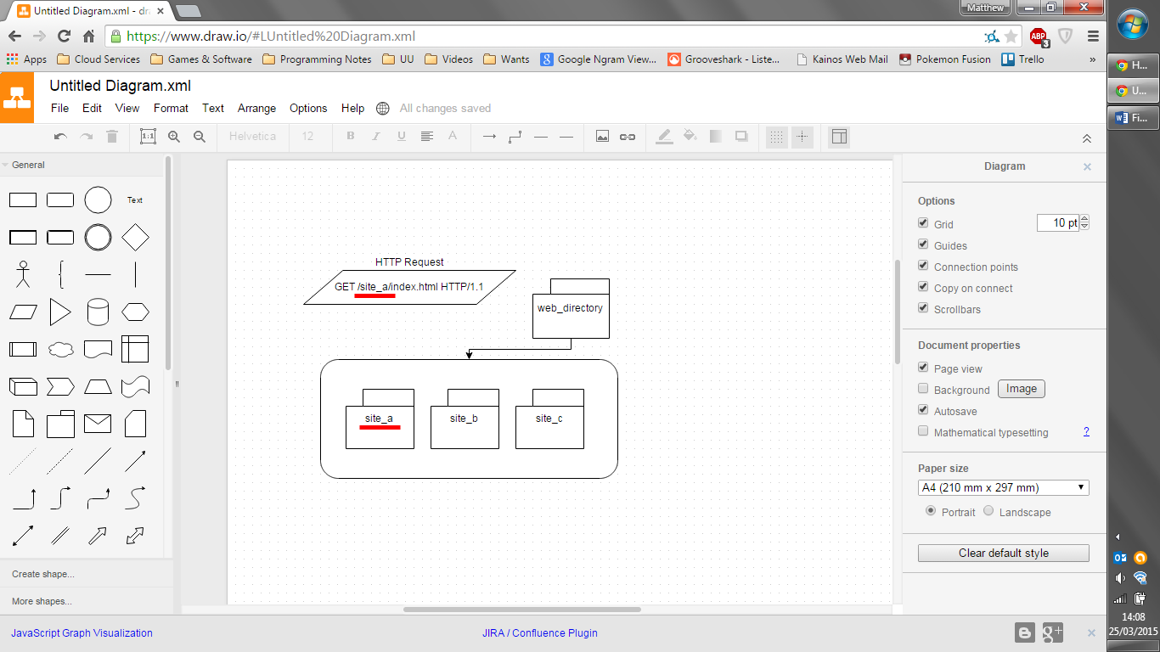

Figure - The HTTP request in the top left denotes the site in the location, underlined in red, and this is matched to the 'site_a' directory, also underlined.

2.10 Relational Databases

Relational databases will be interfaced with by the project to allow developers of web applications to communicate with their back end persistence engine easily and without writing too much boiler plate code; i.e. re-writing the same code to connect to a database, execute queries and return the results.

The database systems for which the project will to build an interface is determined by popularity, the top five most popular relational databases are listed below. (DB-Engines Ranking, 2015)

1. Oracle
2. MySQL
3. Microsoft SQLServer
4. PostgreSQL
5. DB2

2.11 Regular Expressions (Regex)

Regex allows the processing of text information to match patterns and extract formatted data. This is useful when developing a web server application as HTTP is a text based messaging format, with many different formatting standards, often embedded inside other formats.

Programmatically this technology works by compiling a pattern and matching on one or more strings, allowing you to find the sub-string inside any string that matches the pattern. Furthermore, as part of the pattern, you can specify areas of the pattern that should be extracted, this is called a capture; one could specify that a user name contains exactly four letters and two digits, and then extract a capture of the section that contains the digits.

In certain implementations of regex one can also name captures, so this enables named parts of a string to be extracted, this can be quite useful when providing a user with a list of segments from a location in a HTTP request, for example if a request was made for ‘/home/james/index.html’ the ‘james’ sub-string could be extracted and labelled as a field entitled ‘name’.

Another key application of regex is to work with file names and paths, as these have a set of rules and a defined structure it is easy to write patterns that can extract key details, such as the directory a file resides in, the file name and the extension (type) of the file. So for the path ‘/home/files/note.txt’ you could extract that the directory as ‘/home/files’, the file name as ‘note.txt’ and the file type as ‘txt’ (text file).

2.12 HTTP

The Hypertext Transport Protocol is the corner stone of the world-wide-web and used as a valuable middleware tool in many distributed systems. It allows the structured request for web server resources, most often content that is rendered in a web browser or used by clients of web services, such as AJAX calls and RESTful service clients.

HTTP is standardized and is extensively documented in multiple Request For Comment (RFC) documents, stating expected behaviours and data interchange formats. In terms of this project it will approached in a more pragmatic sense, providing the necessary compliance to work with the majority of HTTP clients but not necessarily implementing every edge case and part of the standard.

2.12.1 Routing & URIs

Uniform Resource Identifier (URI) is a text based format used to point to or name a resource. A URI is split into three components, firstly a scheme (e.g. http, https), an authority (e.g. [www.google.com](http://www.google.com)) and a path (e.g. /index.html). While Uniform Resource Locators (URLs/web address) are the most common implementation of a URI they have been used in other applications.

Partial URLs are used in HTTP requests to identify the resource being requested, this is transmitted on the first line of a HTTP request, an example of such a string would be ‘GET /index.html HTTP/1.1’. This instructs the server to locate and deliver the index.html file in the root directory if possible.

The fact that the location of the resource is mapped to a file found on the servers file system expresses the fact that the client is not concerned with the actual location of the file but merely knows what it wants and how to request it in a generic manner; meaning the client has no guarantee there actually is a index.html file and may the server may respond with content that was generated in place of reading in a file.

This idea can be further extended to not only indicate the resource requested but give some metadata about the specific instance of that resource required. For example a request could make a request that reads ‘GET /employees/87 HTTP/1.1’ and the server could have logic to interpret this as get the employee with the id ‘87’ and return it in the HTTP response to the client.

Routing is the name given to this method of interpreting the location as an instruction to perform some logic or redirection. The logic is usually implemented programmatically server side and allows a developer working on a web application to provide clients with a way to request resources using the generic tool of HTTP requests, rather than an application specific format.

Redirection can be as simple as the server holding a list of default documents for certain patterns, so if the request ends in a slash the server will look for an index.html file and serve that. For example the request ‘GET / HTTP/1.1’ will return the contents of the index.html file if it exists in the root directory.

While these seem like simple techniques they can be expanded with regular expressions to allow an application to declare to the server a series of routes that follow given patterns and provide code that will handle the requests that match those patterns; to say lookup a database for a row with a given ID, like the employees request example above, and return the details in the response.

2.12.2 HTTP 1.1

The version of the HTTP standard in most common use today is 1.1, which was standardised in 1999 by RFC 2616 (Fielding, et al., 1999). As stated at the end of section 2.12 this project does not aim to be a fully standards compliant HTTP/1.1 server, and as such only areas of the standard which are required to work with modern web browsers and web service clients will be discussed in this section.

2.12.2.1 Messages

Passing messages using HTTP follows a standard pattern and works using three components, detailed in the table below.

|  |  |
| --- | --- |
| HTTP Message Component | Description |
| Status/request line | If the message is a request, the request line describes the resource being requested and the method being used to do so. (see section 2.12.2.3)  If the message is a response, the status line details the result of processing a request with a status code. (see section 2.12.2.2) |
| Headers | These provide additional information about the message, these often contain metadata about the client or server. (see section 2.12.2.4) |
| Body | This is the payload of the message, text data which can be in any format; optional and not always present in a message. (see section 2.12.2.5) |

The flow of messages in HTTP can be seen in figure 5.

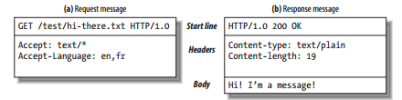

Figure - Sample exchange of HTTP messages. (Gourley, Totty, Sayer, Aggarwal, & Reddy, 2002)

2.12.2.2 Status Codes

When a web server returns a response to a client request it indicates the status of the handling of the request, which is included in the Status-Line seen in the last section. These are made up of two parts, firstly a number identifying the code and a message of a few words describing response type. Below is a table of the code groups and specific examples required for the project server to communicate with a client in a standard way.

|  |  |  |
| --- | --- | --- |
| Status Code Class | Description | Examples |
| 1xx | Informational response used to switch protocols or inform client that the request will be processed soon, another response with a different code will follow one or more of these. | *Not being implemented; mainly used for web sockets.* |
| 2xx | Request was received, understood and accepted | 200 OK – Succeeded, will contain data in content. |
| 3xx | Redirect client to another resource | 302 Found – Provide a URI for the client to alternatively get the requested resource from plus a HTML message to that effect. |
| 4xx | Error with client request | 401 Unauthorized – Client not authorised to request resource, used for HTTP authentication challenges.  403 Forbidden – Server understands request but logic/configuration determined it will should not be served. If you are trying to list a directory for example, but this is disabled.  404 Not Found – The resource request cannot be found on the server. |
| 5xx | Server error while processing request | 500 Internal Server Error – Unexpected state encountered while satisfying request |

Note that while not all status codes are supported, a piece of server side script can handle this internally, for example a web service could modify the response status to 201; indicating a request to create a resource has been fulfilled and resulted in a new entry being stored in the database, for example.

2.12.2.3 Methods

The method for a HTTP request appears on the request line, it indicates how the client wants to interact with the requested resource and also infers some characteristics about the rest of the message. Below is a table describing each HTTP/1.1 method that will be implemented in the web application server for this project; any methods that duplicate functionality or are not commonly used will be excluded.

|  |  |
| --- | --- |
| HTTP Method | Description |
| GET | Request a resource from the server, does not contain any information in the request body. |
| PUT | Update a resource on the server, if it does not exist create it instead. The resource content is defined by the request body. |
| POST | Send input data to server, data is transmitted in the request body. |
| DELETE | Delete a resource from the server, however this is not a guaranteed in any way and/or the server may take some time to delete the resource. |

For web services and interactive web sites these methods are sufficient because it allows a client to preform CRUD (create replace update and delete) operations via regular route calling and resource requesting.

2.12.2.4 Headers

As stated in the previous section HTTP headers transmit metadata about a request, the list of available headers is too verbose to include here, but the below table defines the categories of headers that have been viewed as necessary for the project and some examples.

|  |  |
| --- | --- |
| Header Categories | Examples |
| Request Information | Host: www.google.com | Hostname used in the request  Accept: * | Content type supported by the client |
| Response Information | Server: Apache 4.2 x86 Linux | Description of server software |
| Authentication | Authorization: Basic am10Jdkfi= | Information used in a request to specify credentials to the server |
| Connection Control | Connection: close | What to do with the network connection after the message |
| Compression | Content-Encoding: gzip | The scheme used to encode the body |
| Content Information | Content-Type: text/html | Content type of the message body |

A web application should be able handle and/or add extra headers if they wish, so while there is a core the server should support it does not mean it will not fully process additional and custom headers.

2.12.2.5 Content & MIME Types

The content, if any, of a HTTP request/response is provided directly after the headers, these are separated by two newline character sequences. All content is text based and is often human readable, unless it has undergone compression.

Content is used to deliver content when a resource is request or to upload data to a web server, the classic example being a web form that uses the POST HTTP method to send a series of key value pairs that indicate the fields and data entered on the form. Web services often use content to send and receive JSON or XML data to indicate application specific objects or messages.

The header ‘Content-Type’ denotes the format of the content, this is done by specifying a MIME type. Multipurpose Internet Mail Extensions provides a standard way to indicate the format of a message, often for the purposes of finding the right application/library to access the message or deciding if such a format is supported by the system that is attempting to read it.

All MIME types give two or more pieces of information, the first is the general type name and the second the sub type name that more precisely identifies the format. For example a plain text content would be of the type ‘text/plain’ and a zip archive is indicated by ’application/zip’; there may be more than one MIME type that identifies a particular format and subtypes may be recognised by some applications as one single type, for example ‘image/jpeg’ and ‘image/pjpeg’ might both be opened by a program as simply a ‘jpeg’ file.

A web server can determine the MIME type of the resource requested by reading file extensions or if possible inspecting the file contents. This means a client always has a reasonable way to determine the response format and decode/utilise/display this in an end-user applications interface.

Request content can be dynamically converted to a format that the server side scripting language can alter in memory, usually this means an object or data structure is used to represent the request information. Using libraries that work with JSON and XML allows a server to take request content and present to a server side script and then convert any values returned from the script logic into a reasonable format that the client can process, say JSON or HTML/XML.

2.12.2.6 Compression (GZIP)

Often when responding to a HTTP request it will save bandwidth and reduce transmission time if the response content is reduced in size by being run it through a compression algorithm. This should only be done if the type of compression you intend to preform is supported by the client making the request as they need to be able to decompress the message into plain text.

This behaviour is controlled via the ‘Accept-Encoding’ header, which provides a comma separated list of encoding formats the client will accept in the response. The response header ‘Content-Encoding’ is used to signal the encoding of the response content.

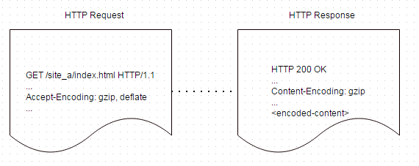

Figure - Example of HTTP compression and associated headers.

Two compression schemes are most common, namely deflate and gzip, both are supported by major modern browsers, but the most prevalent and widely implemented scheme is GZIP compression; both schemes mentioned are provided by the open source and patent free ZLIB library. This widely recognised choice of gzip is due to confusion around the standardization of the deflate scheme which can interpreted in different ways by servers and browsers. (Hoffman, 2012)

2.12.7 RESTful Services

In section 2.12.1 the subject of using URLs to provide a framework for mapping routes can be expanded in a more formal manner through the use of what is known as a RESTful service, REST standing for Representational state transfer. It is a technique used to build scalable web services that can expose data stores and provide remote control over various systems.

The two key elements are routing, discussed previously, and HTTP request methods; combined these signal a particular action to the server. As the methods are verbs it is appropriate for these to directly reflect the side effect of calling a route with that particular method. Below is an example of some routes and methods that could make up a REST service and the full URLs that would be used to make the request

|  |  |  |  |
| --- | --- | --- | --- |
| Route | HTTP Method | Description | Full Url |
| /employees | GET | Return a list of all current employees. | http://www.host.com/employees |
| /employee | POST | Store a new employee. | http://www.host.com/employee |
| /employee/0 | GET | Find and return the details of the employee with the ID equal to 0. | http://www.host.com/employee/0 |
| /employee/0 | DELETE | Remove the employee with the ID equal to 0. | http://www.host.com/employee/0 |
| /employee/0 | PUT | Update the details of the employee with the ID equal to 0. | http://www.host.com/employee/0 |

As you see it is possible to clearly manipulate a data store using a REST service, also note that any action that uses POST or PUT specifies the data associated with action in the body of the HTTP request. It is easy to understand the functions of each call, with HTTP method clearly stating the side effect of calling a particular route.

While other web service technologies have been established and used in extensive systems such as enterprise environments, due to the trend of more development teams and services migrating their services to REST (Oliver, 2013) the project will focus only on providing APIs to create and work with these type of services.

2.13 Web Applications

This section deals with the technologies common to most web server implementations, these are key to the project as developers often expect a certain set of features to rely on when creating various web applications.

2.13.1 Server Side Scripts

When a server receives a HTTP request it can be linked to a piece of code that will dynamically produce a response. This often takes the format of a program script that is loaded and passed the details of the request as parameters. Languages used for this task are often interpreted, such as Perl or PHP.

Scripts are often run with a fixed environment, which provides an Application Programming Interface to access the data passed in via the request, add headers and place content to the response. Using an API scripts never have to deal with the internals of the web server architecture they are hosted on.

Most commonly these scripts output data from a back-end store such as a relational database, allowing a web request to manipulate records in an abstract matter, searching, adding, editing and deleting via programming logic.

2.13.2 Sessions

HTTP is a stateless technology by its design, meaning requests for resources can be made at any time and no state information is carried between one request and the next. Sessions aim to provide a server side solution to provide state information about a client.

This feature is usually a variable maintained in memory on the behalf of a developer and can be used to store data such as a user id, whether a client is logged in or used as a cache to speed up requests; this is then made available to server side scripts to allow a program to work with the session data stored for a client who made the current request.

A timeout is commonly used to prevent the memory for sessions becoming unreasonably large and also increases security by deleting sensitive information from memory after a given time, meaning a web application could use a session to mark a client as logged in and if the client makes no requests within 30 minutes (for example) the session will be deleted from memory and the next request will have a clean session associated with it, containing no data from any previous interactions with the client.

2.13.3 Model View Controller

The MVC design pattern can be applied to any application domain which presents information graphically. Often these systems can be designed in a way that mixes together the logic that handles data and logic that handles presentation, this is bad practice and often leads to code which is hard to read and tries to take on too much responsibility in one place.

MVC separates the concerns of an application by putting any data to be displayed in a model, which is accessed and updated by a controller which in turns works with a view to output the data to a GUI interface. The benefit is that one model can be used with multiple views, say for different platforms such as a desktop browser and a mobile browser. The flexibility this affords means using the existing application in new ways is easier and maintaining the logic can be done in the controller; meaning front-end developers can focus on presentation and back-end developers can focus on algorithms and data structures.

This pattern is ideal for use in web applications as often server side scripts deal with serving HTML for browsers to render whilst also working with databases and variables in memory, all in response to a HTTP request. The resources accessed by requests via URLs can be modelled as routes, as discussed in section 2.12.1, and a collection of these routes can comprise a controller; for example if a web site had a members area a members controller could handle all the pages concerned.

Models are the pieces of data needed to display a page, often represented using classes and objects in object oriented languages. The view would then be a dynamic page or script that prints out the appropriate HTML to wrap the model information, and may make decisions on what elements to show based upon the values present in the model; say a user is an admin, and in that scenario a page will display an area to control other user accounts.

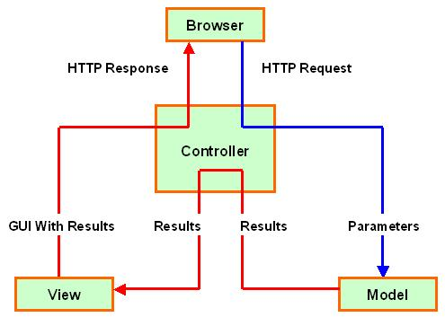

Figure - The process of using MVC to process HTTP requests. (j2mesalsa, 2009)

2.13.4 JSON

Javascript object notation is a plain text data format used to transport data using key value pairs, and despite its name it is independent of any programming language. The standard was developed as a structured way to pass data in HTTP messages between clients and servers.

More web services, in recent times, are preferring JSON as their data format of choice, due to the fact it requires less bandwidth to work with and is supported by many modern development languages. (Oliver, 2013)

Another benefit of JSON is the ability to serialize objects, this means write out the values in memory for an object as plain text. One can then work with any reasonably complex data structure and produce a JSON string on demand to use, additionally languages support de-serializing JSON strings; that is to create an object in memory that represents the plain text values.

When working with applications that run in a web browser JSON is even easier to work with as the JavaScript language can natively parse it, because JSON is a subset of JavaScript. This also assists in AJAX calls as the return content can be used without having to de-serialize the JSON.

2.13.5 XML

Extensible Markup Language (XML) is used to represent digital content in a textual way, with a focus on a document like structure. Its uses in web applications varies from web service responses, database listings and layout information for web browsers displaying pages.

As states in the previous section discussing JSON the benefits of that format are more suited to RESTful web services. XML requires a well-defined layout, which is often very structured and uniform, to represent a specific document type. This requires a developer to set up extra overhead in a programming language to define the document as a class/data structure in memory. With JSON this is not required as any arbitrary variable, of reasonable complexity, can be directly converted to JSON with simply one or two lines of code.

Despite this stark contrast the project would benefit with being compatible with a broad range of data formats, to cover the case that specific clients or technologies require the use of XML it is better to research this and include the features to work with XML while making web applications.

2.13.6 HTML

Hypertext Markup Language has been the standard for formatting and transmitting information on the World Wide Web since it was created. This language uses an XML like syntax to denote the elements and metadata for a web page, and has developed to be an XML document standard rather than a separate technology all together, namely as the standard XHTML.

The syntax and structure of XHTML elements has been researched to facilitate the development of dynamic views which have snippets of code embedded amongst the regular HTML components; however HTML is quite extensible and very most modern browsers are very forgiving in terms of layout and strict adherence to syntax rules.

2.13.7 AJAX

Asynchronous JavaScript and XML is a client side technology used to communicate with a web server without blocking user interaction with a web page. It allows the loading of resources by sending HTTP requests and processing the responses with JavaScript code, meaning elements on web pages can be dynamic (searches, drop down lists) and update automatically (exchange rates, live sports scores).

All web servers support AJAX, as the server receives a request in the same manner as if the web browser was requesting a regular resource, but often a web application designer will create web services to provide a more structured and meaningful interface for AJAX code to call.

Despite the name of this technology, XML is not always involved in requests or data processing and routines can just as easily use plain text or JSON. The original intention being that partial HTML segments would be returned and appended to elements on a web page without any further processing by the client-side script.

2.13.8 PHP

PHP is a scripting language that is popularly used to write web applications, first appearing in 1994 (Group, 2015) it has went on to take 82% of the known market share of development languages used to build web applications, as of March 2015. It is used by many sites but mostly for low traffic applications. (w3techs, Usage statistics and market share of PHP for websites, 2015)

Because of its popularity it would be nice to provide support for this technology on a web server, also easing the transition for developers who are familiar with PHP. The strengths of PHP are as follows:

* Easy access to database systems through built in drivers
* Broad collection of libraries to carry out common web development tasks (image generation, encryption and password hashing)
* Not bound to any single web server architecture, works with applications such as Apache and Microsoft Internet Information Services

PHP scripts can be ran at will by passing the path and request data to the PHP interpreter binary, allowing any program that can work with C-style standard input and output to also integrate PHP, collecting the output after the interpreter has processed the script.

2.14 Logging

As many server applications do not have direct user interfaces, such as a graphical window or command line output, and run in the background as a service they produce logs to allow administrators and developers to inspect and debug HTTP requests and hosted web applications.

Logs can be stored in multiple places, common examples are as files and database records. Logs output can also be controlled by labelling messages with levels of severity, that is what type of message is it; examples are information, error, warning and debug info. This level can be set and any messages which are not as severe as the configured level are not written to the file and this helps reduce the size of the log files and ensures no redundant or debug information is written out.

Logging is key to error reporting due to the lack of direct output and often when building a web application the developers want to ensure that the requests are being handled properly and not throwing any exceptions. While logging can be done in an ad-hoc manner it is better to use a standard format for all logs that is both human readable and can be parsed by applications to automatically detect errors or warnings.

Log messages usually consist of the date and time logged, the level (what severity is the message, such as error, fatal or warning), a title (what area of the program outputted this log) and the message itself (human readable message).



Figure - Example snippet from a server log file.

2.15 Lua

The main language of the project will be Lua and this has been researched extensively for two main aspects, firstly the general appeal and benefits of the language as a platform for sever applications and secondly it’s applicability for use in writing web services and server side scripts.

Lua is dynamic, interpreted language requiring no compilation or extra steps to run code other than saving it to disk and loading it into the runtime.

Below are the keys points that tout Lua as a good platform for developing server applications.

* Although it is interpreted and not compiled, it has one of the fastest execution speeds amongst dynamic languages. (Kulchenko, 2012)
* Runtime is extremely portable, and can be compiled on any platform that supports the C language; additionally the Lua source code is cross platform, similar to Ruby and Perl.
* Syntax and basic features are simple but dynamic, meaning a developer can implement their solution using a broad variety of programming paradigms, a full list these discussed in section 2.15.1.
* The memory footprint of the runtime is very low in comparison with other languages of the same nature, such as Python. (x64 Ubuntu : Intel® Q6600® one core - Computer Language Benchmarks Game , 2015)

When considering using Lua to write web services and server-side scripts, the following list highlights some critical benefits.

* Lua provides built in capabilities to load in executable script from strings and external files, meaning snippets can be located and used dynamically, such as in a server script similar to PHP.
* Environments can be prepared for function calls and external script files so that they are provided with the necessary API classes and procedures
* The environments created can be sandboxed, preventing custom script from changing global variables or loading libraries in the servers’ environment. This also adds an element of security as applications running on the server can never attempt malicious actions to gain access to server side sessions or other sensitive data.

2.15.1 Programming Paradigms

The previous section eluded to fact that Lua supports multiple paradigms for implementing programs. These allow the creator of web applications to choose any approach they feel comfortable with when writing custom logic and data structures.

Below is a list of supported paradigms in Lua and how each one could benefit application development; be it the server or any applications it hosts.

* Scripting – Allow instructions to be interpreted at run time, meaning no compilation is necessary and logic can be changed on the fly, useful during the development of a web applications for debugging web services.
* Procedural – Using classes and functions as interfaces to carry out actions as discrete blocks, without having to deal with the inner workings. This is useful when developing APIs for developers to use, building and documenting interfaces for them to get tasks done while avoiding the issues with changes in internal server logic and data structure.
* Prototyped-Based – Creating template objects that can be replicated and extended on demand. Useful for configuration settings, so a template would specify the configuration keys and their default values and if the configuration needs to be change a user creates a copy of the template, edits this and uses it as the new configuration.
* Object-Orientated – Models entities in a task as abstract classes, having their own private properties and hiding their inner working from end users. Similar to procedural, this is useful for APIs and since object orientated languages such as Java and C# are widely used, it means new developers will feel comfortable using objects right away.
* Functional – Programs that focus on processing input and providing a meaningful output but not maintaining a state, useful for HTTP applications as the protocol is designed to be stateless and produce output based on the request parameters (the input).

2.15.2 Core Language

The core of Lua is very small and only defines the syntax, it is not strongly typed meaning if does not require type definitions to create variables, it supports some fundamental types such as Boolean, string, number and functions. Lua promotes functions as first class types meaning they can be assigned to variables and created anonymously for use in handlers, similar to the way JavaScript uses functions to handle web browser events.

Another key type is the Table, this is a container element that holds other elements similar to structs in C and objects in C# and Java. It allows you to build collections, or arrays and also build objects.

A table in Lua also supports meta-methods, these are functions that handle events such as someone using an index to look up a value in a table or using operators such as plus or minus on a table; these means you build types that work like primitive types, so for example you can add a function that handles a logical equals check between two tables, comparing the internal fields.

Unfortunately the built in system library for Lua is quite small, although it does provide some key features, below is a table of the default libraries.

|  |  |
| --- | --- |
| Library Name | Description |
| Co-Routine | Cooperative multi-threading to allow multiple tasks to execute asynchronously, although this is not as powerful as the more common technique of pre-emptive multi-threading. |
| Package | For loading libraries and other external Lua files, similar to class paths in Java. |
| String & Table | Creating and working with tables and strings. |
| Math | Standard math functions. |
| I/O | Work with files and standard input, output and error. |
| OS | Read environment variables from the operating system; used for paths and shared configuration. |
| DEBUG | Used to trace errors and place hooks to get more information at runtime about the program state. |

2.15.3 C Extensions

Lua also uses C as it primary extension language to allow libraries which provide more complicated functionality, which is not available in the core language or third party libraries, to be loaded; it also provides a full interface for passing values between C and Lua to allow seamless integration.

This means libraries written for the C language can be used in Lua through the use of a C library for Lua that provides an interface; this is a powerful point as it means that almost any existing C library is usable from Lua, this means mature and useful libraries can be easily imported.

2.15.4 LuaRocks

LuaRocks is a package manager for Lua. It provides facilities to search for, download and install software libraries. It also attempts to streamline any C extensions by automatically building the C source files into a shared library suitable for use with the Lua language; another useful feature is the ability to download binary copies of C extensions if you do not have the necessary compiler tool chain installed.

It uses a command line interface and maintains a registry of libraries installed and their versions, allowing a user to update and remove libraries with little side effect. Additionally it manages dependencies, so if a Lua library requires several other libraries it will recursively download and install these until no unmet dependencies remain.

Unfortunately this tool has a very narrow scope and makes no attempts to ensure other environment dependencies, such as external third party static libraries or binaries, are met properly. This often means unless you are familiar with the components a library requires it may be broken until you install extra software on your system.

2.16 Source Control

Source control, otherwise known as revision or version control, is a technique for tracking changes to a collection of files. The most common use is in computer programming to manage a large project over time, this is done by comparing a file to a known version and noting the changes, then logging these changes in a custom format data file known as a repository.

Such logging is known as making a commit or adding a change set, such commits will contain information on the files that have been updated/deleted/added and a short message from user describing the changes. All commits can be synchronised between multiple users by utilising a remote repository hosted on a networked server; this is known as distributed source control

Remote repositories often contain accepted changes from multiple local repositories and allows a development team to manage what goes into the main repository to prevent bad/unacceptable changes to code being accepted.

The benefits of source control are as follows:

* Link commits directly with units of work to allow tracking what was implemented/changed to complete that work.
* Ability to revert to earlier versions of code to test features for a specific version.
* If you end up making changes that break a project, and you are unable to cleanly fix it, you can roll back some or all files to the last commit to get back to the last good version.
* Source control can integrate with products to allow downloading the latest version, configuring/compiling the application and running tests on it automatically; this is often triggered when someone makes a commit and is known as continuous integration testing.
* As stated it is possible to synchronise the work of a whole team of engineers in a remote repository, you can also see who committed changes allowing you to get information about features and potential bugs from the developer responsible for a section of code.

In the scope of this project source control repositories will be used to manage the various source code artefacts and contribute towards project management.

2.17 Linux

Linux is a free piece of software that provides a complete operating system that runs on the majority of computing hardware, from small form devices such as micro-controllers to server clusters. Versions of this operating system are called distributions, and they often compile various extra pieces of software such as a graphical desktop manager and other familiar packages.

All versions of Linux provide excellent features that a web application server can leverage; obviously because Lua is cross-platform these benefits are transparent to the web server implementation but will be noticeable during runtime, also because Lua depends on C extensions if the libraries for a particular operating system are more stable and mature they will provide better performance to the high level Lua code accessing them.

Below are some of the key benefits using Linux to host a Lua web server application (Haas, 2013):

* Ability to install required libraries automatically using a package manager that will download, compile and install the necessary software; all Linux distributions come with some version of a package manager.
* Linux is a very stable operating system, requiring less reboots and being able to handle multiple processes running concurrently quite well.
* Security is at the heart of a Linux system, needing special access to install software and manage configuration, also less viruses/malware are actively targeting the Linux platform.
* Less hardware resources are required to run a Linux system, and this means it can often outperform other operating systems even on less impressive hardware.
* Linux is built using the C programming language and offers excellent environment for building and installing programs and libraries written in C; this is ideal for managing the C extensions required for some Lua libraries.

The specific distribution to be decided for the project will be discussed in the implementation chapter along with how some of the third party libraries perform better when built and installed on Linux.

3. Requirements Engineering Process

Within this chapter the requirements engineering process is defined; this process covers the entirety from how the requirements where collected and analysed, to aspects such as listing the complete requirements along with our methods of ensuring they were exactly what the stakeholders wanted, and also needed in their system.

A proper understanding of requirements and careful management thereof can prevent project failures and contribute to the delivery of quality software products to intended clients (Chemuturi, 2013).

The proceeding sub-sections provide a detailed analysis of the requirements engineering process partaken for the proposed system.

3.1 Elicitation & Analysis

Requirements elicitation is concerned with collecting the needs and wants of stakeholders for a system; in other words this is gathering initial requirements. Elicitation is an important part of the requirements engineering process as it is the base-point in which requirements are established and constructed to form project requirements.

In addition, requirements analysis runs parallel to elicitation; this is because analysis is concerned with taking the elicited information and data from the stakeholders, and forms them into initial requirements which will be reviewed at a later date, and then finalised. For the proposed system, elicitation was carried out through two unique techniques:

* Formal interviews
* JAD session

The following sub-sections detail these two techniques and explain how elicitation was successfully achieved:

3.1.1 Formal Interviews with Client/Stakeholders

One technique used was holding multiple formal interviews with the project stakeholders in which all their opinions were gathered on how the system should work, and also what should be included.

One-to-one interviews are among the most popular types of requirements elicitation, and for good reason: they give the opportunity to discuss in-depth a stakeholder’s thoughts and get their perspective on the business need and the feasibility of potential solutions (Masters, 2015).

This meeting included only a number of the stakeholders, and the main output gathered was their needs and wants for the system. This information was then recorded and analysed at a later date.

3.1.2 JAD Session

Another technique used was a JAD session (Joint Application Development) in which many stakeholders were present at the same time to openly discuss their requirements for the proposed system.

These sessions are unique to the elicitation and analysis phase as participants’ may also brainstorm together and listen to each other’s input; they can provide immediate feedback and refinements to identified business needs, which can ensure a fast, effective elicitation of requirements (Masters, 2015).

To ensure all data and information was gathered effectively, session notes were recorded and scripted to allow the data to be analyse at a later stage during this phase.

3.1.3 System Analysis

System analysis is the process of gathering requirements by studying similar projects. The main activities include reviewing documentation and user guides for recommendations and best practices. Furthermore the actual functionality, user interface and design are also studied both in theory and by applying the similar projects to see how they implement solutions, structure tasks and overcome common problems.

Section 2.3 in the literature is a prime example of system analysis, as it demonstrates research into existing web application servers and defines several key features that all severs attempt to provide in their own way; this is evidence in itself for a good requirement as a requirement that is replicated again across several projects shows an end user demand.

While formal interviews and JAD sessions are used to refine requirements and note recommendations/advice, the system analysis carried out will be the main source of functional and non-functional requirements.

3.2 Specification

This section deals directly with the requirements identified and techniques used to more fully explore each requirement; the main technique used for this was Volere shells, samples of which are included in the section 3.2.1.1.

3.2.1 Functional Requirements

Below is a list of the projects functional requirements; these are requirements that when fully met at the end of the project will validate the project as a success.

|  |  |  |
| --- | --- | --- |
| Requirement ID | Requirement Description | Complexity Estimate |
| FR01 | The server should be cross platform, running on Windows, OSX and Linux. | 4 |
| FR02 | The server should be able to parse HTTP requests and author HTTP responses. | 5 |
| FR03 | The server should provide a web application API (Application Programming Interface) | 6 |
| FR04 | The web application API should be available from Lua scripts. (as importable modules) | 6 |
| FR05 | The web application API should allow a user to create web services. | 7 |
| FR06 | The web application API should allow a user to customise the configuration for a website hosted on the server. | 7 |
| FR07 | The web application should model the current HTTP request and provide a model to detail the HTTP response. | 8 |
| FR08 | The server should be able to process dynamic pages which are written in HTML with embedded Lua code snippets. (Similar to PHP script in design) | 9 |
| FR09 | The server should handle errors by responding with an appropriate HTTP status code in a response, such as 500 for an error and 404 for resource not found. | 5 |
| FR10 | The server should serve files from the file system by matching them with request resource paths. | 6 |
| FR11 | The server should allow a directory on the file system to act as the root directory for all sites on the server, with each sub directory of this root directory being recognised as an individual site. | 7 |
| FR11 | Sites hosted on the server should allow loading of application logic and site configuration from a Lua source code file located in the root directory for the site. | 9 |
| FR12 | The server should provide and manage server side sessions. | 6 |
| FR13 | The server should provide configuration and adhere to this for server behaviour. | 6 |
| FR14 | The server should log messages about events, requests, errors and warning in log files. | 7 |
| FR15 | The server should automatically de-serialize data contained in HTTP requests and serialize data to be used in HTTP responses. Specifically JSON, XML and web form data should be convertible from text to Lua values and back to text. | 7 |

3.2.1.1 Volere Shells

A selection of Volere shells are placed below, however see Appendix G for a full listing.

**Requirement #**: FR08 **Requirement Type**: Functional

**Description**: The server should be able to process dynamic pages which are written in HTML with embedded Lua code snippets. (Similar to PHP script in design)

**Rationale**: To allow developers to write server side scripts and provide functionality in line with other popular web application frameworks.

**Originator**: Matthew Snoddy – Senior Requirements Engineer.

**Fit Criterion**: The server request handling should automatically process files with a ‘lhtml’ extension as dynamic pages, evaluating Lua code snippets and writing output to the page.

**Customer Satisfaction**: 4 **Customer Dissatisfaction**: 4

**Dependencies**: None.

**Conflicts**: 0

**Supporting Materials**: Project Activity Diagrams (See section 5.2.8).

**History**: Created 15th October 2014

**Requirement #**: FR07 **Requirement Type**: Functional

**Description**: The web application should model the current HTTP request and provide a model to detail the HTTP response.

**Rationale**: Enable developers to have an abstract and understandable, readily parsed, view of HTTP messages.

**Originator**: Matthew Snoddy – Senior Requirements Engineer.

**Fit Criterion**: HTTP requests and response should be appropriately modelled during request handling.

**Customer Satisfaction**: 5 **Customer Dissatisfaction**: 5

**Dependencies**: HTTP request received is not malformed/corrupted. **Conflicts**: 0

**Supporting Materials**: Project Activity Diagrams (See section 5.2.3).

**History**: Created 15th October 2014

**Requirement #**: FR11 **Requirement Type**: Functional

**Description**: The server should allow a directory on the file system to act as the root directory for web resources.

**Rationale**: Provide an entry point for administrators to deploy individual sites in a structured way under specific names.

**Originator**: Matthew Snoddy – Senior Requirements Engineer.

**Fit Criterion**: The root directory should hold all sites to be hosted on the server, with each sub directory of this root directory being recognised as an individual site

**Customer Satisfaction**: 5 **Customer Dissatisfaction**: 5

**Dependencies**: File system being operational and server configuration being valid. **Conflicts**: 0

**Supporting Materials**: Project Design (See section 5.1 – Component 6).

**History**: Created 15th October 2014

3.2.2 Non-Functional Requirements

|  |  |  |
| --- | --- | --- |
| Requirement ID | Requirement Description | Complexity Estimate |
| NFR01 | The server should support database connectivity with an extra API on top of existing drivers. | 5 |
| NFR02 | The server should record log messages in a reasonable format, having the date and time of the message and the level of severity clearly visible. | 3 |
| NFR03 | The server should support HTTP compression. | 4 |
| NFR04 | The server should support running requested PHP scripts using an external interpreter and returning the result in the HTTP response. | 6 |
| NFR05 | The server should maintain a cache of files requested for performance reasons, refreshing the cache when a file is modified or deleted on the file system. | 7 |
| NFR06 | The server should support HTTP authentication and provide an API to set this up in the site configuration. | 7 |
| NFR07 | The server should come with an administrative web application built in to monitor the server performance, show the details of hosted sites and display server logs. | 6 |
| NFR08 | The server should have an accompanying end user guide that details the installation and configuration of the server. This documentation should also deal with developing websites for the server and the web application API. | 3 |

3.2.3 MoSCoW

MoSCow is a technique for understanding requirement priority and importance, allowing distinct categories to defined and worked on in a top down order. Additionally this technique also enables the establishment of scope for the project, by explicitly stating the requirements or desires for the project that will not be worked or could be worked on given sufficient time and resources. (MoSCoW Method, 2014)

A full list of MoSCoW style requirements were developed for this project and have been used to aid design goals; see Appendix A for a full listing of the MoSCow requirements.

3.3 System Modelling

This section provides a visual representation of how the proposed system will interact with internal entities such as other systems and process, and external entities such as users of the system.

3.3.1 Use Case Model

A use case model describes the actors involved in use of the systems and the actions they participate in.

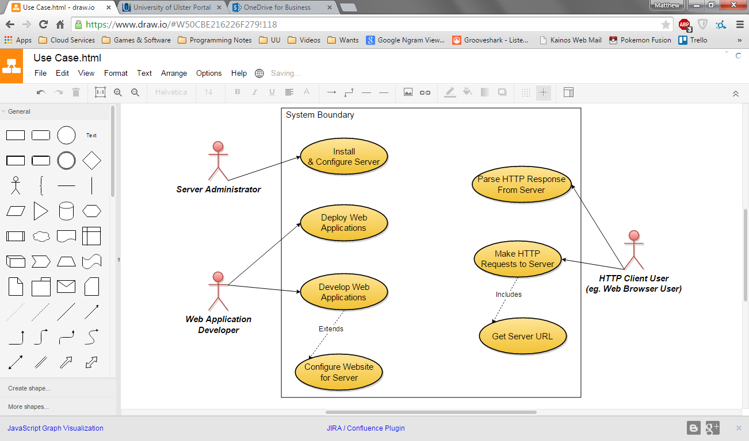

Figure - Use Case Model of the Web Application Server and Clients

3.3.2 System Context Diagram

A system context diagram considers the other external systems that will be utilised by the main system in the project. A more detailed view of the resources accessed can be seen in section 5.1, high level system architecture.

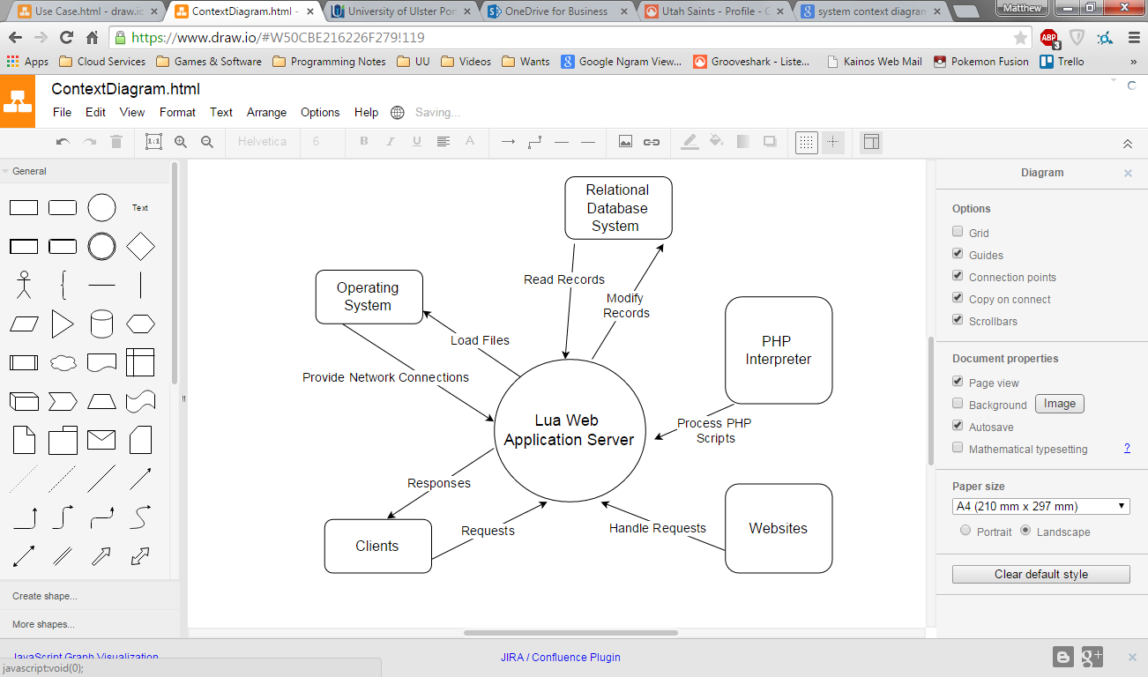

Figure - System Context Diagram for the Web Application Sever

3.4 Requirement Validation

Requirements validation is concerned with requirements quality and ensuring the requirements are necessary towards the projects overall aim. It involves constantly clarifying the data given to you in order to check its validity; this will ensure that the requirements engineering process produced is complete, consistent and ready for the formal validation process (Requirements Validation, 2010). Throughout the entirety of the proposed systems lifecycle the requirements gathered from all stakeholders where continually evaluated against the projects aim; by doing this, this enabled the requirements to remain valid, and consist with the project.

3.5 Requirements Management

Requirements management specifically deals with managing and maintaining requirements within a projects lifecycle; this means that it explicitly deals with documenting and tracing requirements throughout the project, and prioritizing them into an order which best meets the demands of the stakeholders i.e. the most relevant requirements will be prioritized at a higher level to other requirements which are deemed desirable and not essential.

An important area within requirements management is *change management* which deals with how requirements are handled when changed or modified; the following sub-section defines this.

3.5.1 Change Management

Change management refers to how requirements can change or be modified within a project, and how they handled. Within the proposed system several requirements where integrated and modified to the extent that they had to be discussed with the project stakeholders; to ensure these new or modified requirements were necessary meeting where held. During these meetings the following areas where addressed:

1. What is the purpose of the new/modified requirement?
2. Is the new/modified requirement necessary?
3. If the new/modified requirement isn’t implemented, what are the ramifications?

By addressing these key points our team was able to identify whether or not the requirement would be necessary, and also identify if it was essential or desired; from these findings we could also evaluate whether or not implementing the new/modified requirement would be viable.

3.6 Software Development Life Cycle

Design and implementation of the system to meet the requirements outlined in this chapter requires a structured methodology, a software development lifecycle. Below is an overview and comparison of possible life cycles, with a conclusion on the most suitable for this project.

3.6.1 Staged Delivery

Stage Delivery contains many characteristics similar to that of the Waterfall model in terms of its requirements analysis phase and design phases, but during development it breaks down into an incremental approach which allows the main components of the project to be developed in their own individual stages.

Within each stage a requirements analysis and design phase occurs for that specific component; this also enables the project to be separated into different sections to develop and test separate components, and then combine them together when they are all complete.

3.6.2 Waterfall

Waterfall requires a team to have a full and exhaustive list of client requirements before engaging in any design or implementation. Design is also fully expanded and detailed before any development starts, with all sections and components for a system fully decided upon. It is only once a waterfall project has released a version of their software that they can consider being collecting more requirements again.

While this approach lends itself to great predictability and reliability, it also suffers from over specification and focus on documentation and design; meaning that development never influences decisions on features to include and client requirements cannot be modified mid project or the scope of the project changed.

The last note on scope and change management is dangerous, as a client can become dissatisfied if key elements of their business change or simple changes are rejected as they interfere with the laid down design documents and development plan.

3.6.3 Agile

The agile methodology focuses on client interaction and feature development, with a view that no requirement list is truly complete and changes to a project should be easy to make. Initial design and specification is done with a high level of abstraction, not focusing on individual elements but rather the end goal and purpose of the project.

Work units are then broken into epics, which define buckets for development tasks to be created and managed in; epics are never fully expanded until development for that work area is ready to commence. Development tasks are known as user stories, pieces of work that a developer directly manages, estimating time to completion and tracking actual time taken to complete.

Using Epics and user stories Agile allows a software project to dictate how long it will take to complete a new epic which is estimated by the developer(s). This done by analysing the time taken by the developer(s) on previous occasions and the complexity of the technical piece/feature.

Epics are slotted into iterations/sprints which are defined periods of time, say two weeks, where work is planned out from epics, worked on by developers, and reviewed at the end to check for any issues or good lessons learned during that sprint. Not only does this involve the developers in the review process of the software but enables constant review, and discourages complacency.

Agile does not require a project to be well defined, nor does it predict significant issues during development or project evolution; meaning projects can get started quickly and start to deliver demos of actual functionality within several weeks, allowing for critical evaluation and stakeholder input to determine if the direction taken is useful or harmful to the project. This constant review often results in a higher quality project, with a more satisfied customer that feels they have a voice throughout the project growth and production.

3.6.4 Conclusion

The below table demonstrates my evaluation of the software development life cycles discussed in this section. As is evident it was decided that the agile approach is most suited to the nature of the project, allowing gradual evolution and constant reflection and improvement.

Despite the often team based nature of Agile the project feel that if the developer monitors all elements of the software management through an Agile view, utilising user stories and sprints, it will lend a necessary structure and time tracking to the project. Keeping tabs on difficult issues for review later using bugs and analysing user stories that came in over the estimated time; so that lessons can be learned about the technical work undertaken, and ultimately the nature of the project as it evolves.

|  |  |  |  |
| --- | --- | --- | --- |
| **Suitability Criteria** | Agile | Staged Delivery | Waterfall |
| All requirements defined in full before development | 2 | 4 | 5 |
| Constant review of requirements | 5 | 4 | 1 |
| Constant review of completed work | 5 | 3 | 1 |
| Constant end-user involvement | 5 | 2 | 1 |
| Can be used in a solo project | 3 | 3 | 3 |
| Breaks work down into manageable chunks | 5 | 5 | 1 |
| Documentation light | 5 | 2 | 1 |
| Suitability Points | 28 | 23 | 13 |

3.7 Project Constraints

The section deals with the constraints imposed upon the project by the team and the external stakeholders.

3.7.1 Constraints

|  |  |
| --- | --- |
| Constraint Type | Constraints |
| Design | The software should not be complicated to install, requiring only a short list of third party libraries. |
|  | The server should adhere to the HTTP 1.1 standard for any features it implements. |
| Ethical | The software should be made open source and have no restriction on modifications, use and distribution. |
| Resources | Appropriate development tools should be used to expedite and manage development work where possible; using integrated development interfaces and version control. |
|  | The environment running the server should have sufficient hardware resources to run the server and handle the volume of requests required. |
|  | The environment running the server should have an operating system which is capable of running a standard Lua interpreter. |

3.7.2 Assumptions

Several assumptions have been made about the final system and the persons using/administrating the server, these are listed below.

* A server administrator will deploy and manage hosted websites on the web server.
* Developers of web applications will have a basic experience level with the Lua programming language.
* Both developers and administrators will have a knowledge of HTTP and associated technologies, including web services, RESTful services and MVC website design.
* End users (HTTP clients – web browsers/mobile devices) will expect no modifications to be made to communicate with web applications running on the server. (It should be transparent whether the application was developed using C#, PHP or Lua)
* Developers of web applications are responsible for use and configuration of backend relational database systems.
* The appropriate network conditions for communication between the server and intended clients should be pre-existing; for example the server is available to the internet, or hosted on an intranet and firewalls have been configured to authorise any traffic generated by the web application server.

4. Project Management

4.1 Project Plan

The project will follow a plan that uses the agile software development lifecycle, as stated in section 3.6.4. This involves the planning of sprints throughout development and the creation of epics and user stories to structure work tasks. Appendix H shows the Gantt chart for the project timeline, which contains seven sprints in total, each of the dates for the sprints are detailed below.

1. 14th November 2014 – 28th November 2014
2. 12th December 2014 – 23rd December 2014
3. 19th January 2015 – 30th January 2015
4. 2nd February 2025 – 13th February 2015
5. 16th February 2015 – 27th February 2015
6. 2nd March 2015 – 13th March 2015
7. 16th March 2015 – 27th March 2015

4.1.1 Contingency Plans

While seven sprints have been planned, it is foreseen that work, if the project proceeds smoothly, will not require a seventh sprint. This means any remaining remedial work to resolve issues or implement any outstanding functional requirements can be completed in this remaining time.

Additionally if work for a particular epic takes longer than estimated due to time or technical constraints it can be completed in the following sprint and all other stories can be moved down by several days, either making certain iterations busier or using the final sprint again.

4.1.2 Resources

Below is an outline of the categories of resources and assets required throughout the running of the project.

*Software*

* IntelliJ IDEA (IDE)
* Lua 5.1 Interpreter (Runtime)
* Taiga (User story and sprint management)
* Mercurial (Source Control)
* BitBucket (Cloud Based Source Control Repository)

*Hardware*

* Development machine

*Technologies*

* 3rd Party Lua Libraries
* Lua Standard Library
* Windows/Linux/MAC OSX

*People*

* Project Manager
* Lead Developer
* *Project Supervisor*

4.1.3 Risks

Before embarking on the project a series of risks have been identified. Below is the description of each risk, and a rating of its likelihood and the impact of the consequences if it did happen. (Both likelihood and impact are rated out of 5, with higher being more likely/devastating)

|  |  |  |  |
| --- | --- | --- | --- |
| **ID** | **Description** | **Likelihood** | **Impact** |
| 0 | Data loss of project source code | 2 | 5 |
| 1 | Loss of work on supporting materials, reports and documentation | 3 | 5 |
| 2 | May face greater technical challenges when attempting to implement some features | 2 | 3 |
| 3 | Work load from other projects increases | 5 | 3 |
| 4 | External work commitments start to interfere too much with project | 3 | 4 |

Now that the risks themselves have been identified, the below table will discuss briefly the measures that can be taken to avoid or minimize impact.

|  |  |  |
| --- | --- | --- |
| **ID** | **Plan** | **Solution** |
| 0 | Avoidance | Working with source control and my online source repository (BitBucket) my work will be stored in the cloud and on my development environment. |
| 1 | Avoidance | Using an online file system provider (e.g. OneDrive) to have work constantly synched to the cloud and backed up on the development machine. |
| 2 | Contingency | Use the sprints set aside for COULD (See section 3.2.3) user stories for more time. |
| 3 | Contingency | Again use Agile nature to shift user stories to later iteration. |
| 4 | Contingency | Communicate with responsible external parties to reduce hours during busy weeks. |

4.2 Epics & User Stories

As discussed in section 3.6.3, the agile software development lifecycle uses high level buckets known as Epics to describe work/features to be implemented. Epics were derived from the requirements outlined in chapter three, along with appropriate user stories that details the tasks required to release an Epic in the project. A listing of these epics can be viewed in Appendix D.

Often when estimating the amount of time an epic will take it is useful to use abstract units known as story points, these are arbitrary numbers used to signify how complex a particular feature or requirement is. A sprint will have a set number of story points, often aiming to complete a similar number of points in each sprint, this is possible if the development capacity is predictable, which in this project it is as only one developer will be assigned throughout.

4.2.1 Note on Agile Management Software

To aid in the monitoring of sprints and epics online software was used that allows you to enter in the details of your project, adding descriptions to work items and organising these items into sprints and track the progress of each user story, epic, change and issue.

Initially this was done using the free cloud software SonicAgile, continuing to be used until around the fifth sprint. Unfortunately due to unforeseen circumstances the service was abruptly shut down without warning near the end of sprint five. Appendix K details the issues around the service and evidences work completed with existing screen shots and some data from the project hosted on that service.

Another piece of cloud software, Taiga, was chosen instead in a hope to demonstrate the features of agile software that the project has utilised and the benefits these afford to any software development project. The Taiga software is detailed in the following sub-sections.

4.2.2 Taiga

The Taiga software suite is a web application that allows a user to create agile projects and manage the roadmap for a project over a series of sprints, using epics and user stories. (Taiga, 2015) The main dashboard for a project is shown in the figure below, this screen allows a user to see the story points remaining and the burn down of points over the course of the project; the sprints and epics assigned to each sprint can be seen to the right of the figure.

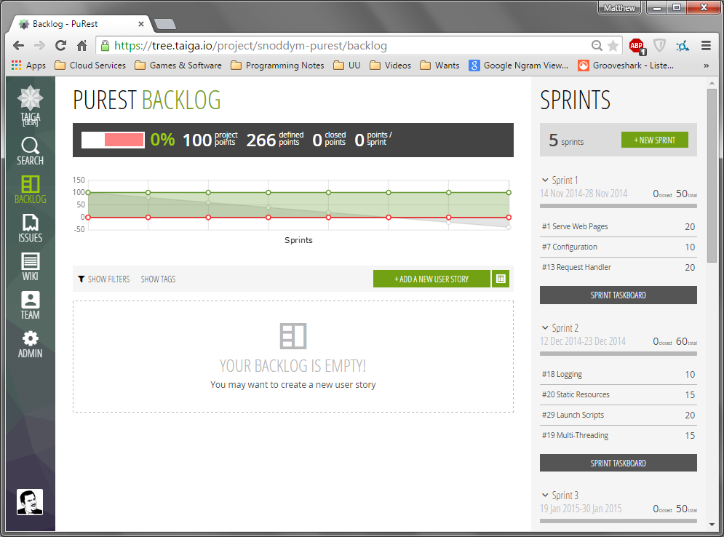

Figure - The Taiga Dashboard, showing the banner with project story points with sprints on the right hand side.

4.2.3 Kanban Boards

Epics can easily be defined in the project backlog, and expanded to have related user stories to act as development tasks. During each sprint a technique known as a Kanban board can be used to track the status of user stories. This is a table where the first column contains new user stories that have yet to be started.

These can then be moved right to ‘in progress’, ‘ready to test’ and ‘needs info’. By viewing the user stories in various columns a project manager can gage the progress of a sprint and see which stories are completed and being currently being developed.

This view can be used as a tool when making decisions on moving epics between sprints and deciding if a sprint is over loaded with too many stories; also it presents a starting view which allows developers to at a glance see all user stories for a sprint, grouped by the epic they are related to.

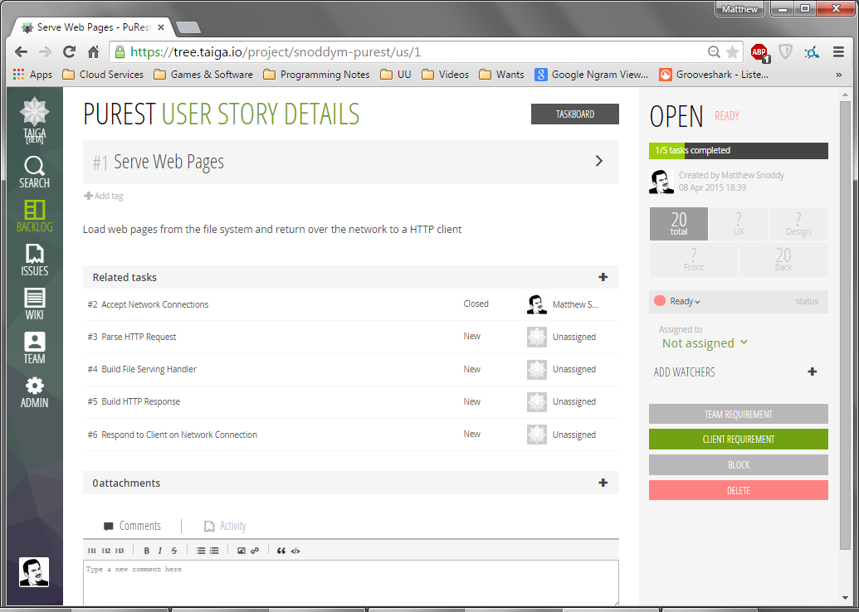

Figure - An Epic (seen as a user story in Taiga) with realted tasks, note the story point estimation on the right hand side.

4.2.4 Change Control and Issue Tracking

Taiga also provides features to raise issues within the software and a managed process is used to resolve these issues, storing notes on the resolution and cause. This is useful as a developer may simply want to record an issue instead of working on it right away, and managers can oversee how many issues are being raised and the severity of these.

Extra user stories can be created under epics to denote change requests, and tracked in the same manner as regular user stories; shifting the associated epic into the 1desired sprint in which to make the change.

4.3 Source Control

As discussed in section 2.16 source control is a technology to manage versions of source control files over time, and gather changes into individual units called change sets. These change sets can be labelled in an arbitrary manner, meaning they are suitable to denote sections of work and can be linked directly to user stories being developed for the project.

The project source code will be stored in several repositories, logically separated by overall purpose in the final product. These are to be managed using a cloud based master repository service and managed on development environments locally using appropriate software.

Additionally source control offers the possibility to revert to a previous version of the source code for a repository, meaning changes can be undone if they break the program or too many files have been corrupted.

Many different systems exist that provide source control, this project will use Mercurial as the lead development and project manager are familiar with associated software and well versed in its configuration and use.

4.3.1 BitBucket

BitBucket provides a cloud based service which hosts Mercurial based source code repositories, for the purposes of this project all repositories will be private. All repositories can be synched with a local repository on a development machine, meaning it acts as a backup of all source materials on a local environment. Committed changes to repositories and history can all be viewed via the web application provided by the server, see the below figure to view this. All source code repositories for this project will be hosted and managed using this service.

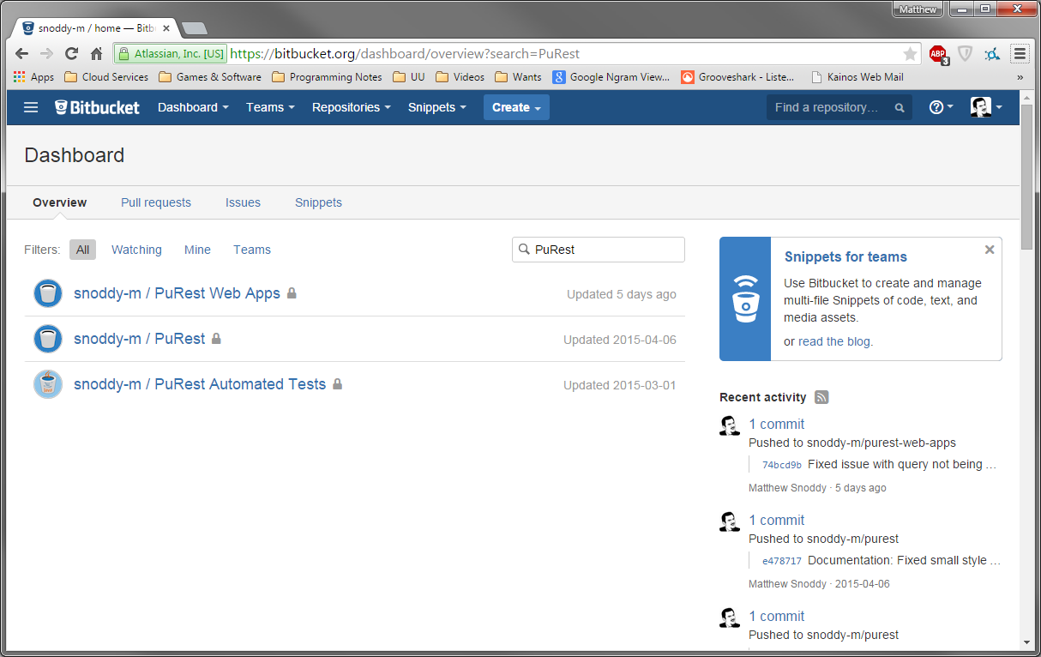

Figure - Source Code Repositories Hosted on BitBucket

4.3.2 TortoiseHG

TortoiseHG provides a client to manage a local repository and sync change sets with a master/remote repository, such as the BitBucket online repository discussed in the previous sub-sections. A full GUI interface is provided to author commits and upload changes to the master repository online, a very powerful facet of this is to visualise the history of changes in the UI, helping the tasks of merging in changes from the master repository or browsing to find a relevant work unit. All local repositories will be maintained using this tool throughout the project, below is a figure depicting the GUI available. 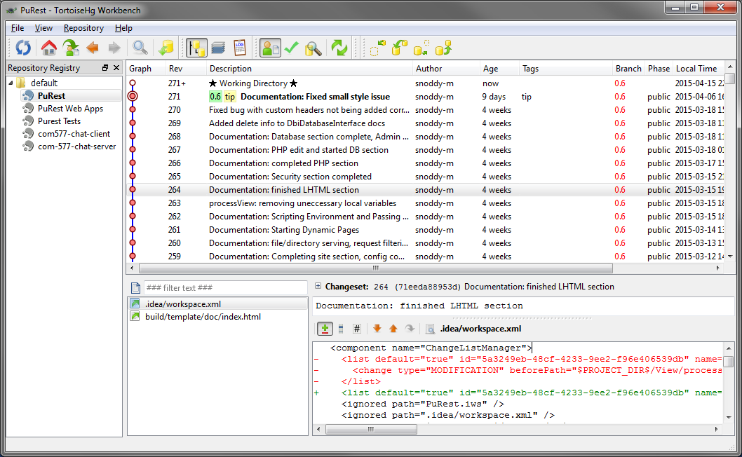

Figure - Tortoise HG User Interface

5. Design

5.1 High Level System Architecture

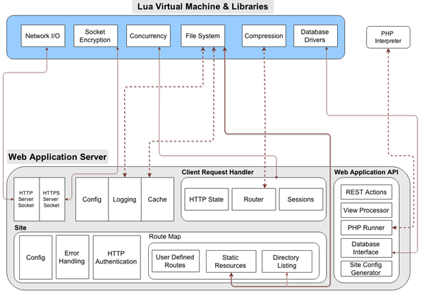

Figure - An overview of the web application server's high level architecture, the grey filled box contains the components of the web server and the blue filled box contains external libraries.

Fig. 12 shows the components that make up the web application server and the libraries to be loaded into the Lua virtual machine; these libraries provide the functionality needed to carry out key tasks in components.

The web application server is made-up of seven high level components, these are listed and explained below:

1. ***HTTP/HTTPS Server Sockets*** – These listen for new connection from clients on the network, once connected they will use concurrency to spawn a new client request handler in a worker thread; this will deal with all HTTP messaging that occurs on this connection, receiving requests and sending responses.
2. ***Config*** – Loads and maintains a list of configuration values for the server, these can be set by the system administrator.
3. ***Logging*** – Provides an interface to write log messages from two sources, firstly the server thread listening for new clients and each worker thread dealing with HTTP messages from a client connection. These are written to separate files, one for the server thread and a file for each worker thread.
4. ***Cache*** – This will load any large or commonly requested files in memory for set period of time, improving performance by reducing the time needed to fulfil future requests for cached resources.
5. ***Client Request Handler*** - Parses the HTTP request and builds a state object that will represent the headers and parameters of the request including the data in the request body. This state will also provide a template for the HTTP response, again allowing the parameters such as status code, headers and response body to be set. The state will then be able to generate a HTTP response from this template object.

The *router* sub-component will try to match the location in the HTTP request with a static resource, user defined route or a directory to list; these sub-components are present in the Route Map. This matching is done using regular expressions and will also include extracting part of the location to define URL parameters, as discussed in section 2.12.1.

*The Sessions* sub-component provides access to a client session across all client request handler worker threads. The session data will be loaded into the HTTP state so any route matched can be passed this information.

1. ***Site*** – This component models a site on the web server, which is defined as a sub directory of the directory that is configured to be the web directory for the server. A web directory holds the resources used to fulfil HTTP requests, such as web services, files and dynamic pages.

The *config* sub-component acts in the same manner as the config component for the server but instead serves the specific configuration for each site; these settings are different in nature and deal with site contextual matters such as request filtering and security.

*Error handling* is carried out by the sub-component of the same name and ensures that if no route to handle a request is found an appropriate response is sent to the client, the same happens if an error occurs while route is processing the request.

*HTTP authentication* sub-component scans incoming requests and checks against the site config to see if the resources asked for require authorization, if so it will check that appropriate credentials are present in the HTTP headers or respond to the client with a status code 401 to signal a challenge to provide credentials to access the requested resources.

The *route map* sub-component preforms the actual matching of request location to a server-side resource, containing the actual code for web service calls and built in routes to serve static resources, processing dynamic pages and listing directories. This will call the selected route procedure with the HTTP state, providing the request parameters.

The route will add content and edit the response template in the HTTP state, and if the route returns any values these will be used in the response body depending on site configuration.

User defined routes and site config are loaded dynamically at request time through the use of launch scripts. These scripts are Lua files in the top most directory of a site that return a list of custom routes and/or site configuration values. Both routes and config will be validated for correct format and structure.

1. ***Web Application API –*** Launch scripts should have an API provided by the server to create custom route handlers and configure elements such as security. This API provides that as a series of Lua modules that can be imported and used by web applications. The API includes classes to create route handlers and place these in a route map that is used by the site component.

The *REST actions* sub-component is designed specifically for creating a RESTful web service, allowing routes to always respond in a uniform manner, so the client will always receive the data template that specifies these three properties: if an error occurred while fulfilling the request, the nature of the error, if any, and the data being returned by the web service call.

This ensures that any clients will always receive a predictable response and errors can be handled gracefully in client side logic. This sub-component will also prevent any errors propagating to the error handling component in a site to ensure the HTTP response status code and response body is not modified in any way.

The *View Processor* sub-component allows a developer to programmatically load a view (dynamic page) with a given data model, meaning the Model View Controller pattern can be implemented by building classes in Lua to act as controllers and passing model data to views.

Views are defined as LHTML files, which are regular HTML files with snippets of Lua code embedded in them, similar to PHP. These are provided access to all request parameters and the same API as the launch scripts and also can be provided models as described above; additionally they have functions available to write output to the HTML response sent to the client, usually in place of where the Lua code snippet resided in the original LHTML file.

The *PHP Runner* sub-component will allow a developer to load a PHP file programmatically, this is dependent on the configuration for the PHP interpreter being correct. All PHP files are passed the same request information as routes and views, however PHP files cannot change the HTTP response headers, only the response content.

Both the PHP Runner and View Processor components are used by the server when a static resource (file) is requested and it is of the appropriate type, PHP and LHTML respectively, and will pass any request parameters and automatically construct a response from the output.

The *Database Interface* sub-component will provide an intuitive interface to most supported relational databases, listed in section 2.10. The developer should be able to do simple select and delete queries without writing SQL queries and be able to perform inserts, updates and more complicated queries using prepared SQL statements; these are SQL queries that are bound to a list of parameters then executed.

To use the database interface, all that should be required is a functional database system and a configuration object instructing the server on how to connect and log into the database system.

Finally, the *Site Config Generator* will allow a launch script to get a clean copy of the site config initialised with default values. This is to enable the script to set up any properties it wishes before returning the modified config object to the server when invoked.

5.2 System Events and Processes

This section deals with the events that occur within the system, and what processes are kicked off by these events. A web server is an event driven piece of software, meaning it requires actions to happen outside of the internal system to trigger processing; for example the server will not be serving HTTP requests if no client has connected to the system.

While events are required for program segments to run, because the server for this project is multi-threaded many processes and events will be fired and dealt with asynchronously.

Only a selection of the most critical activity diagrams has been include in this chapter, for a complete listing of the remaining figures see Appendix I.

5.2.1 Server Start-Up

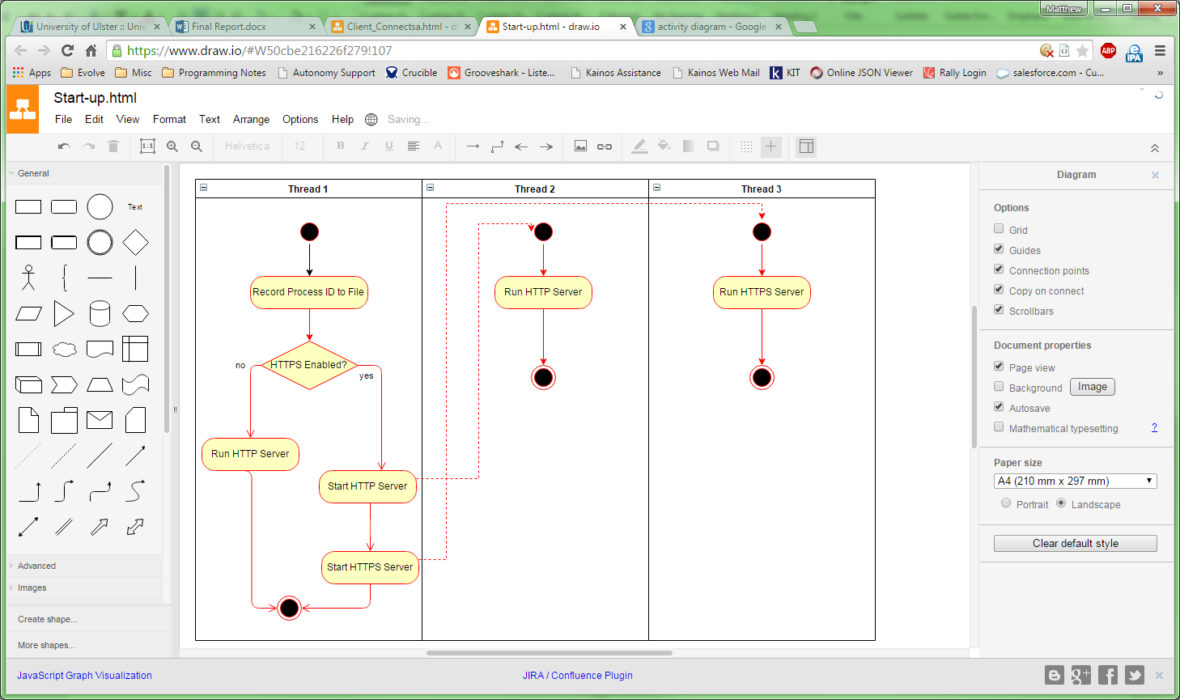

Figure - Activity Diagram: Server Start-Up

5.2.2 Accepting New Client Connections

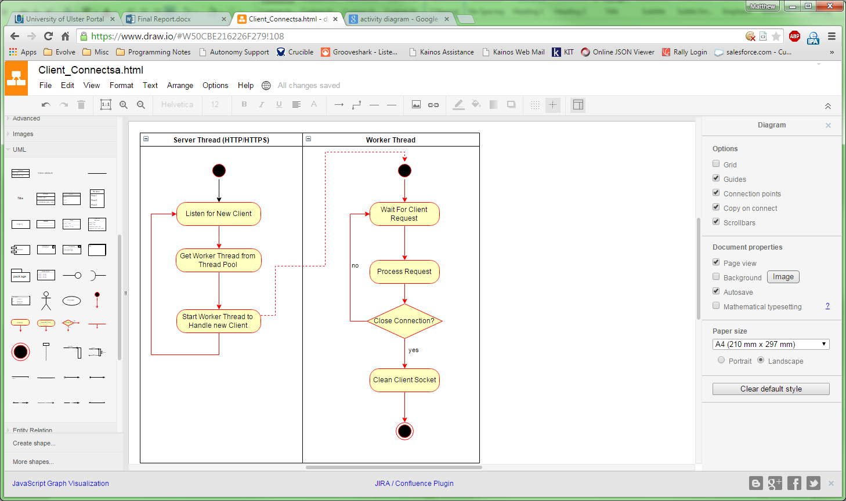

Figure - Activity Diagram: Accepting New Client Connections

5.2.3 HTTP Request Received

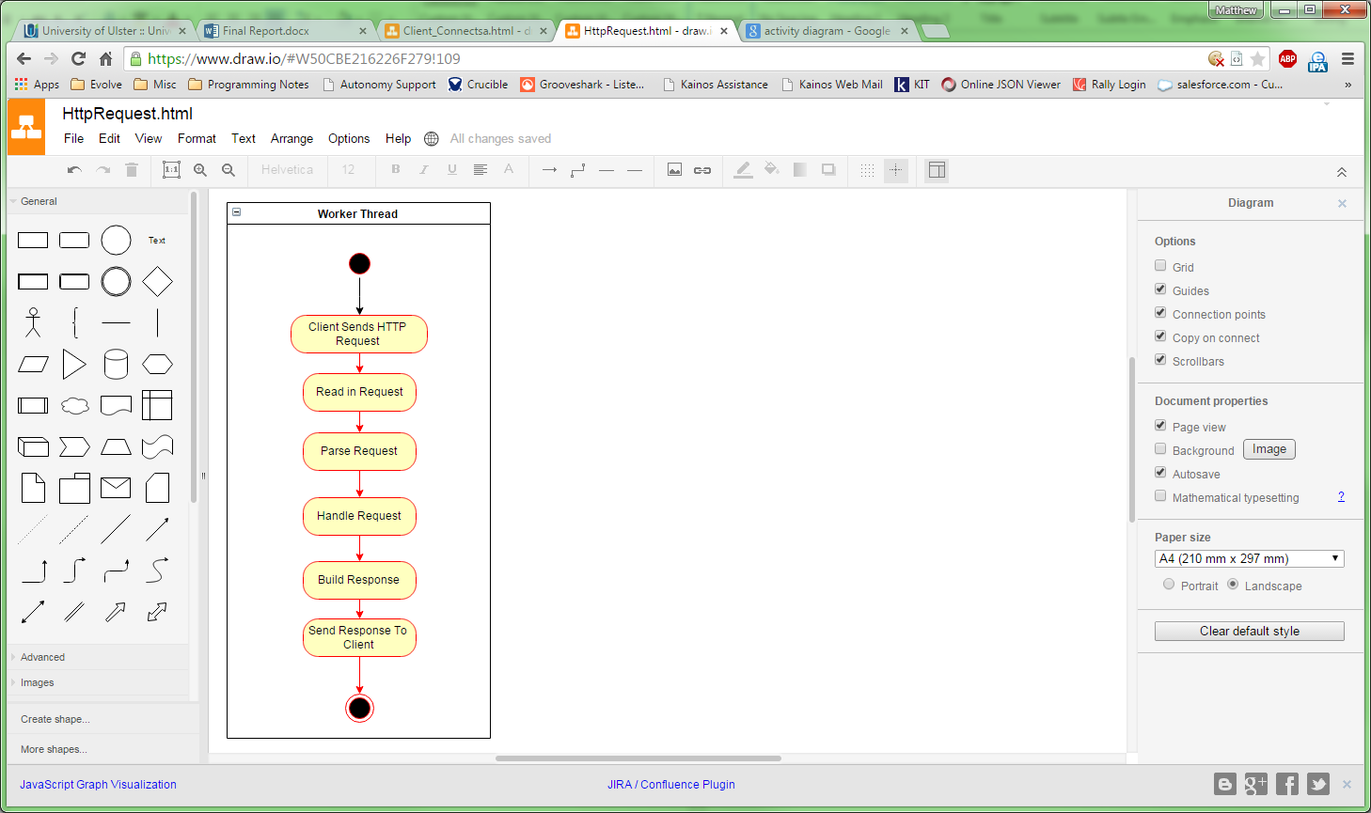

Figure - Activity Diagram: HTTP Request Received

5.2.4 Router Resolving Resource

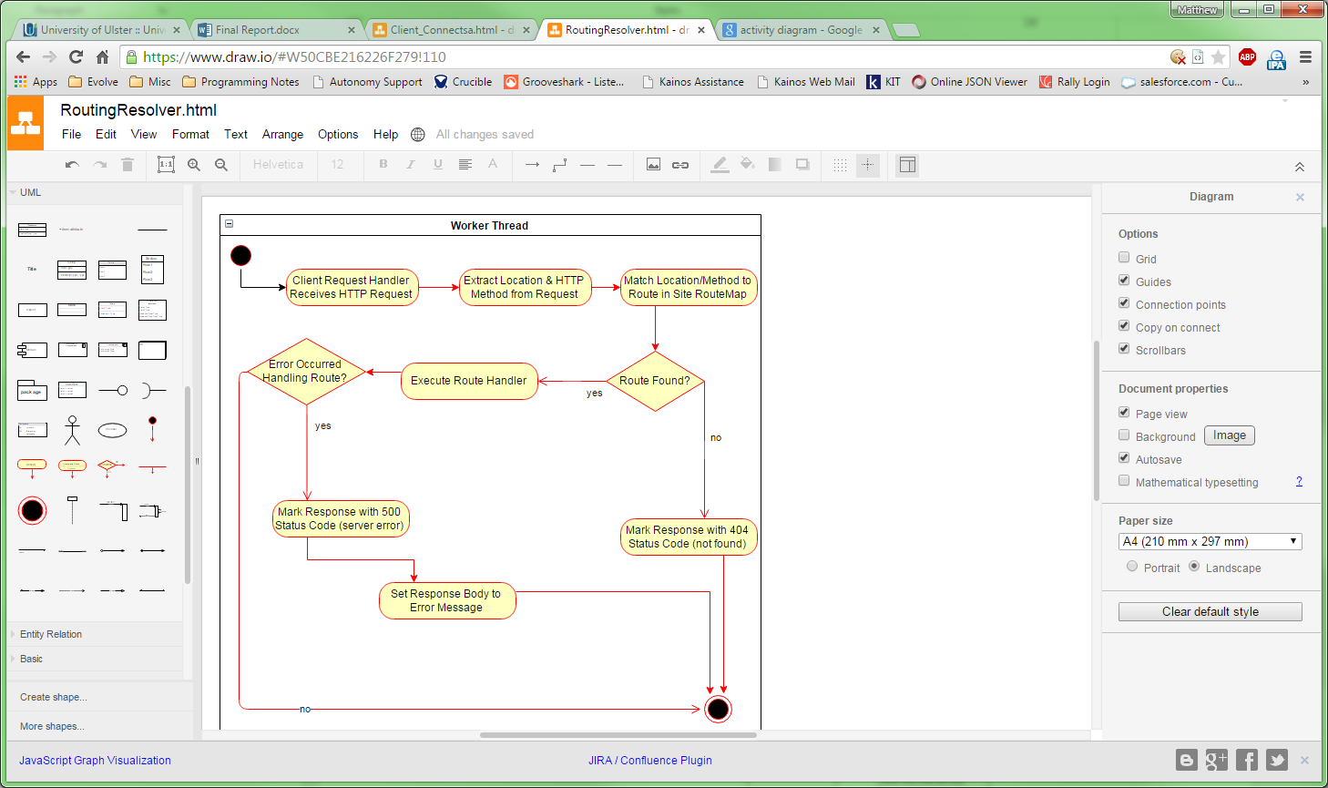

Figure - Activity Diagram: Router Resolving Resource

5.2.8 Processing a View

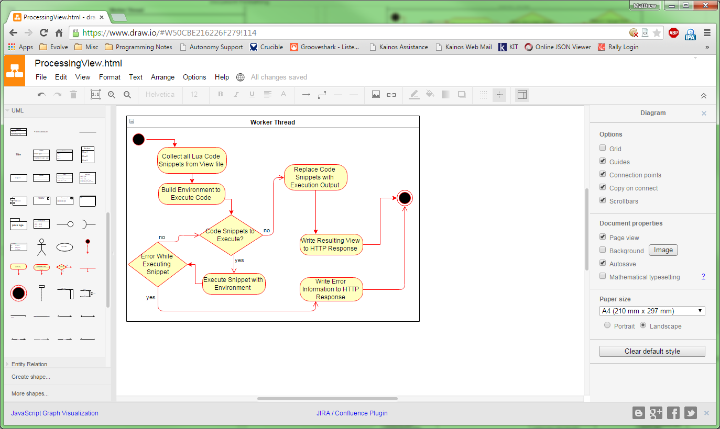

Figure - Activity Diagram: Processing a View

5.3 Class Diagram

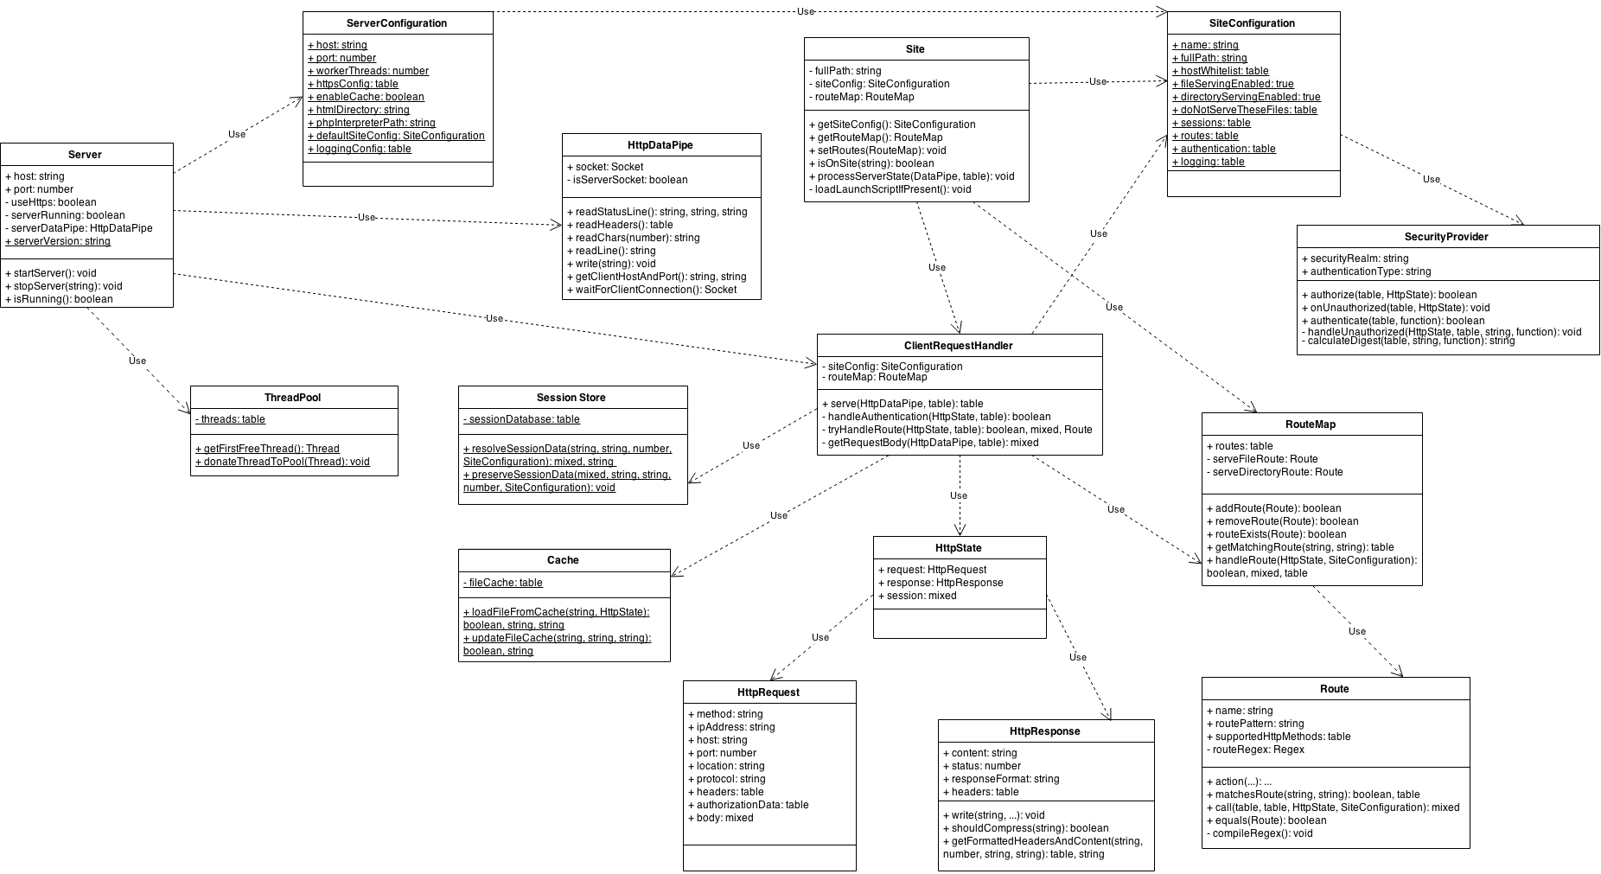

Figure - Complete System Class Diagram

Fig. 13 presents a complete diagram of the classes that comprise the server system, most of the class names listed can be directly linked to components in the system architecture overview (Fig. 12).

As is evident the flow of information and logic starts with the ‘Server’ class, leftmost on the class diagram, with the ‘ClientRequestHandler’ class taking on the main responsibility for combining five classes to process any client requests; the ‘SessionStore’ and ‘Cache’ are static classes used for persistence between requests and across worker threads.

‘Site’ defines a class that will load launch scripts and extract route maps and configuration, it then uses this information to instantiate a client request handler each time a request is received, the ‘processServerState’ method is the entry point used to kick off processing of a HTTP request.

The ‘ThreadPool’ static class handles management of worker threads, halting the main thread if no more free threads are available and assign threads for use as workers. The ‘HttpDataPipe’ acts as a network I/O abstraction layer that will either receive requests using a server socket or send responses using a client socket; this class also has methods to read a HTTP status line and headers, formatting them into appropriate data structures once read.

The ‘HttpState’ class is used to track updates to the response via the ‘HttpResponse’ object and provides access to the parameters of the request in an ‘HttpRequest’ object; this enables a highly structured and well described overview of HTTP messages for end points to work with. ‘HttpResponse’ also provides methods to build a HTTP message from its own fields, also compressing the content if the data is suitable and configuration permits it.

‘RouteMap’ and ‘Route’ detail classes that are used to implement the route handling logic necessary to identify resources from a HTTP request and match these with an end point that will generate the content for the resource; the ‘RouteMap’ comes with two default routes to handle file serving and directory serving, whether these are used is controlled by the site configuration represented by the ‘SiteConfiguration’ class.

5.4 Admin Web Application Design

The Admin web application is to be used as a gateway for system administrators to see what applications are loaded onto the server, the performance of the server, read log files and preform simple tests to ensure configuration is correct. The developer documentation will also be available from this site and provides information on how to configure the server and build web applications for the platform.

5.4.1 Web Service

To feed the web pages up to date information on server performance and log messages a web service will be used. This will provide the following routes:

|  |  |
| --- | --- |
| Route | Description |
| /api/performance | Get a list of performance data for the current server process: CPU usage, memory usage, number of threads and up time. |
| /api/logs/server | Return the messages stored in the main server log. |
| /api/logs/worker/{number} | Get messages stored in a specific worker thread, the {number} placeholder in the route URL identifies the worker thread by ID. |

All data is returned in JSON format and will be consumed on the client side by using AJAX.

5.4.2 UI Mock-ups

The following sub sections detail the user interfaces for the administration application. Note the section at the top of each mock up is the navigation tabs for the site, all components will be based on bootstrap styles when implemented.

5.4.2.1 Web Application Listings

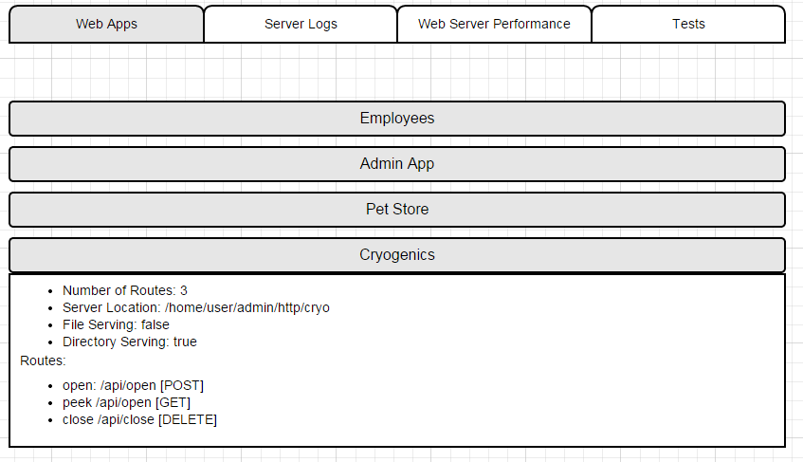

Figure - Admin Application: Web App Listings

5.4.2.2 Server Logs

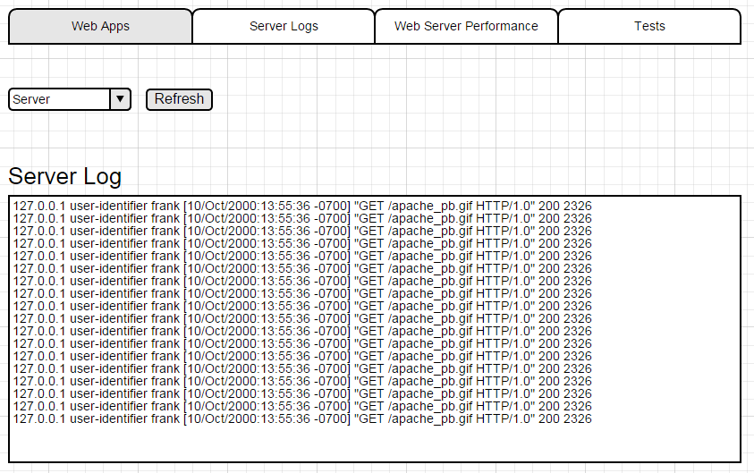

Figure - Admin Application: Server Logs

5.4.2.3 Web Server Performance

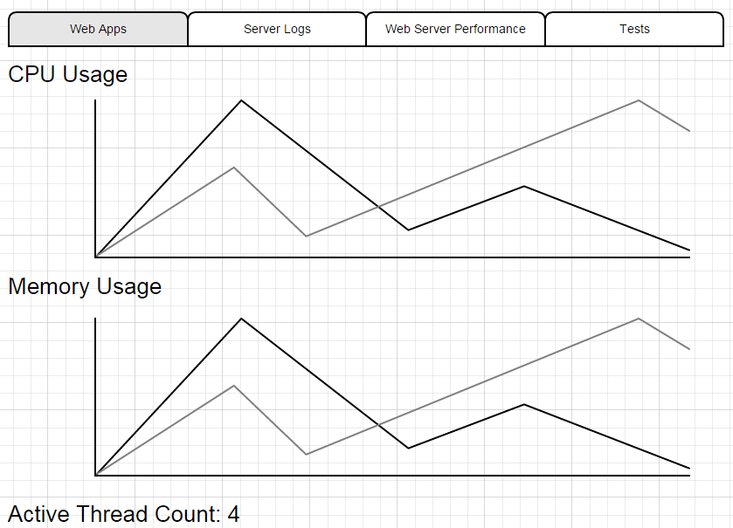

5.4.3 Developer Documentation

To enable a developer who wishes to create web applications on the server it is necessary that comprehensive documentation for administration and programming to be produced. The format decided upon will be a HTML file, as this can be opened on any device that has a web browser. It will use the Bootstrap (Bootstrap, 2015) framework for styling and compatibility; this is a HTML5 compliant CSS and JavaScript library that can create layouts compatible with desktop and mobile browsers.

For tutorials and code snippets the ‘highlight.js’ (highlight.js, 2015) JavaScript library to display the source code, this library will highlight keywords and variables in a similar manner to an IDE.

The documentation will cover installing, configuring, writing websites and web services for the server. It will be in a reference style, allowing the user to navigate to any given section without requiring knowledge of previous sections. Focus will be given to specific scenarios such as:

* Creating a RESTful Web Service
* Producing a MVC style dynamic Web Site
* Loading Custom Server and Site Configuration
* Set up HTTP Authentication
* Configure HTTPS communications
* Working with PHP files
* Using the database API

6. Implementation

6.1 Lua Libraries

The first section of the implementation chapter deals with listing the third party libraries used and the features they make available that are useful to a web server application.

6.1.1 Apache Portable Runtime

The Apache Portable Runtime is a cross-platform C library that provides abstraction for broad range of capabilities that would normally need to be accessed using operating system specific libraries; additionally the library will emulate any functionality that is not available for the current OS.

The runtime is most popularly utilised as the main library for the Apache web server, and as such has proven itself very stable and mature. As discussed in section 2.15.2 the core Lua language only offers a very small set of functionality in comparison to platforms such as Java and C#; which both include extensive system libraries. The Apache Portable Runtime (APR) will provide the foundation for the project, providing the additional facilities listed below.

* File system handling (Directories, files)
* Encoding & Encryption (Base64, MD5 etc.)
* Pre-emptive Multithreading (including memory sharing)
* Full network I/O (sockets, DNS lookup)

Lua/APR is a binding of the APR library for Lua that allows a program to utilise the above features from within the Lua runtime, the project will use this to access the C library. (rodding, 2011)

6.1.2 LuaSec

LuaSec provides a binding for the OpenSSL library to the Lua language; OpenSSL encrypts data for communication over sockets to and thus provides HTTPS security. (Silvestre, 2015)

6.1.3 LrexLib

Lrexlib is a binding for many popular Regex libraries for Lua, it enables the use of the library PCRE, Perl Compatible Regex. This provides access to a more sophisticated and standards’ compliant regular expressions.

6.1.4 LuaLogging

LuaLogging provides a native Lua logging system, with options to write logs to the console, files and databases. The project will use the rolling log option of this library to produce log files will have any messages generated by the web server appended to it. It also provides standard formatting structure for log messages as shown in fig. 8 in section 2.14.

6.1.5 lzlib

Lzlib provides a binding to the ZLIB C library, which is use to compress strings of characters and files using the GZIP compression algorithm. This will be utilised to provide HTTP compression as discussed in section 2.12.2.6.

6.1.6 JSON.lua

JSON.lua provides a native Lua library to work with the JSON data serialization format. JSON will be used to process HTTP request body’s that contain JSON data, to convert this data to a Lua object, see section 2.13.4 for more information on this projects use of JSON.

6.1.7 RapidXML Parser

RapidXML library provides the ability to convert XML into Lua objects and vice versa, this will be utilised to process HTTP request content and write to HTTP response content, mainly for web services.

6.1.8 Alien

Alien is a unique library for Lua, it allows the loading of dynamic C libraries on demand and call functions listed in the C library. This is useful for calling native operating system procedures to get performance information about the current system, or using C libraries that have no existing Lua binding available.

6.2 Gradle

Gradle is a build system that allows developers to organise projects of code for debugging and release. It works by providing facilities to copy/rename files, create zip archives and build programs automatically. In its simplest form it builds a program and runs it, however since the project language Lua is an interpreted language and does not require compilation this will not be the case in the context of this project.

Gradle works by reading a build script which is written in a JavaScript like syntax that specifies build tasks and how to carry these out. Dependencies can be declared and Gradle will download and install these as necessary, using an online repository of packages to resolve the dependencies.

This project will use Gradle to prepare versions of the server for release by generating source code documentation and including necessaries libraries along with the source code, producing a zip file that will contain everything required to install and use the server.

6.3 IntelliJ IDEA

JetBrains IntelliJ IDEA is a general purpose integrated development environment, it uses a modular architecture of plugins to support multiple programming languages. The key features include:

* Integration with source control products
* Code highlighting and completion (prompting the user while they type with available variable/method names)
* Refactoring (Renaming references to a variable or class/method names)
* Error detection and highlighting (syntax errors, logical errors, spelling mistakes)
* Plugins available for Lua, PHP, HTML, JavaScript and CSS.
* Full support for the Gradle build system.
* Support for automated testing frameworks (See chapter 7 for more information)

This project will create three projects using IntelliJ Idea, one for the main server product, another for the sample web applications and finally a project to run automated tests on the server.

6.4 Sprints

Following the Agile software development lifecycle and the project plan as laid out in section 4.1 the main body of the work will be completed in several two week sprints. This section details the outcome of each sprint and any side effects (bugs, changes) or external work that affected development.

The format of the following sections detail varies depending on the outcome of the sprint, for issues encountered and unscheduled activity, only if anything needs to be reported will there be a section detailing these areas.

6.4.1 Sprint 1 Retrospective: 14th – 28th November 2014

Sprint one started by taking the research and development done before the project formally began and transforming existing code to meet user story requirements and implementing any new features that the initial design demanded. The first epic approached focused on serving web pages, which encompasses the network I/O, HTTP message parsing and file system interaction.

Accepting network connections in any language is straight forward task, involving the binding of a server socket to a host name and port. This is the public access point that a client can connect to. Connections are then accepted by the server once a client issues a connection request. This is done inside an infinite loop so once a client has connected and the request has been dealt with the server can again listen for a new connection.

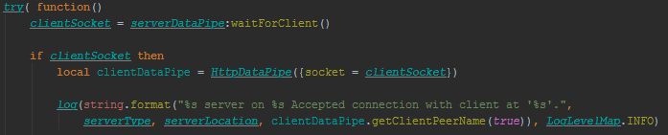

Figure - Logic to accept a new client connection in the ‘startServer’ method of the Server Class.

At this point the program can exchange data between the server and client by writing to streams, a data buffer intended for either input or output that the operating system ensures is transmitted using the data socket. This way a HTTP request can be read in until no further lines are available in the input buffer, and when processing is complete the output buffer can be filled with the HTTP response.

Parsing the HTTP request required using regular expressions to model each line, the first being the protocol, HTTP method and resource location. Once the location was determined processing could load the resource at the path of the HTTP root directory, so if /goal/scores.html was requested one could build a path /www/goal/scores.html to locate the file on the file system of the server.

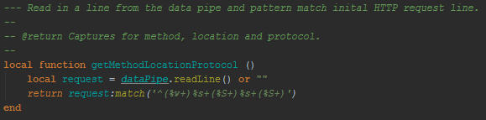

Figure - Extracting the components of the inital line from a HTTP request; this method is present in the HttpDataPipe class, see section 5.1 for more information.

A handler was created that takes the parsed HTTP request and preforms the file lookup and either returns the contents of the file or sets the response to have a status code of 404 if the file does not exist. Once the handler has finished the model of the response can be broken back down into a textual HTTP message by formatting the fields into an initial line of protocol, status code and a brief phrase explaining the status code.

Key to the structure of HTTP message whilst being processed was the HttpState class which models the request and response as object; see section 5.1 for more information on this class and its design. The below figures show some key features of the HttpState class implementation.

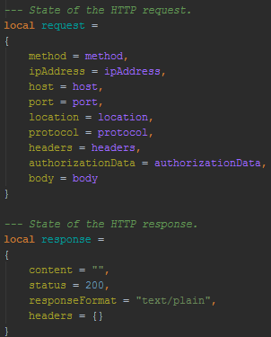

Figure - The HTTP request object modelled in the HttpState class.



Figure - The HTTP response modelled in the HttpState class.



Figure - Initial HTTP response line being constructed in the ‘getFormattedHeadersAndContent’ method of the response object in the HttpState class.

Once the serving of web pages was working at a fundamental level, configuration work was completed to allow server administrators to customise their installations of the web server. The main motivation for completing this work early in the life of the project was that each new feature will have associated configuration and this can simply be added to the existing configuration framework.

Configuration files would use Lua code to represent keys and values, returning a simple object to create the server configuration. A default module would come with the server and through the definition of an environment variable on a system the location of custom configuration could be specified; environment variables are a simple cross platform technique that defines key value pairs that all processes on a system can access.

To aid in working with configuration a Site class was created to model each site on the server and this also contained a default configuration module which could be customised by web applications running on the server. The values for the default site config would be stored under a key in the default site configuration. See appendix C, end user documentation, for more information on the actual configuration options and structure.

Building on the work serving web pages, the next epic, the request handler, dealt with providing a more formal framework for routes to be processed in, opening the door for custom route handlers similar to the file serving handler. A route was modelled in a class, this would define the pattern to match on the HTTP request location and the acceptable HTTP methods to use when calling the route.

Initially regular expressions were chosen to create the patterns for request locations, however based on examples from other web frameworks that handle routes it was decided that a simple syntax would be used and then converted into a regular expression.



Figure - Creating a Route that will match when a GET request is recieved for the method resource. The ‘methodTest’ parameter is a function that is called to handle the route when requested by a client.

All routes are relative to the Site directory, which will be an immediate child directory of the server web root directory.

The ability to extract meaningful parts of a URL location is desirable when creating web services, so for example if I called the routes ‘/employee/2’ and ‘/employee/4’ it would trigger the same route but pass in the second part of the location as a variable, in this example the id of the employee requested.

The route model supports this by allowing parts of the pattern to specify named parameters that will be captured using regex and labelled with the given phrase. This can then be used as a variable name when extracted URL parts are passed to route handlers so they can use then in their custom logic, such as the employee ID to look up an entry in a database.



Figure - A route designed to capture a URL parameter after a '/params/' location starting string; this would match '/params/one' but not '/params/one/two'.

Once the endpoint of a route was modelled thoroughly it was necessary to create a class that would hold multiple routes, to represent the endpoints available on a site hosted on the server. The RouteMap class was created to hold multiple routes and provide a handling service, so the route that matches a HTTP location string can be selected and the associated handler called, returning the result of calling the route to the existing server logic.

The RouteMap also contains any server default handlers such as the file handler, and in later sprints the directory listing logic. It only invokes these if no other handlers are found and the location string matches the required pattern, in the case of the file handler this is a filename with an extension.

A RouteMap also takes any parameters for a request and passes them to the route handler being called so that it can view data such as the request body and any query string values supplied; these parameters also include the URL parameters discussed earlier.

Using the routes and route map it was now possible to register a series of endpoints for a site, provide custom handling logic for each endpoint and in that way enables the creation of web services.

6.4.1.1 Epics

* #1 – Serve Web Pages
* #2 – Configuration
* #13 – Request Handler

6.4.1.2 Unscheduled Activities

The main external activity was reviewing the code from the proof of concept for the server created before the server started and looking through the commit history of the source repositories. Primarily this was to ascertain the level of functionality achieved and understand the refactoring of existing classes and logic that would need to be undertaken to meet the requirements and design created for this project.

Additionally time was taken to review other web technologies such as PHP and ASP.NET to see how they approach the task of endpoints and routing, in particular how they allow a developer to set up a pattern for matching on a given route.

6.4.2 Sprint 2 Retrospective: 12th – 23rd December 2014

Logging sever events and messages is key for system administrators solving performance and configuration issues. Developers also rely on server logging in a web server system to debug their systems.

The approach to logging for the web application server was to output messages to several files on the host system, these would all share a common format. One file was to be used for the main server log, which records clients connecting and the network events registered by the web sever. The remainder of the files are allocated to each worker thread that handles requests.

LuaLogging is a library, mentioned in the introduction to this chapter, which allows outputting of formatted log messages to specific files. This was utilised to work with log files and provide various levels for message; levels provide a category for a log message, ranging from fatal errors to debug information.

Logging was included in the server configuration, allowing specification of the output directory and other settings.

Building on the serving of web pages in the first sprint, work was undertaken to make serving static resources more sophisticated. The first improvement was to notify clients in the HTTP response of the type of data being returned in the body, whether this be an image, a CSS file or a PDF.

The media type in HTTP is indicated by the header ‘Content-Type’ which will contain a MIME type that corresponds to the body of the message; Multipurpose Internet Mail Extensions (MIME) types denote a data type using a simple pattern of ‘category/type’. An example MIME type would be ‘video/mp4’ for video data encoded using the mp4 format.

To facilitate detection of MIME types from the files requested by clients it was necessary to create a dictionary that matches file extensions to MIME types. This was then used once the file handler was called to fill in the ‘Content-Type’ header text.

When dealing with static resources it is often useful to filter certain resources from being served to clients, such as sensitive/system files. A list of file extensions was introduced to the site configuration that instructs the web server which file types to not serve and instead return a status code of 404 to a client if they are requested.

In the previous sprint the use of the RouteMap and Route classes to provide handling of HTTP location endpoints was defined. Unfortunately there was no method to attach a custom series of route handlers, this was set to change in this sprint with the introduction of Launch Scripts.

In the context of the project launch scripts are Lua scripts stored in the root directory for a site which will return custom configuration for the site and a RouteMap object that defines the endpoints for the site. Lua can natively execute script files on demand, enabling arbitrary launch files to be executed when a HTTP request is received for a specific site.

In the server config a series of standard names for launch files were defined, meaning a server directory could be scanned to see if any launch script can be detected. Once a full path to the script file is built the server inspects the return values, if any, and configures the site using the RouteMap and configuration before handling the client request; all return values are validated before being used to ensure they are of the right data type.

This means all route handlers will be loaded and the HTTP location can be matched to an endpoint immediately after loading the launch script.

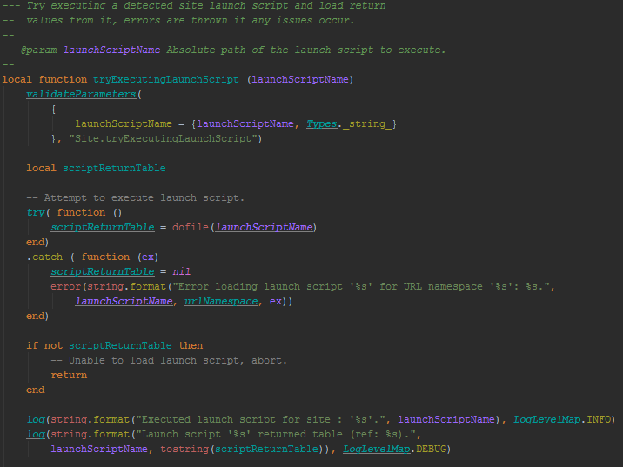

Figure - Logic to load the launch script from the file system and checking return value; from the ‘tryExecutingLaunchScript’ method in the Site class.

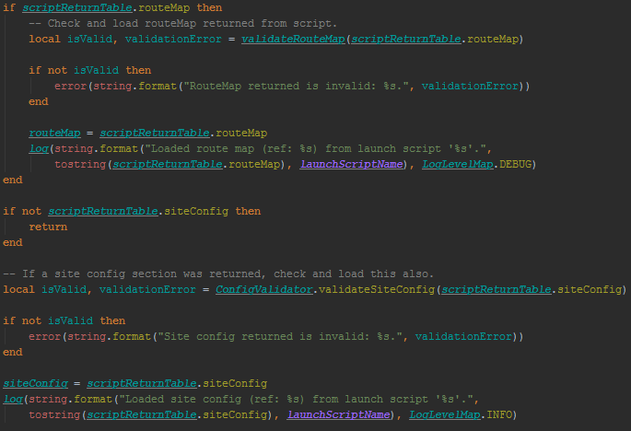

Figure - Logic to validate the return values from the Launch script; from the ‘tryExecutingLaunchScript’ method in the Site class.

The final epic of this sprint focused on taking the existing server logic and making this multi-threaded so multiple clients can connect to server at once. This will also improve the performance of web browser clients as they typically create multiple connections to a web server to request all the resources of a web page simultaneously.

The best to way to model this was to run all logic past the initial accepting of the network connection in a worker thread, as designed in design chapter using figure 15. Additionally a thread pool was used to manage the allocation and clean-up of finished worker threads. All functionality for worker threads and cross thread data sharing was provided by the Apache Portable Runtime, which provides pre-emptive multi-threading.

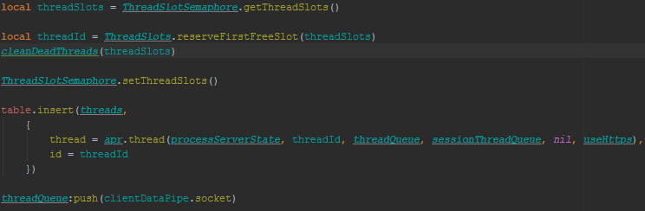

Figure - Logic in the Server class that uses the thread pool (or thread slots) to get a new thread and start it, passing the client socket to the new thread using the thread queue on the last line.

From that point on the worker thread will process the request using the existing logic and respond to the client using the passed in client socket. Once a worker thread has completed processing a request it exists and is cleaned up in the future by the thread pool.

6.4.2.1 Epics

* #18 – Logging
* #20 – Static Resources
* #29 – Launch Scripts
* #19 – Multi-Threading

6.4.2.2 Issues/Bugs Raised

One key issue when implementing the multi-threading was the ability to pass data between threads. This is done by serialising the data to be shared so that it can be transferred, however this means that the values cannot be of a complex type, say a network socket or a thread object. The problem this presented was that data needed to be as simplistic as possible, with no circular references or sophisticated data structures.

Eventually it was whittled down that only the client socket needed to be passed, allowing the worker thread to reload any extra modules, files and libraries it needs. The sharing of the socket was only possible because the Apache Portable Runtime supports transferring complex types it has created.

Another issue around logging occurred when the first implementation of the logging, the library refused to save log messages to the given file until the server was shutdown. This was due to the logic for the ‘FileLogger’ class only flushing messages to disk when the object was destroyed, a fix for this was to call the garbage collector once a message had been passed to the object and this immediately flushed the message.

6.4.3 Sprint 3 Retrospective: 19th – 30th January 2015

Due to the main work in previous sprints to create the server core, parsing HTTP requests and serving requests, this sprint was the first to enter the territory of adding some extra features and writing some web applications to test the server.

Automated testing was the chosen method to test the web server, as discussed in chapter seven, and in this sprint the testing program was written and initial tests created. Again using IntelliJ IDEA a Java project was created and the software libraries for the Junit testing framework, Selenium Web Driver and Apache HTTP Client were installed. Initial tests focused on HTTP requests delivering the correct information.

A test using Junit consist of three elements: the identifier, logic to set up the test and preform an action to generate output and finally an assertion which will throw an exception if it fails to be true. An assertion in this context usually means ensuring values are equal, so that the actual output of an operation matches the expected, e.g. correct, output.

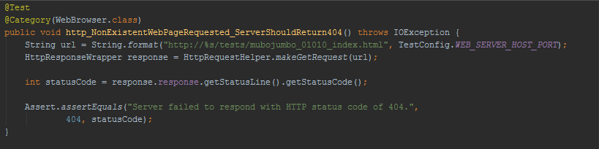

Figure - A JUnit Test Created for the Project, using the Apache HTTP Client to Request a Resource and Inspecting the HTTP Status Code.

HTTP authentication introduces some security for the server and was implemented by following the book ‘HTTP: The Definitive Guide’ (Gourley, Totty, Sayer, Aggarwal, & Reddy, 2002). Chapter twelve of said book details the format and process involved in authenticating a user via HTTP. Both the basic and digest methods of authentication were implemented, as detailed in section 2.7.1.

A handler approach was used to implement a ‘SecurityProvider’ class that allows an end user configuring a web application to override a method that will be invoked when a resource protected by HTTP authentication is requested. The username and password are passed in and this can be checked by whatever means the developer sees fit, calling out to external systems for example.

Additionally in the site configuration, fields were made available to allow registering of end routes on the site that require authentication and also a flag that when enabled will prevent all resources on the site from being served without successful authentication.

Implementing basic authentication was straightforward as it simple requires the extracted information from the HTTP headers to be decoded from base64 to plain text, an operation that takes on line of code to complete, then the username and password can be parsed from this plain text.

Digest Authentication was more troublesome however as this requires the generation of a complicated hash that comprises of the username, password, request information and some random data. This is very secure as it never transmits the password, more of a fingerprint for that request, implementing this required using MD5 hashing and random character generation; trial and error was involved in formatting the information into HTTP headers correctly and getting a web browser to successfully authenticate with the server.

The final section of work completed in this sprint was the creation of the Administrator web application for the server, more details on this can be found in section 5.4. While most of the work to create a template using Bootstrap and writing JavaScript to call the web services was straightforward, the tasks to collect performance data from the system and retrieving the server logs took more resources and effort.

Collecting performance data about the server process required interfacing with the host operating system, as no Lua libraries provide access to this information in a cross platform manner.

For the Windows operating system this required calling system libraries to get a handle on the process and load data around memory usage. Unfortunately the only language that can interface with such libraries is C, however a unique solution was found to this problem. The Alien Lua library discussed in section 6.1.8 allows calling C libraries directly from Lua, bypassing the need for any third party components. Once the library calls involved were understood, getting the information was pre-functionary; the below figure shows an example for loading a C library from Lua using Alien.

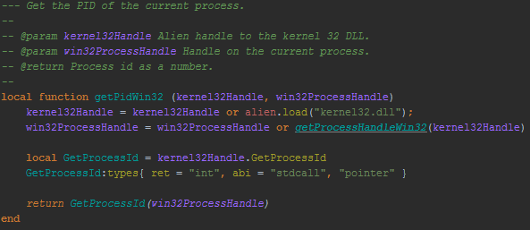

Figure - Requesting the Process ID of the Server from the Windows OS using Alien.

For Linux and other UNIX like systems, such as Mac OSX, the process to get information was simpler and provided more detailed figures, such as CPU usage, where readily available. The command line utility ‘ps’ was used to query the operating system, as Lua can natively open a process programmatically and read in all output, this is detailed in the below figure. Information such as CPU Usage, Memory Usage and server Up Time was readily accessible and only required parsing the output.

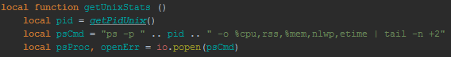

Figure - Building the Command Line Call and Executing using the Lua I/O Library.

Once performance information was accessible, the server logs were inspected by scanning the log output directory and reading in all files; this was convenient but takes a few seconds to complete, however the logs section of the admin application was a manual update so this was acceptable.

Both the performance and logging information where made available through a simple web service in the web application, which responded with JSON objects, easily consumable by AJAX calls from a browsers. Once the log area was completed and displaying logs the next task was to model the performance data in a meaningful, and as shown in the UI designs this would be done using charts.

Highcharts.js provides a simple interface to load data and display a chart using JavaScript, the chart was loaded with new data points every second or so to provide a real-time view of the memory and CPU usage as it changed over time. The only down side was that the chart cannot be scrolled back to look at earlier data, only the current data in the window can be viewed.

6.4.3.1 Epics

* #79 – Build Automated Tests & Web App
* #25 – HTTP Authentication
* #80 – Server Admin Web App

6.4.3.2 Issues/Bugs Raised

The key issue raised during this sprint was the stability and performance of the web server when handling HTTP requests. To fix these problems research was done into how different browsers request resources and the time the server spends dealing with each step in its processing. It was then decided that the keep alive feature of HTTP/1.1 was to implement as a measure to combat these issues.

When a HTTP message is sent, a header ‘Connection’ is always included to tell the server/client what to do with the TCP/IP connection established, used to transmit the messages. If this reads ‘close’ then the connection is terminated and not used again, however using keep alive it can be marked ‘keep-alive’ which means that the server will listen for more HTTP requests and respond to these using the same network connection already existing.

This improved loading times for the admin web application and stopped client browsers form creating too many server threads at once, now only opening a small set of connections and using these for multiple requests.

6.4.4 Sprint 4 Retrospective: 2nd – 13th February 2015

This sprint returned to working on more extensions to the server core that are expected of a modern web server. Error handling is key to making sure any HTTP requests always get some response, even if it informs the client of an error. This was implemented by wrapping any sections of code that dealt with potentially dangerous operations in error blocks, similar to the try catch functionality found in languages such as Java and C++.

Lua does not explicitly provide such functionality, but instead used protected function calls, these return the status of execution and any return values or an error message. This was extended to provide a convenient sudo-syntax to capture errors, the below figure demonstrates the try catch functionality created.

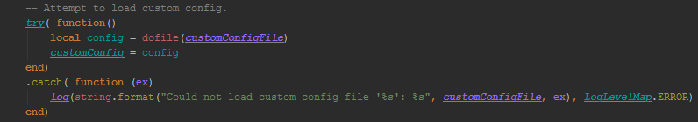

Figure - The Try Catch used to Run Logic and Report Errors.

Any errors that were generated when handling a request were logged, placed in the HTTP response and the status code set to 500, which signals a server error to any clients. This is important also for web applications as any erroneous code in a launch script or a dynamic page should be captured and reported.

Additionally a server state was maintained during a request so the output of any request can be known, so they can be logged for monitoring and debugging purposes. The server state was also used to mark the request response code during certain special handlers, such as when the user requesting the user is not authenticated (a status code of 401) or the route requested is disabled (a status code of 403/4, an example of which could be turning off file serving the site config.

A file cache was created to enhance performance by keeping any requested files within a size range to be held in memory until they changed in the underlying file system. This used the file system routines in the Apache Portable Runtime to inspect the last time files were updated and if they had been deleted.

Configuration was added to the server to enable/disable the cache along with directions on the acceptable minimum and maximum file sizes that can loaded into the cache; the size range is to prevent massive files being stored using up too much system memory, as well as to stop files that are small enough to load from the disk quickly, and being stored in memory would provide no real benefit.

The next epic covered, HTTPS, was not initially present in the requirements for the project but due to some research and development a solution was found with chosen software libraries to implement HTTPS fully; see the unscheduled activates in section 6.4.4.4 for more information on this research.

Once the back end logic to support HTTPS was complete, an additional architecture change was needed. HTTP and HTTPS run on separate ports on a web server, so the client clearly knows which protocol to use based on the port. Another instance of the main Server class was needed to handle requests, and encrypt the channel with LuaSec, before processing HTTP messages.

This was done by having two main threads, each running a loop to receive new clients, listening on different ports. Some memory sharing was required to be set up so that any shared configuration data was the same to web applications being accessed via HTTP and HTTPS.

Server side sessions are a common feature for web servers to provide data persistence on a client basis, between HTTP requests. As the server is multithreaded the sessions store created was a shared data structure that provided atomic access to data, so that each request will have the most recent data and multiple requests do not corrupt the data before it can be used by request logic.

Session IDs were devised to uniquely identify a client by its request parameters, such as IP address, client port and the user agent; the user agent is a string a browser will add in the HTTP headers to detail its compatibility and supporting software. The logic uses user agent and IP over IP and port as this means that sessions will be used for the same browser regardless of multiple instances using separate ports to communicate with the server.

Configuration was added to allow disabling of sessions, and selection of one or both methods of generating session IDs from client request information. Sessions are automatically loaded into the HttpState object that is used to model a HTTP request, meaning all information about a client is stored in one place during request processing.

6.4.4.1 Epics

* #21 – Error Handling
* #22 – Cache
* #23 – HTTPS
* #24 – Sessions

6.4.4.2 Issues/Bugs Raised

Once HTTPS was implemented several crashes at times where noted, these were due to some issues with the way that the LuaSec library loads OpenSSL to encrypt traffic, this was resolved and tested with several browsers; at this time Mozilla Firefox was the most compatible with the HTTPS implementation as Google Chrome needed special configuration to accept the certificate used by the sever.

Log messages were also reviewed in this sprint as it was found these were becoming too verbose, especially when being used by the Admin Web Application, as the AJAX calls to fetch the log contents took up to 60 seconds at times. Additionally an issue was noted where the calls to get the logs from the web service were logged and always appearing as the last activity in the server log viewer, which was very un-user friendly and slightly silly to witness. A log switch was introduced into the site config so that during request processing the maximum log level was changed to the one found in the site config, meaning one could set it to log nothing and keep any web service calls hidden from the logs.

6.4.4.3 Unscheduled Activities

HTTPS was originally not included in the roadmap for the project as the main network library chosen, the Apache Portable Runtime, did not support it natively and Lua libraries to provide network encryption were not compatible with it either. To overcome these difficulties a technique was devised to emulate a network library that an encryption library supports, the main library for HTTPS was LuaSec as noted in section 6.1.2.

LuaSec uses the LuaSocket library, which provides cross platform network I/O, to implement its support for HTTPS. It does this by taking an object that represents a network socket and wraps it inside another object that will encrypt outgoing traffic and decrypt received data. This means it only requires an object that looks and behaves like a LuaSocket network socket, i.e. an emulation.

Lua supports a technique called meta-programming which involves overriding the default behaviours of indexes and operators on an object to dynamically provide methods. An example of this is to override the indexing mechanism that is triggered when code attempts to call a method by name on an object. A router can be made that redirects calls from the emulation object to the appropriate methods in the underlying implementation, in this case an Apache Portable Runtime network socket object. The below figure displays a snippet of how this router technique would work in practice.

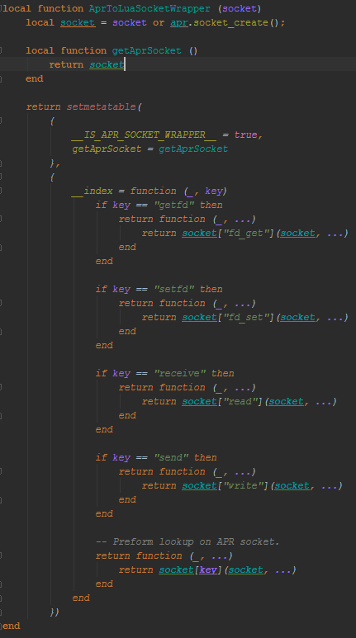

Figure - The LuaSocket emulation class, showing the setmetatable function providing the __index method which handles index calls and redirects them based on the value of the key used.

The emulation required was two way, wrapping a socket object to work with LuaSec, then wrapping the object that the library returns to be compatible with existing code on the web server that expects an Apache Portable Runtime implementation. Once both these emulation objects where created no existing code needed to be introduced past a simple initialisation routine to encrypt a new socket before exchanging HTTP messages.

6.4.5 Sprint 5 Retrospective: 16th – 27th February 2015

This sprint focused on delivering the internals required to harness the web application server for RESTful web services and MVC websites, providing a web application API to achieve common actions.

When creating a RESTful web service it is often useful to ensure that clients always receive a reasonable status code, so that the calling library does not register an error if say a code of 500 was returned. It is more useful to always return a code between 200 and 299 to signal request was handled successfully and internally in the response body denote if an error occurred.

This means clients can check for an error and take appropriate actions if necessary. The API function ‘restAction’ was developed to provide this functionality with as little code as necessary. It acts in the same manner as a try catch block, but with the order being try, finally, catch instead.

One can run the logic for the request, then even if this throws an error any resources such as database connections can be cleaned up before completing the request. An object is passed as a parameter to each handler that holds the template containing: the data for the response, the status of the request (success or error) and details of the error if any. The below figure shows the rest action being used to add an entity to a database.

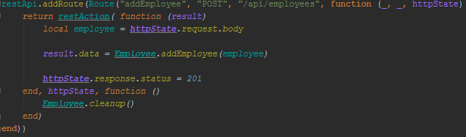

Figure - The restAction API function used to add an employee to a database, note the clean up call in the second handler function passed to restAction.

The second element to the web application API was an interface to work with relational databases, which are often used as the data backend for web sites. The intended purpose of this interface is to allow a web application developer to work with a database without writing much code or SQL queries.

Similar to the HTTPS work the interface used meta-programming to get information for operations from method names used. This technique works by using patterns to match method names to common database operations, the table below demonstrates how this works in practice; this example focuses on a database with a table named ‘person’ that holds details for people.

|  |  |  |
| --- | --- | --- |
| Pattern | Description | Example |
| get{table}ById | Get a row from a table by matching on a column by value. | getPersonById |
| get{table} | Get all rows from a database table. | getPerson |
| delete{table}ById | Delete row(s) from a table by matching on a column by value. | deletePersonById |

The figure below shows how this pattern matching was implemented in code, using an index handler which is called when a method with a given name is not found in an object.

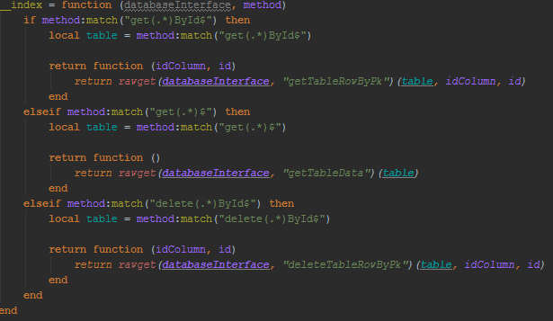

Figure - Method name pattern matching in the database interface class.

On top of the basic queries provided by the dynamic methods the ability to quickly run parameterised SQL was provided; this is technique of writing and SQL query with placeholders for variables, then providing an array of values to use. This then enables a developer to write code to perform the remaining database operations of inserting and updating rows, as these require specific knowledge of the structure of tables.

Finally a configuration object was devised that details the database type, connection details and access credentials. This is passed into the object constructor and it will automatically establish and manage the connection with the database.

The last piece of the web application API was the ability to build a copy of the site configuration defaults on demand, so that you can alter this to provide rules specific to a site and set up elements such as HTTP authentication.

The next epic was probably one the more complex features that was engineered for the web server, a complete implementation of a PHP like scripting environment and processor that uses Lua snippets embedded in HTML files. The aim was to create a feature set that would allow an end user to create small scripts or entire pages dynamically, also featuring MVC style parameters, allowing models to be passed to views (pages) programmatically.

First identified task in the development process was to create a format for Lua snippets that could be recognised by a parser and then executed dynamically by the language; as Lua supports executing strings and files on demand; it was decided that using the format shown below would be convenient.

**<% --Lua Code-- %>**

This meant that using regular expressions, the code could be extracted by looking for the text between any set of angle brackets followed by a percentage sign. This extracted string can then be executed as discussed above.

To facilitate code snippets executing on a page sharing data an environment was set up that is available to all the blocks of code. The environment for LHTML dynamic pages provides access to any model provided by the web application, a write function to output text to the HTML page, the site configuration and any request parameters such as POST data, query string data and access to the current HttpState object which contains the session data store.

To evaluate Lua code, logic was devised that used regular expressions to extract all snippets, replacing their locations in the HTML file with a unique ID that is used to put the result of the evaluation in place of the code. Once all snippets are harvested and replaced by placeholders, each snippets is evaluated in turn and any output produced is then written to the location of the unique ID of that snippet.

Three types of snippet are defined, these are listed below.

* Executor – A piece of code that may use the write function discussed above for output, but no value is expected to be evaluated.
* Printer – The statement in this snippet is evaluated and that value to written in place of the snippet.
* JsPrinter – Similar to the printer, however the value is serialised to the JSON data format before being written in place of the snippet.

The request handler logic was modified to allow any LHTML requested to be automatically processed by the server, meaning an end developer does not need to write a launch script and can just place dynamic pages in their site. An API function was made available to allow web application logic to dynamically call a dynamic page on a site, and optionally pass a model if the page is being used as a view.

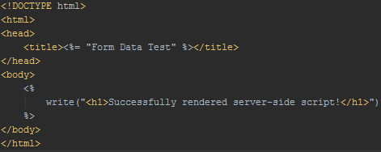

Figure - An example LHTML file, with a printer snippet in the title element and an executor snippet in the body element.

To facilitate testing the web application API and other features developed up to this time it was decided to create a small database driven web application that would manage employees. This site used AJAX and JavaScript libraries that the lead developer was familiar with to connect with RESTful services powered by a sample MySQL database hosted on the server and the web pages were powered by an MVC controller; more detailed design and implementation can be seen in section 7.1.2

The last epic of this sprint was to support running PHP files on the server. The design for this uses an external PHP interpreter to run requested script files with the associated parameters, POST data and query string values etcetera. This involved using an API provided by the Apache Portable Runtime to open up a process (the PHP binary executable) on the system and read in any errors and output; similar to the performance monitoring code for the admin web application.

Standard streams are provided by operating systems to enable distinguishing between output and errors, these are named as such being standard out and standard error. These were utilised when connecting to the PHP interpreter process to read in the resulting HTML from processing the script, and if any errors were detected using the standard error stream they were returned in the HTTP responses with a status code of 500.

Similar to the dynamic LHTML views the PHP scripts run for the server are provided all request parameters, this was done by serialising each parameter value as JSON then passing these in as command line arguments to the PHP interpreter, these can then be accessed and de-serialised using the standard PHP libraries.

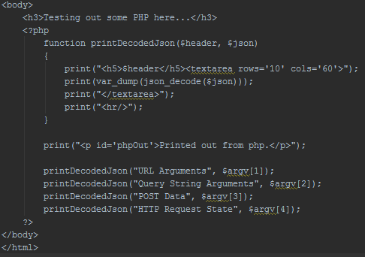

Figure - A PHP script that output the request parameters passed in by the web server.

6.4.5.1 Epics

* #26 – Web Application API
* #27 - Dynamic Views & MVC Support
* #78 - Employee Web Application
* #28 – Support Running PHP Scripts

6.4.5.2 Issues/Bugs Raised

During the beginning of this sprint a lot of technical faults with libraries and binaries were being found, often these were severe as crashing the entire server program. These were triggered by multiple things, sometimes it was using HTTPS other times it was loading a database driver.

The root cause of the majority of these errors was poorly built libraries for the Windows operating system, as most of the third party libraries required a C language component to be compiled and access at run time. Windows was used out of convenience up this point in development, however there were plans to use Linux if possible due to the benefits outlined in 2.17.

It was decided that the time and effort to rebuild libraries and ensure all errors had subsided was greater than what would be involved in moving to a Linux based development environment, where C libraries are automatically build and dependencies are resolved for you. See the following unscheduled activities section to see details of this platform migration.

6.4.5.3 Unscheduled Activities

As stated in the previous section the development environment was shifted to the Linux operating system, more specifically the Lubuntu distribution. The decision to use Lubuntu was based on its provided software package for the Apache Portable Runtime, Lua and the projects required third party libraries.

Initially the main work centred on gathering a list of packages that would be required to run the web server, and testing these were installed and configured correctly. This took some trial and error as some dependencies where well hidden due to the previous Windows based environment having some software installed automatically.

Once the dependencies were resolved configuring the Lua runtime was another challenge as this required modifying some system configuration files so that all source code files and installed libraries were available to the Lua virtual machine. Once these issues were resolved the server was then ran through the automated tests ran up until this stage to ensure no functionality had broken due to the change of server host.

The key reason most of the transition was painless is due to the cross-platform nature of the Lua language and the third party libraries, especially the Apache Portable Runtime as this was design from the ground up to provide the same interface across all supported platforms.

A bonus of moving to Linux was an update to version of the HTTPS library, LuaSec, which supported the encryption scheme TLSv1.1, whereas the Windows build only supports up to TLSv1 which has been deprecated by the network security community. In conclusion the bugs and issues did not appear again once the switch to Linux was made, confirming my suspicion that the Lua libraries being compiled where done so in an incomplete or unsafe under the Windows environment.

6.4.6 Sprint 6 Retrospective: 2nd – 13th March 2015

The final sprint was devoted to creating an extensive piece of end user documentation. Section 5.4.3 details the contents and purpose of this so it will not be repeated here. The overall process of the documentation took all of the sprint and was quite intense, as it required creating examples and verifying behaviour by running tests with the server software.

See Appendix C to view the finished documentation in full.

6.4.6.1 Epics

* #81 – End User Documentation

6.4.7 Sprint 7 Retrospective: 16th – 27th March 2015

Due to the demands of other coursework and the construction of the overall final project report no further work was scheduled for this sprint. This decision was also made because it was felt by the team that all requirements laid out in chapter three had been met and functionality was in line with the designs in chapter five.

7. Testing

Testing the web application server was done by building sample web applications and running manual and automated tests, using techniques such as integration testing and Blackbox testing. The first section, 7.1, will deal with the actual web applications and section 7.4 and 7.5 will demonstrate how these where used to test the server.

7.1 Testing Suite

To comprehensively test the web application server it is necessary to develop a series of tests, this will involve some client side tests and sample server side web applications to provide the functionality for testing.

7.1.1 Test Web Application

The following sub-sections detail the tests that are provided after building the application.

7.1.1.1 Functionality Tested

Endpoints are provided to test the following areas of the application:

* Static Resources (file serving)
* URL Parameters
* URL Routing
* JSON Web Service
* Server Sessions
* MVC Views
* Web Form Data Upload (POST/GET)
* HTTP Authentication
* Request Filtering (File Type Exclusion, HTTP Methods)
* HTTP Response Content Serialization (Converting Lua Values to XML/JSON)

7.1.1.2 Launch Script

The launch script will set up the route handlers for the test endpoints and configure any request filtering and HTTP Authentication using the site configuration. This will also test the Launch script functionality, loading and applying route maps and configuration, as if these are not working correctly the tests will not load correctly when called by a client.

Additionally, as a side effect of using server modules, the web application API will be tested to see if it imports the correct classes/functions and provides the desired functionality to a developer building a web application.

7.1.1.3 PHP Tests

Simple PHP tests will be ran additional to the core functionality of the server API, these will involve writing PHP scripts that process HTTP request parameters and output elements on the page using these parameters, which will not be present if the file is served directly without processing through a PHP interpreter or the interpreter throws an error will loading or running the script; files will be loaded using static resource requests and also using the API to dynamically load the PHP script.

7.1.2 Employees Web Application

While the test web application is extensive in its test coverage of server features it is also necessary to build a miniature web site that uses the web application API provided by the server to the full extent. This will involve working with databases, building an MVC style website and RESTful web service; intended for all modern web browsers in section 7.2.

7.1.2.1 MySQL Sample Database

To power the employees’ application a sample database provided by the MySQL production company was used to provide a back end schema and records. (MySQL :: Employees Sample Database, 2008) See appendix H for the schema of the database, this was unmodified apart from adding auto incrementing indexes for some tables; necessary to dynamically add new records.

7.1.2.2 MVC Site

The site consists of two main screens, the index page and the employee editor page. The index page enables a user to search for employees using the REST service discussed in the next sub-section and then proceed to delete or edit found employees, additionally new employees can be added from this screen.

The back end code for the index page handles the HTTP POST request to edit/delete/add employees in the database, then adds a status message on the web page when served to indicate the result of a database operation.

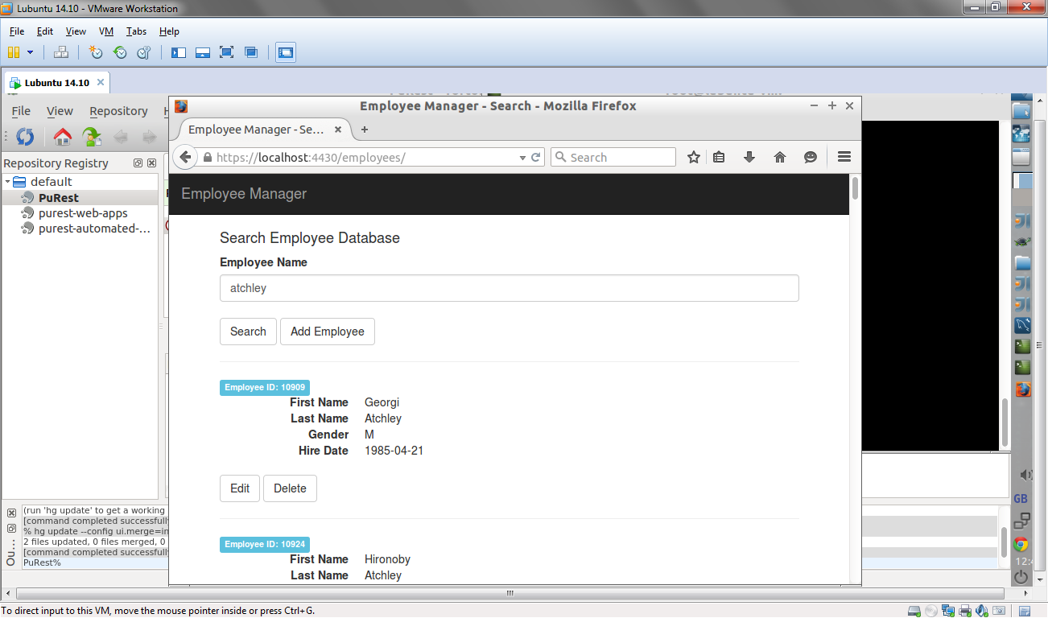

Figure - Employees Index Page, Showing Search Results.

The employee editor page handles data entry for adding an employee and presents the current information for an employee being edited. For display of a current employees details the database is connected to the controller of the MVC application to look up details using the employee ID passed in via the query string, e.x. “/employee?mode=edit&emp_no=10909” would signal that the form should allow the user to edit the employee with the ID 10909.

Changes to existing employees or new employee data is submitted using a web form via HTTP POST to the index page, as discussed earlier in this section.

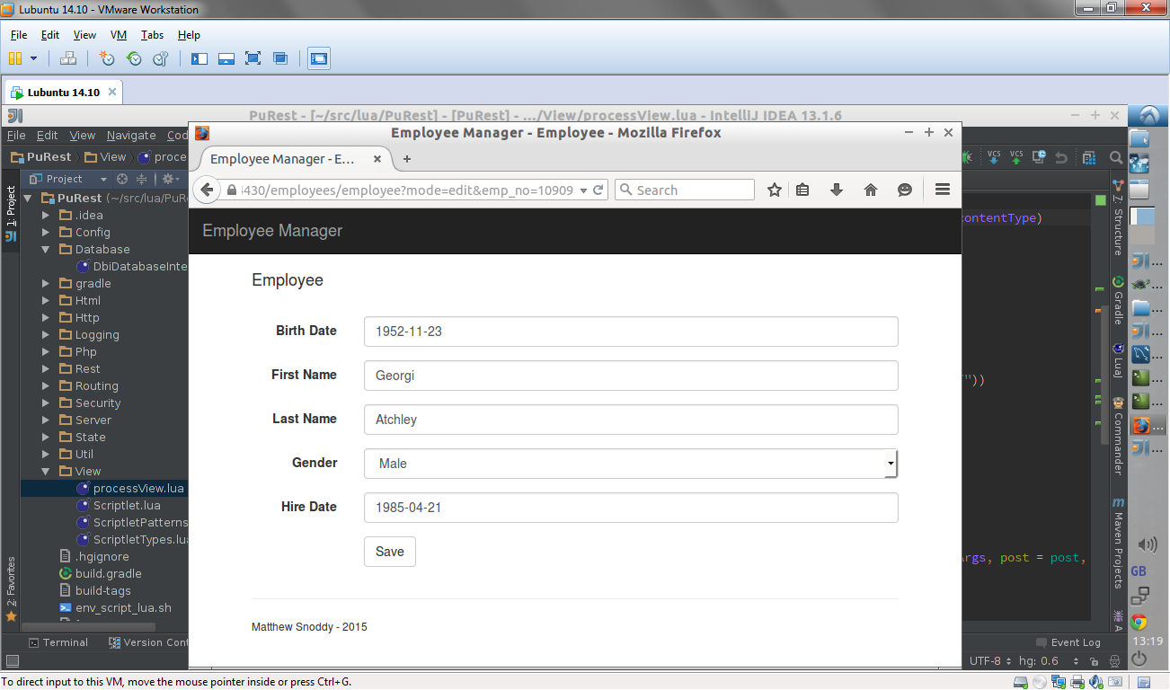

Figure - The Employee Editor Web Form.

Both these pages, and the site backend code, test several key aspects of the server web application API, areas include:

* Dynamic Views
* Embedded Lua Code Snippets
* URL Routing (Controller)
* Database Interface (MySQL)
* Ajax Calls (Consuming REST Service for Search)
* Serving Static Resources (HTML, CSS & JavaScript)
* Request Parameters (POST data & Query Strings)
* Web Form Data Upload

7.1.2.3 REST Service

An extension to the Employee application is a RESTful web service that allows any HTTP client to work with the employees’ database using URL parameters and JSON. The service provides routes to add, update, delete and search for employees in the database. See the below figure for an overview of the routes.

|  |  |  |
| --- | --- | --- |
| Route | HTTP Method | Description |
| /api/employees | POST | Add an employee to the database. Request body is a JSON object representing the new Employee. |
| /api/employees/{id} | GET | Get an employee from the database by ID. |
| /api/employees/{id} | PUT | Update an employee in the database by ID, request body should be a JSON object representing the existing employee. |
| /api/employees/{id} | DELETE | Delete an employee from the database by ID. |
| /api/employees/search | GET | Search the employee database by first and/or last name. Request body should be a JSON object with one or more search terms. |

To utilise this service, the developer will write test cases to call and check results from the routes and manual tests can be performed using an AJAX application in JavaScript to check return values and route action correctness. See the continuous integration tests to see how the test cases to use this web service were implemented.

7.1.2.4 Bootstrap

Bootstrap is a HTML5 CSS and JavaScript user interface library that allows for development of mobile and desktop web applications using the same elements, providing a default style and set of widgets; this is 7also used for the server Admin application discussed in section 5.4. For the employee application this library was used to build the search page and the employee editor web form, providing a quick way to produce a clean and modern layout without writing CSS from scratch.

7.1.2.5 Knockout

Knockout is a JavaScript library that uses the Model View View Model (MVVM) design pattern to enable the display and editing of data. (Knockout : Home, 2015) This was used to build the search screen, as it was initialised using the data returned from calling the search REST route and applying a template on that data to display search results as rows; you can define the HTML for a single item then apply that for every item in the current data set.

7.2 Web Browsers

The web browsers selected for client side testing were selected by market share, to ensure compatibility with modern browsers; see the two figures at the end of this sub section for more information. The four browsers that will be used to run automated and manual tests are:

* Google Chrome
* Mozilla Firefox
* Internet Explorer
* Safari

This selection of browsers cover the most widely used modern browsers on both desktop and mobile platforms. The testing in terms of browsers focused on their handling of HTTP messages, network connections and resource downloading, ensuring they can receive pages and make requests successfully; if the page does not render correctly or there is a style or logic issue, but the files were downloaded correctly over HTTP, then it will not be considered a failed test, simply a browser compatibility issue for that page.

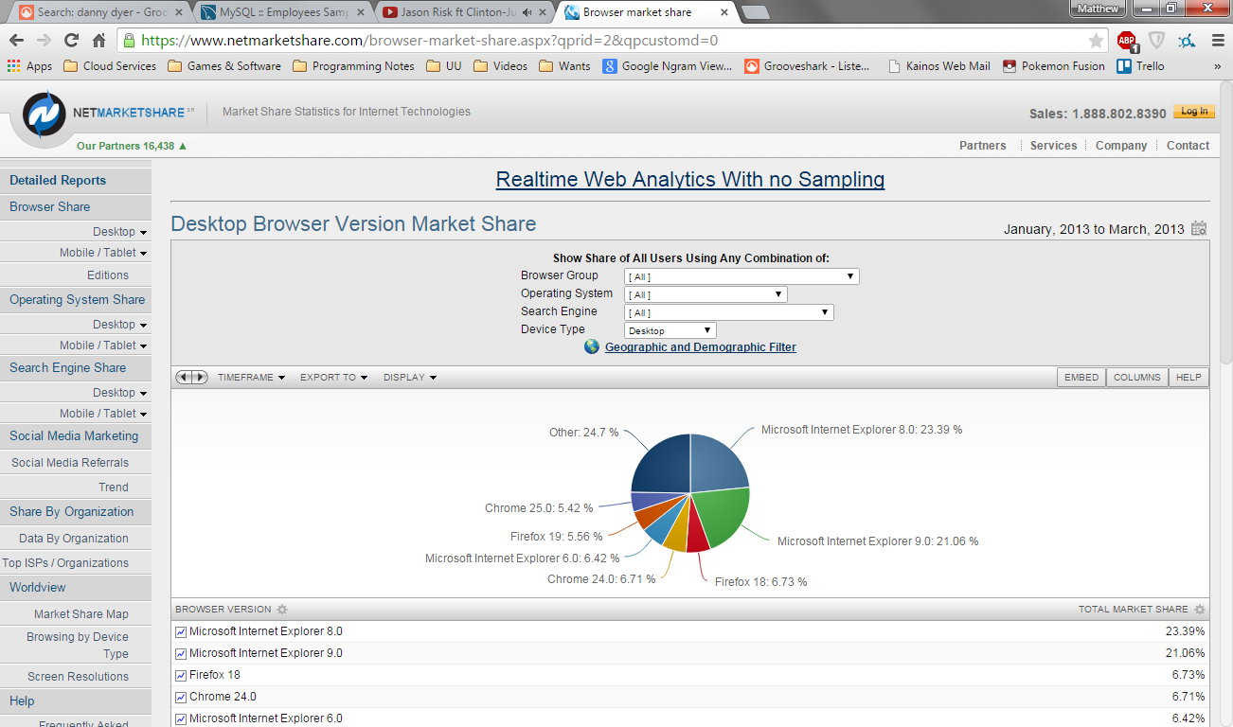

Figure - Desktop Browser Market Share as of April 2015. (Applications.com, Desktop Browser Version Market Share, 2015)

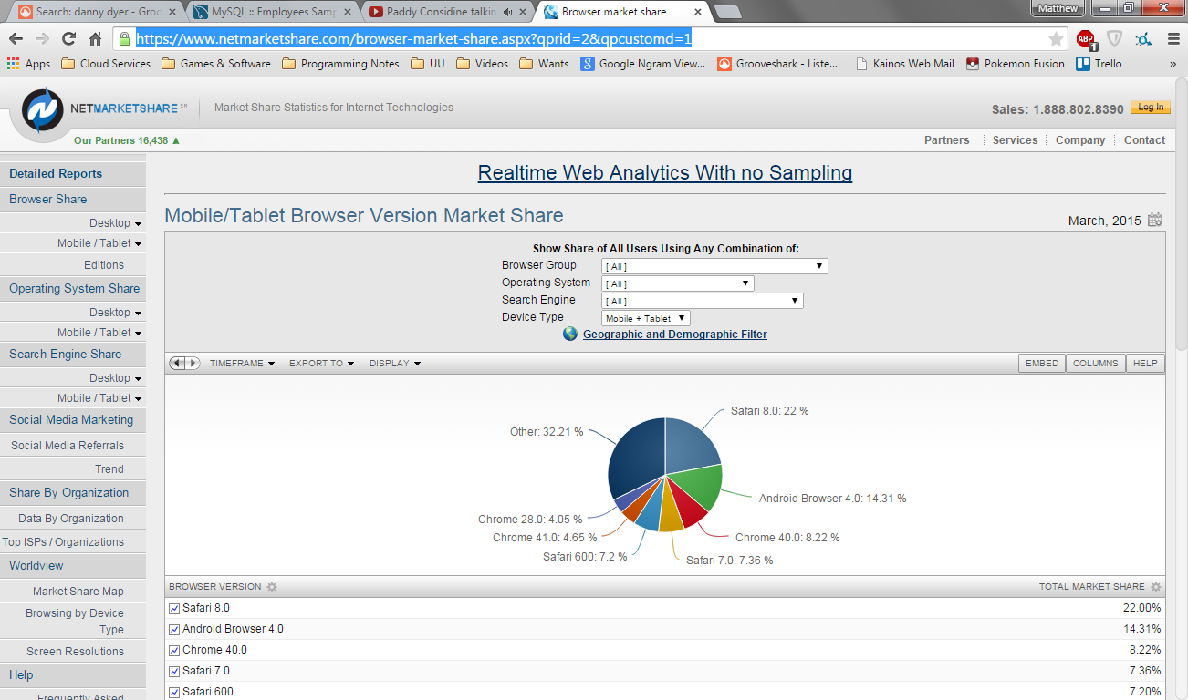

Figure - Mobile/Table Browser Market Share. (Applications.com, Mobile/Tablet Browser Version Market Share, 2015)

7.3 HTTP Client - Postman

Postman, an extension to the Google Chrome web browser, was used to author and execute HTTP calls to RESTful web services and debug HTTP messages. (Postman, 2015) This tool is a lightweight HTTP client allowing you to specify the request body and headers manually, allowing for a more precise test for server endpoints and routes. The below figure shows a catalogue of calls used to test the employee web application.

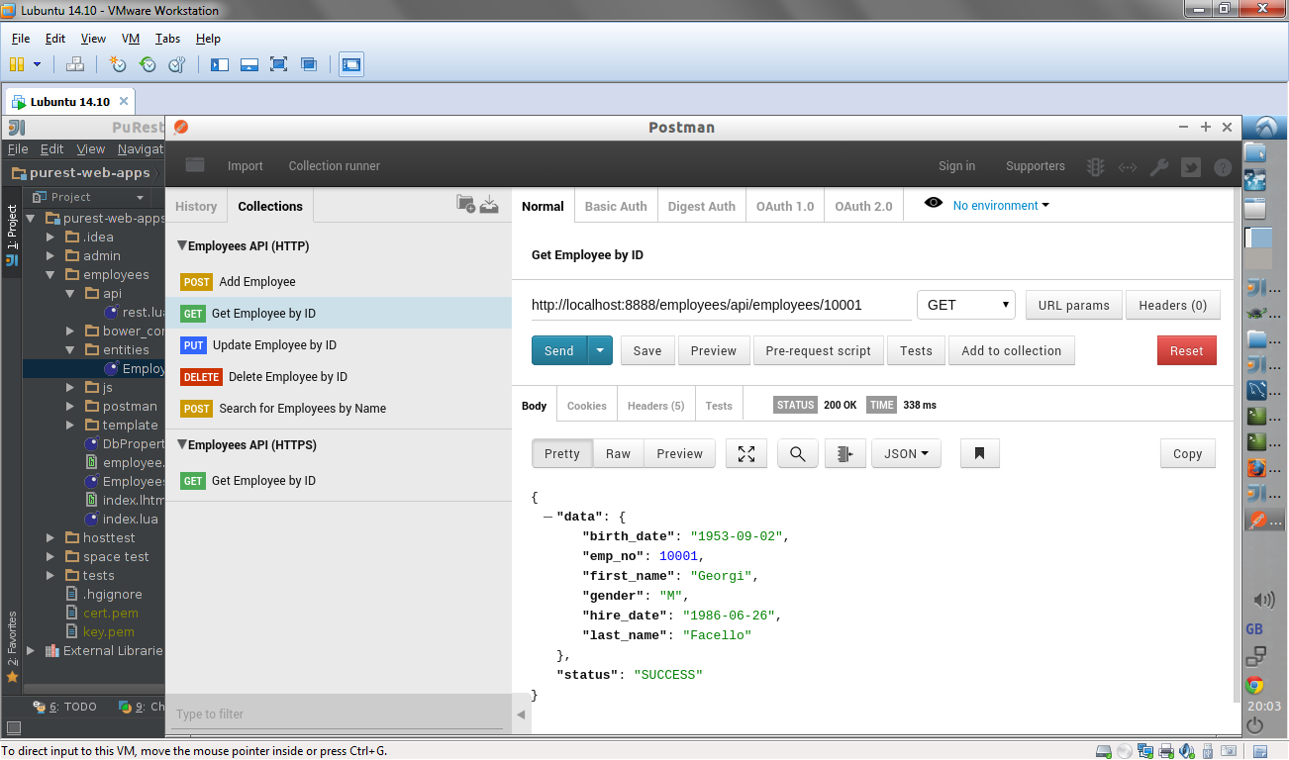

Figure - Employees REST API In Postman.

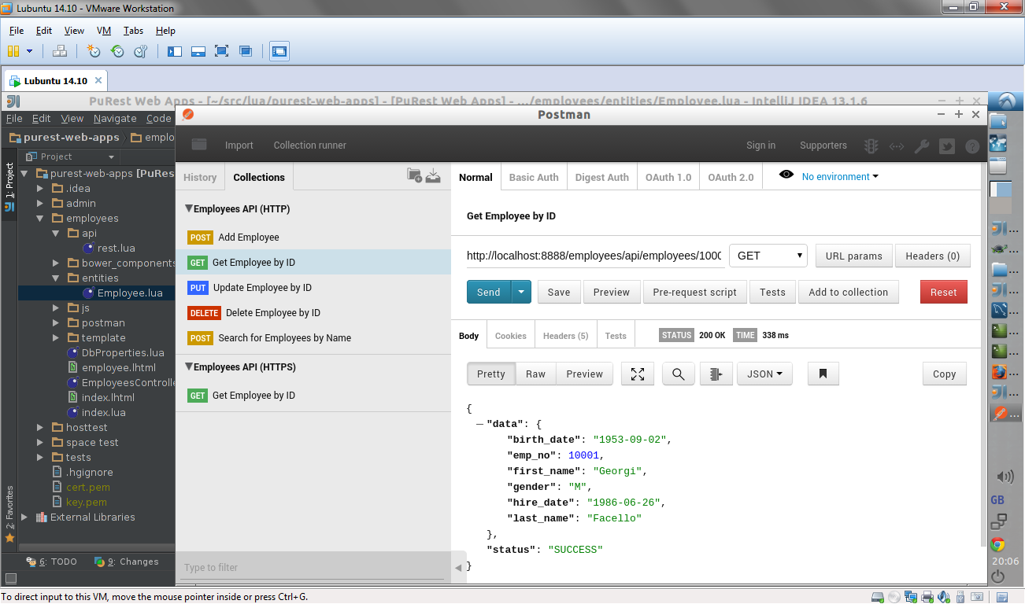

Figure - Authoring a HTTP request in Postman.

Postman will be used in manual testing and during development for debugging of HTTP message parsing.

7.4 Blackbox Testing

Blackbox testing is the technique of feeding a system a series of inputs to perform an operation and observing the output to see if it tallies with assumptions and requirements. All testing, automated and manual, will be carried out using this technique as it perfectly suits the paradigm of distributed systems.

The reason Blackbox testing in so suitable is because distributed systems communicate by passing messages and sending signals, often using abstract formats such as HTTP to format and relay information. The internals of the server or client are never revealed to ensure compatibility, this means that no tests can be ran on those components only on the correctness of responses.

7.5 Continuous Integration

Continuous integration is the practice of taking changes in a source control system, merging them and insuring that the product still runs correctly and provides existing functionality. This idea is often extended to then automatically verify that the integration was successful and the system still meets requirements and maintains compatibility with older versions.

In many team based projects a collection of commits for a source repository are merged at the end of the working day and the product compile and run, then tests are ran and any errors or warnings are reported automatically; this can also be triggered by a commit being made, so the product is verified every time a developer completes a section of work.

7.5.1 JUnit

Junit is a unit testing framework for the Java language, allowing developers to write short methods that will test assertions about outcomes of operations. (JUnit, 2014) One can set up an environment for testing and tear it down for each testing method, which allows more complicated systems to be tested, such as database connections and network operations.

Java and Junit were chosen for the task of writing automated tests because of the cross-platform compatibility, reflecting the same qualities found in the Lua language that the web server is written in; additionally the lead project developer is familiar with these technologies, expediting test authoring.

Once a Junit project was created it provided a platform to preform automated tests once tasks were complete, allowing user stories to be verified for functionality. Writing tests was a requirement for each user story to ensure that tests were available when a story status changed to complete.

7.5.2 Selenium Web Driver

While Junit provides a framework for preforming tests and recording their success, tools are necessary to communicate with the web server and be able to process responses in a practical way. The first of these tools was the selenium web driver, which works with the major browsers listed in section 7.2 to allow requesting of web pages and inspection of elements programmatically. (Selenium WebDriver, n.d.)

Being able to communicate with a web browser in such an intimate way using Java means browsers can be tested in Junit and ensures compatibility across all browsers for all tests; highlighting any niche issues upon every test run. Additionally the web driver, as mentioned, can inspect web document elements allowing tests to be written that ensure that elements were placed on pages correctly, for example when a dynamic page is loaded to ensure that the script executed correctly and wrote the correct HTML to the response.

7.5.3 Apache HTTP Client

Another tool used to communicate with the web server from the automated test environment was the Apache HTTP Client, a library which provides helper classes to send and receive HTTP messages in an abstract manner; similar to the Postman tool discussed in section 7.3. (Apache HttpClient Overview, 2015)

The benefit of this client is that it enables uploading data to the server, to make POST requests, which the Selenium Web Driver is incapable of performing. Also HTTP headers can be inspected and status codes also checked to ensure, for example, that HTTP authentication has blocked a request from being served and returned a status code of 401.

Web services developed in the test web applications for the server can be easily tested using this client as it allows the use of all HTTP methods, such as DELETE and PUT, which are used in RESTful APIs; furthermore web services often require tracking of IDs while making several related requests and this is more suited to a programmatic approach where these can be stored in memory whist preforming tests.

7.5.4 Tests Developed

Below is a list of the areas covered by the automated tests developed for the project.

* HTTP Content and File Handling
* HTTP Messaging
* MVC
* Dynamic Pages
* Server Side Sessions
* URL Routing
* Request Filtering

For a complete listing of all automated tests and an example of the output given when these are executed after a new commit is made to the source code repository, see Appendix G.

7.6 Manual Testing

Automated and continuous integration are the main techniques used for testing the project, however during development manual testing was used consistently to check correctness and functionality. The below subsections discuss the tools used to verify manual tests on the web server.

7.6.1 Error Handling

As the web server must always attempt to send a response to a HTTP request regardless of security issues, run-time errors or missing resources, error handling is key to expected behaviour from a client’s view. To achieve affective error handling, any areas of code that are prone to error or are made up of custom code written by the developers of a hosted web application on the server, must be wrapped in a protected area of logic to catch exceptions.

7.6.2 Profiling Code

Often it is useful to know how much execution time is spent on individual tasks when preforming requests on a server, this enables the developers and end users to understand the penalty of enabling components such as cache and writing very long dynamic pages and complicated web service endpoints.

The developer of the project used profiling to ensure the performance of the web service during requests, enabling algorithms and library usage to be optimised. Time intensive operations can also be identified by profiling each element in a process, helping guide recommendations for end users on how to configure set features of the server.

7.6.3 Logging

As stated in section 2.14 due to the background nature of a server application logging is vital to recording requests processed and any errors while dealing with clients or setting up the server. For testing purposes it is also necessary to monitor actions and errors that occur, also it means that any failures detected while running automated tests can be easily investigated by reviewing the most recent logs.

8. Evaluation

This chapter provides a thorough evaluation of the completed project; this involves evaluating the projects functional and non-functional requirements, while addressing whether they were met or not. Proceeding this an evaluation of the key technologies used throughout the project is detailed to discuss how effective they were in contributing to the overall success of the project.

The project’s software development lifecycle methodology is then evaluate to identify whether or not it was suitable to the project and if it would be used again if a similar project was to be developed. An end-users evaluation is then carried out to identify what users have felt were the positive and negative aspects of the project, along with identifying any desired features they would like to see if future development was granted.

Finally, a system evaluation is discussed to evaluate whether or not the project met the initial project aim along with its respective project objectives.

8.1 Requirements Evaluation

Below is an overview of the project has met requirements, upon evaluation of the final product.

8.1.1 Functional Requirements

The table below shows all functional requirements of the project along with an indication of whether the requirement was met or not:

|  |  |  |
| --- | --- | --- |
| Requirement ID | Requirement Description | Pass/Fail |
| FR01 | The server should be cross platform, running on Windows, OSX and Linux. | **PASS** |
| FR02 | The server should be able to parse HTTP requests and author HTTP responses. | **PASS** |
| FR03 | The server should provide a web application API (Application Programming Interface) | **PASS** |
| FR04 | The web application API should be available from Lua scripts. (as importable modules) | **PASS** |
| FR05 | The web application API should allow a user to create web services. | **PASS** |
| FR06 | The web application API should allow a user to customise the configuration for a website hosted on the server. | **PASS** |
| FR07 | The web application should model the current HTTP request and provide a model to detail the HTTP response. | **PASS** |
| FR08 | The server should be able to process dynamic pages which are written in HTML with embedded Lua code snippets. (Similar to PHP script in design) | **PASS** |
| FR09 | The server should handle errors by responding with an appropriate HTTP status code in a response, such as 500 for an error and 404 for resource not found. | **PASS** |
| FR10 | The server should serve files from the file system by matching them with request resource paths. | **PASS** |
| FR11 | The server should allow a directory on the file system to act as the root directory for all sites on the server, with each sub directory of this root directory being recognised as an individual site. | **PASS** |
| FR11 | Sites hosted on the server should allow loading of application logic and site configuration from a Lua source code file located in the root directory for the site. | **PASS** |
| FR12 | The server should provide and manage server side sessions. | **PASS** |
| FR13 | The server should provide configuration and adhere to this for server behaviour. | **PASS** |
| FR14 | The server should log messages about events, requests, errors and warning in log files. | **PASS** |
| FR15 | The server should automatically de-serialize data contained in HTTP requests and serialize data to be used in HTTP responses. Specifically JSON, XML and web form data should be convertible from text to Lua values and back to text. | **PASS** |

8.1.2 Non-Functional Requirements

The table below shows all non-functional requirements of the project along with an indication of whether the requirement was met or not:

|  |  |  |
| --- | --- | --- |
| Requirement ID | Requirement Description | Pass/Fail |
| NFR01 | The server should support database connectivity with an extra API on top of existing drivers. | **PASS** |
| NFR02 | The server should record log messages in a reasonable format, having the date and time of the message and the level of severity clearly visible. | **PASS** |
| NFR03 | The server should support HTTP compression. | **PASS** |
| NFR04 | The server should support running requested PHP scripts using an external interpreter and returning the result in the HTTP response. | **PASS** |
| NFR05 | The server should maintain a cache of files requested for performance reasons, refreshing the cache when a file is modified or deleted on the file system. | **PASS** |
| NFR06 | The server should support HTTP authentication and provide an API to set this up in the site configuration. | **PASS** |
| NFR07 | The server should come with an administrative web application built in to monitor the server performance, show the details of hosted sites and display server logs. | **PASS** |
| NFR08 | The server should have an accompanying end user guide that details the installation and configuration of the server. This documentation should also deal with developing websites for the server and the web application API. | **PASS** |

8.2 Technologies Evaluation

This section gives a brief evaluation of key technologies that played vital roles in the project and its successful completion.

8.2.1 Lua

Working with Lua the lead developer found that it was a powerful language for its small size and portability; being flexible enough to provide features such as emulating external classes and running script segments in sandboxed environments. Despite this however the key complaint around the platform would be the unreliable quality of many third party libraries designed to work with Lua.

Often third party libraries are only ever carried forward to an alpha or beta stage and few surpass a version number of 1.0. This means that the developer is signalling they do not have confidence in the set of features offered, and often these are pulled from an existing C library; which can be frustrating as often not all features are surfaced or more technically challenging ones avoided.

Another concern is that Lua is built with an ANSI C environment in mind, this platform is standards compliant and implemented on all operating systems. The windows operating system does have software packages to work with this environment, but often they require emulating a UNIX system to some degree and do not truly integrate into the system; as stated in the implementation section this was so frustrating for the main developer the decision was taken to move to Linux to overcome third party library issues.

8.2.2 Apache Portable Runtime

Most features made available by this library were stable and extremely fundamental to the web application servers’ core logic. This is a credit to the underlying C libraries and their heritage and development maturity. A problem encountered with the Lua platform implementation was the fact it is not maintained by the lead developer.

Although no project breaking issues where found, some undocumented behaviours and bugs did hamper development.

8.2.3 Automated Testing

The experience with setting up and utilising automated testing to verify project functionality was an extremely positive one. Using the JUNit library was straightforward as a rich wealth of material on how to design projects was available. Using the selenium web driver was a similar experience, but also disappointing because of the lack of certain useful features.

These included being able to author HTTP post requests and do more sophisticated analysis of responses from web servers. The Apache HTTP Client library was used to overcome these difficulties, as it provides a generic, non-browser based, HTTP client.

8.2.4 IntelliJ IDEA

IntelliJ IDEA was used to author all the programs for the project, from the server to web applications to the Java automated tests. This IDE is very versatile and was found to be adept at refactoring code and highlighting some simple syntactical and spelling errors that would have otherwise gone un-noticed.

Additionally the IDE supports source control integration, meaning it can add files to a local repository automatically and display which files and lines have change since the last commit; this is useful to understand the full impact of a particular change to the code. The only negative comment is that the plug-in for the Lua language lacked some advanced features like custom module recognition (to recognise data structures and methods) and type inference.

8.2.5 Source Control

Source control was one of the most vital tools to keep track of changes and make code not only organised but automatically provided an online backup of the entire project when commits were uploaded to the BitBucket account. Additionally it was convenient when switching development environments to download changes from the previous environment and continue working right away.

8.3 Software Methodology Evaluation

Agile helped the project team maintain a view of tasks that were remaining at any given time during development and also provided a tool with which to plan in new features to the existing workload. Applying a logical structure to development tasks helped get the project running, only fleshing out the actual specifics before a sprint, meaning no great amount of time was spent planning out how to achieve each task, simply referring to the design for guidance.

The project team was used this software methodology again, due to the evolving nature of its management approach, both developers and managers felt that they had ownership and responsibilities during active development. The reflective capabilities once sprints were completed also proved powerful, for example comparing the estimated time stated to complete tasks with actual time to get a feel for the team’s ability to estimate problem sizes and the speed at which they work.

8.5 End Users Evaluation

The stakeholders identified in chapter three were brought in to review the progress of the application once to project was coming to close, they were each asked to give a view on certain aspects of the final product. The following sub-sections summarises the findings of these reviews.

8.5.1 Positive Aspects

The broad range of features implemented was praised by all parties, comments made around the similarity of the framework with popular web server technologies acknowledged this; the fact that a developer is allowed to be able to build free-form web services for example was a big positive.

Additionally is range of the end-user documentation was also praised, being seen as vital to any new developer taking on the product feeling comfortable and beginning development smoothly.

8.5.2 Negative Aspects

The server software has several issues, which were identified during brief demos with the stakeholders. These include being unable to shut down the server in an elegant way, requiring a software restart to refresh server configuration values and the verbosity of the server logs.

These comments are further commented upon in section 9.2, future developments. In general most notable negative aspects involved issues and bugs.

8.5.3 Desired Aspects

The desired aspects requested by stakeholders focused mainly on better performance and a broader support for more sections of the HTTP/1.1 standard. This includes things such as redirecting a client while handling a request and being able to cache files on client side using standard HTTP headers.

These, again, are sources of motivation for the future development section and serve to demonstrate that a highly sought after criteria for web services is performance and compatibility.

8.6 System Evaluation

All system objectives discussed in chapter 4 were met by the end product through the fulfilment of the requirements laid out in chapter 3. To meet the requirements the comprehensive literature review in chapter 2 was used to influence and guide the system design in chapter 5. The management of the project as laid out in chapter 4 in conjunction with the implementation discussed in chapter 6 worked to complete the design envisaged and thereby meet all requirements put forth.

9. Conclusion

This chapter provides a reflection of the entire project and its overall success. This chapter details the potential future development work which could be partaken if the project was granted an extension.

Finally, the chapter will focus on the learning outcomes that have been achieved and experienced through the lifecycle of the project; this outcomes will detail skills gained and developed.

9.1 Project Reflection

Upon reflection the project teams feels that the project was a success, in terms of the scope initially defined and the work carried out to realise this. Several points have been raised, that would be done differently if the project was ran again from the beginning:

* Ensure that any agile management software is guaranteed to be available for the entire duration of the project.
* More research could have been done to understand the requirements of the operating system for the server, as the mid development change to Linux from Windows demonstrates this area was poorly judged.
* Greater review of work past raising issues and resolving them should have been undertaken, particularly the quality and performance of code used to implement features.
* Carrying on from the previous point, more structure and methodical performance testing as part of the project would have been more productive that ad-hoc measures during development to substitute for this.

9.2 Future Development

While all objectives were meet the project team feel that several areas in terms of the product could have been improved upon:

* More streamlined installation for all operating systems, especially Windows were a lot of teething pains were discovered.
* Using more well maintained and mature libraries, as some libraries used had bugs for which no active developers had responsibility over.
* Enabling web services to communicate together could be useful to providing modular distributed services.
* Support for non-relational databases would also prove beneficial as many projects are starting to utilise these in recent years.
* Reloading of configuration during the running of the server would be desirable, as often web servers cannot afford to be down even for a few minutes at a time.
* Full compliance with HTTP/1.1 would be desirable to make the server reliable with any client which also complies with this standard.
* Enable PHP scripts ran by the server to modify the HTTP response headers, allowing equal functionality between the LHTML dynamic pages and PHP scripts.
* All bugs and issues to be ironed out, preparing for a clean and stable release.
* Release the software as open source to the Lua programming community in its full form, including documentation and full source code listings.

9.3 Learning Outcomes

Throughout the duration of the project a lot of experience and skills have been developed; this mainly resolves around the experience of managing a project which is greatly vast in terms of anything experience before. Therefore below several learning outcomes have been listed which include skills and experiences gained while completing this project:

* The ability to take a realistic software problem and engineer a functional and effective solution while applying software engineering principles.
* The ability to carry out extensive research into a particular software problem to identify and discover a suitable solution.
* The ability to communicate in a professional manner to project stakeholders to identify and elicit requirements that would be used to successfully complete the finished system to the stakeholder’s needs and wants.
* The ability to develop a software solution using the Lua programming language without having much exposure to a large scale standalone Lua system beforehand; this project provided an opportunity to develop an innovative solution using Lua and further enhance previous skills.

Bibliography

(2015, April 21). Retrieved from Taiga: https://taiga.io/

Alexander, I., & Beus-Dukic, L. (2009). *Discovering Requirements: How to Specify Products and Services.* Wiley.

Allen, S. (2012). *HTTP Succinctly.* Syncfusion.

*Apache HttpClient Overview*. (2015, March 31). Retrieved April 12, 2015, from https://hc.apache.org/httpcomponents-client-4.4.x/index.html

Applications.com, N. (2015, April 10). *Desktop Browser Version Market Share*. (netmarketshare) Retrieved April 10, 2015, from https://www.netmarketshare.com/browser-market-share.aspx?qprid=2&qpcustomd=0

Applications.com, N. (2015, April 10). *Mobile/Tablet Browser Version Market Share*. (netmarketshare) Retrieved April 10, 2015, from https://www.netmarketshare.com/browser-market-share.aspx?qprid=2&qpcustomd=1

*Bootstrap*. (2015, January 1). (Bootstrap) Retrieved April 8, 2015, from http://getbootstrap.com/

Burnett, C. M. (2007, June 11). *Wikipedia - Thread_Pool.svg*. (Wikipeida) Retrieved March 25, 2015, from https://en.wikipedia.org/wiki/File:Thread_pool.svg

CERN. (2014). *The birth of the web*. (CERN) Retrieved october 25, 2014, from http://home.web.cern.ch/topics/birth-web

Chemuturi, M. (2013). *Requirements Engineering and Management for Software.* New York: Springer Science & Business Media.

Cisco. (n.d.). *TCP Handshake Diagram*. (Cisco) Retrieved March 23, 2015, from http://www.cisco.com/web/about/ac123/ac147/images/ipj/ipj_9-4/94_syn_fig1_lg.jpg

Cockburn, A. (2006). *Agile Software Development: The Cooperative Game.*

Cohn, M. (2004). *User Stories Applied: For Agile Software Development.* Addison-Wesley.

Comer, D. E. (2014). *Computer Networks and Internets.* Addison-Wesley.

Coulouis, G., Dollimore, J., & Kindberg, T. (2005). *Distributed Systems.* Addison Wesley.

*DB-Engines Ranking*. (2015, March 31). (db-engines) Retrieved March 31, 2015, from http://db-engines.com/en/ranking

*Employees Structure*. (2008). (Oracle) Retrieved April 10, 2015, from https://dev.mysql.com/doc/employee/en/sakila-structure.html

Fielding, R., Gettys, J., Mogul, J., Frystyk, H., Masinter, L., Leach, P., & Berners-Lee, T. (1999, June 1). *RFC 2616 - Hypertext Transfer Protocol -- HTTP/1.1*. (Network Working Group) Retrieved March 27, 2015, from https://tools.ietf.org/html/rfc2616

Foundation, T. A. (2007, January 1). *Overview of new features in Apache 2.0*. (The Apache Software Foundation) Retrieved March 27, 2015, from https://httpd.apache.org/docs/2.2/new_features_2_0.html

*Getting Started - About Version Control*. (2015, January 1). (git) Retrieved April 1, 2015, from https://git-scm.herokuapp.com/book/en/v2/Getting-Started-About-Version-Control

Gourley, D., Totty, B., Sayer, M., Aggarwal, A., & Reddy, S. (2002). *HTTP: The Definitive Guide.* O'Reilly.

Group, T. P. (2015, January 1). *History of PHP*. (The PHP Group) Retrieved March 26, 2015, from https://php.net/manual/en/history.php.php

Haas, J. (2013, April 6). *Linux Benefit: For the Undecided*. (about.com) Retrieved March 31, 2015, from http://linux.about.com/od/linux101/l/blnewbie0_4.htm

*highlight.js*. (2015, April 2). Retrieved April 8, 2015, from https://highlightjs.org/

Hoffman, B. (2012, February 12). *Lose the Wait: HTTP Compression*. (zOompf) Retrieved March 25, 2015, from http://zoompf.com/blog/2012/02/lose-the-wait-http-compression

j2mesalsa. (2009, January 1). *mvc.JPG*. (j2mesalsa) Retrieved March 25, 2015, from http://www.j2mesalsa.com/struts/img/mvc.JPG

Jones, C. (2009). *Software Engineering Best Practices: Lessons from Successful Projects in the Top Companies.* McGraw-Hill Osborne.

Jung, K., & Brown, A. (2007). *Beginning Lua Programming.* Wiley Publishing.

*JUnit*. (2014, December 4). Retrieved April 12, 2015, from http://junit.org/

*Knockout : Home*. (2015). (knockout.js) Retrieved April 10, 2015, from http://knockoutjs.com/

Kulchenko, P. (2012, March 25). *Lua: Good, bad, and ugly parts*. (ZeroBrane) Retrieved March 31, 2015, from http://notebook.kulchenko.com/programming/lua-good-different-bad-and-ugly-parts

Larman, C. (2003). *Agile and iterative development.* Addison Wesley.

Leiden, C., & Wilensky, M. (2009). *TCP/IP For Dummies.* Wiley Publishing.

Logic, R. T. (2014). *mako server*. (Real Time Logic) Retrieved october 25, 2014, from https://makoserver.net/

lua.org. (2014, september 15). *about*. (lua.org) Retrieved october 25, 2014, from http://www.lua.org/about.html

Luvit. (2014). *Luvit*. (Luvit) Retrieved october 25, 2014, from http://luvit.io/

Masters, M. (2015). *An Overview of Requirements Elicitation*. (ModernAnalyst.com) Retrieved April 2nd, 2015, from http://www.modernanalyst.com/Resources/Articles/tabid/115/ID/1427/An-Overview-of-Requirements-Elicitation.aspx

Microsoft. (2009, January 1). *Overview of Available Features in IIS 7*. (Microsoft) Retrieved March 27, 2015, from https://technet.microsoft.com/en-us/library/cc753198%28v=ws.10%29.aspx

*MoSCoW Method*. (2014, June 21). (projectsmart.co.uk) Retrieved April 13, 2015, from http://www.projectsmart.co.uk/moscow-method.php

*MySQL :: Employees Sample Database*. (2008). (Oracle) Retrieved April 10, 2015, from https://dev.mysql.com/doc/employee/en/

Oliver, A. C. (2013, January 24). *Web services are dead -- long live REST*. Retrieved March 25, 2015, from http://www.infoworld.com/article/2613314/application-development/web-services-are-dead----long-live-rest.html

Postman. (2015). *Postman REST Client*. Retrieved April 4, 2015, from https://twitter.com/postmanclient

*Requirements Validation*. (2010, July 1st). (Requirements Management School) Retrieved April 2nd, 2015, from http://www.requirementsmanagementschool.com/w1/Requirements_Validation

rodding, p. (2011, January 1). *Lua/APR Apache Portable Runtime binding for Lua*. (peterodding.com) Retrieved April 1, 2015, from https://peterodding.com/code/lua/apr

*SDLC Overview*. (2014). (tutorialspoint) Retrieved october 27, 2014, from http://www.tutorialspoint.com/sdlc/sdlc_overview.htm

*Selenium WebDriver*. (n.d.). Retrieved April 12, 2015, from http://www.seleniumhq.org/projects/webdriver/

Shaw, Z. A. (2011). *Tir Web Framework*. (Mongrel2) Retrieved october 25, 2014, from http://tir.mongrel2.org/

Silvestre, B. (2015, March 12). *LuaSec 0.5*. (github) Retrieved April 1, 2015, from https://github.com/brunoos/luasec

Thakur, S. (2010, April 26). *Overview and Benefits of Tomcat Server*. (Whir) Retrieved March 27, 2015, from http://www.thewhir.com/article-central/overview-and-benefits-of-tomcat-server

w3tech. (2015, March 26). *Usage statistics and market share of Microsoft-IIS for websites*. (w3tech) Retrieved March 26, 2015, from http://w3techs.com/technologies/details/ws-microsoftiis/all/all

w3techs. (2015, March 26). *Usage statistics and market share of Apache for websites*. (w3techs) Retrieved March 26, 2015, from http://w3techs.com/technologies/details/ws-apache/all/all

w3techs. (2015, March 27). *Usage statistics and market share of Lua for websites*. (w3techs) Retrieved March 27, 2015, from http://w3techs.com/technologies/details/pl-lua/all/all

w3techs. (2015, March 26). *Usage statistics and market share of PHP for websites*. (w3techs) Retrieved March 26, 2015, from http://w3techs.com/technologies/details/pl-php/all/all

w3techs. (2015, March 26). *Usage statistics and market share of Tomcat for websites*. (w3techs) Retrieved March 26, 2015, from http://w3techs.com/technologies/details/ws-tomcat/all/all

*x64 Ubuntu : Intel® Q6600® one core - Computer Language Benchmarks Game* . (2015, March 31). (benchmarksgame) Retrieved March 31, 2015, from http://benchmarksgame.alioth.debian.org/u64/compare.php?lang=lua&lang2=python3

Appendix A: MoSCoW Requirements Listing

|  |  |  |
| --- | --- | --- |
| **MUST** | | |
|  | *Complexity (1-5)* | *Important* |
| Serve web pages and associated resource files (CSS, JS etc.) | 2 | ! |
| Bind server to a configurable host and port | 1 | ! |
| Have a configurable web directory | 1 |  |
| Provide an abstract model of the current HTTP request | 2 | ! |
| URL Routing | 2 | ! |
| Allow capture of URL parameters from predefined routes | 1 | ! |
| Come with all available Lua database drivers built-in | 4 | ! |
| Present an API to create REST web services | 3 | ! |
| Performance/Admin/Status UI (Built in Web App) | 3 |  |
| All configuration files should be intuitive to use | 1 |  |
| Produce logs with a configurable log level | 3 |  |
| Installation should include all required binaries/libraries | 2 | ! |
| **SHOULD** | | |
| Support GZIP compression for response data | 3 |  |
| Consume and provide object model of the query string | 2 | ! |
| Convert data format of return values from request handlers to a configurable format | 3 | ! |
| Automagically convert request data to a Lua object and back to origin format in response, based on request headers | 3 | ! |
| Virtual directory support | 2 | ! |
| MVC API (HTML view with a Lua model and embedded code snippets) | 4 | ! |
| Persist custom Session data between calls | 3 | ! |
| Work on Mac/Linux/Windows | 5 |  |
| **COULD** |  |  |
| Cache system for files/sessions/sites | 3 | ! |
| Lua-JIT optimisation (Building the source code into byte code) | 5 |  |
| Tune performance/timings comparable to IIS/Apache | 4 | ! |
| PHP support | 2 |  |
| Security (Basic Digest) & provider API | 2 | ! |
| Abstract threading API | 2 |  |
| Asynchronous requests (Non-Blocking/tokens) | 4 |  |
| Provide inter-app HTTP communications API | 2 |  |
| **WON’T** | | |
| HTTPS/SSL functionality | - | ! |
| Make performance a 100% mirror of IIS/Apache | - | ! |
| Detailed support for dynamic pages | - |  |
| Support extra languages | - |  |
| Force end users to build/configure/install (should just work OOTB) | - | ! |

Appendix B: Project Journal

The lead developer kept a record of development activity after January 2015 to enable a record of the issues and successes of the project; additionally some idea pitching sessions can be seen that underline the creativity and resourcefulness of the developer. Note that user stories and epics referred to in this text existed solely on the SonicAgile management system and do not tally with any such id’s shown in the appendices or report of this project, more about this can be read in Appendix K.

Week Beginning 19th January

|  |  |
| --- | --- |
| Technical Work Completed | Basic\Digest HTTP Authentication |
| Areas Researched | HTTP, security, configuration, logging |
| Notes | First week after end of semester one to work on project, due to holiday/family time and examinations.  Used ‘HTTP Succinctly’ & ‘HTTP: The Definitive Guide’ book as guides on authentication.  Working through pages 291-295 & 298 for the technical details of the digest algorithms.  Made some changes to allow site configuration to be supplied via helper function so only areas needed can be modified by site script.  On Thursday completed Digest authentication and completed a few bug fixes. Digest tested with chrome, request for authentication is made once per page visit that is protected, might be a bug, I.e. hold authentication during whole session.  Need to look into keeping connections open and asynchronous requests as this is standard for HTTP/1.1and modern browsers. Will enhance performance as well. |

Week Beginning 19th January

|  |  |
| --- | --- |
| Technical Work Completed | Build Automation, Testing, WebApps & HTTP Keep-Alive |
| Areas Researched | Integration testing, logging, configuration, HTTP/1.1, TCP/IP sockets, JUNit, Gradle, Apache HttpClient & selenium web driver |
| Notes | Working on refactoring the release/testing build process and associated scripts, using Gradle instead of PowerShell due to issues around configuration and compatibility with TeamCity. Gradle build script is in the project directly so more tightly linked, providing a run configuration in IDEA.  Installed TeamCity on development machine (Laptop ‘portabilis’) and configured new project to pull down VCS roots and launch Gradle build script.  Also created automated testing project using Java, IntelliJ IDEA and JUNit. Uses Apache HttpClient & Selenium WebDriver to run tests, first suite focused on HTTP communications with server.  Refactored Admin site to remove pointless tests and created a dedicated test site with an initial list of test endpoints and resources for use in automated testing.  Moved onto Async I/O by using HTTP/1.1 Keep-Alive to allow multiple requests from a client to be piped in one socket connection preventing handshakes, which wastes time.  The work was very buggy however required a lot of additional error checking and logging to be introduced. Also tuning of socket and keep-alive timeouts was time consuming, but was able to improve timing on Admin site from 1.35s to 1.16s for average loading all components (Scripts/styles etc.) so a step in the right direction.  Changed multi-threading model to a pool instead of static processors, allowing scalability. Threads are managed and added/deleted from memory as they are needed and terminate respectively.  Used several web sites to understand keep-alive (see http://nginx.com/blog/http-keepalives-and-web-performance/) and manually ran tests to calculate stability and averages as keep-alive work progressed. Also researched time to the first byte to understand network latency better. (see <http://www.rackaid.com/blog/time-to-first-byte/>)  Logged several bugs around database driver access for sessions from too many threads at once (need semaphore in place to share this resource better…) Also bug filed around URL formatting affecting site loading and IE bug (not working at all with IE) still persists.  Concerns around stability still plague me as the keep-alive debugging caused extremely high CPU usage during erroneous conditions. (Timeouts and socket misuse/misconfiguration…) Timeouts not used as of rev.107 as it was causing major issues! Filed related bug. |

Week Beginning 2nd February

|  |  |
| --- | --- |
| Technical Work Completed | Continuous File Caching, Code Time Benchmark Logging, Fixed bugs with Sockets and HTTP, Admin Site Performance/Logging web APIs and front-end |
| Areas Researched | Caching, Code Timings, Config, File System APIs, Sockets, Networking, HTTP, Caching, Admin, Performance Logging, SSL, Windows API, C++ |
| Notes | Focusing on performance testing and code optimisations, hopefully come up with some more efficient ways of keeping the timings down.  Some ideas off the bat for optimisation :   * Only detect the site requested, don’t load all of them * Fix the site cache as it seems not to hold for too long * Change site cache to only hold a list of folders(sites) in the current web directory * Replace the SQLite database with an in-memory cross thread solution * See how much faster the HTTP routines from Lua APR are compared to own code (They are compiled C after all) * Site cache should only just refresh when the web folders contents is modified in some way (operating system hook)   Came up with some ideas for server optimisations:   * Web cache based on directory modified dates, checking launch scripts and sub directories of the web root folder * File cache continuity, so load file, get if in cache and still exists in current state or remove/update on delete/modified respectively. (Implemented) * Client site cache via standard HTTP headers   Implemented the continuous file cache idea and discovered it is better to set the min file size to a few MB or so as the effort to use the cache is more than reading files up to this limit.  Refactored a lot around the way config is loaded and validated. Broken down into smaller package imports so code reuse can be higher across other components. Removed old error handling routine in place of another custom piece witch adds try/catch style blocks to Lua.  Timings are now reported for the most time consuming areas of client request processing; loading files/launch scripts/views/php and compressing and formatting requests and responses. Providing insight into how the server is preforming.  Still facing issues with IE, but somewhat more worryingly facing issues with Firefox, I think is to do with the fact that my initial development and testing is and was ran with Chrome, e.g. WebKit engine (Same as safari which also runs without error).  Issues with FF and high CPU usage are now fixed: Issues stemmed from the fact that when Firefox makes a request on F5 press it uses keep-alive, whereas on CTRL+F5 it makes a new set of connections and closes existing ones.  Server was not accepting the close connection ‘error’ thrown by the socket on read / handling series of timeouts when seeking new requests.  Socket error reporting now works correctly and logs as well. Also added wait of 10ms to end of processServerState loop, after handling a request and before waiting for a new one. Really helps on CPU usage when reading requests.  HTTP Keep-Alive issue fixed: Key problem was that formatting of header values removed the \n from the end but not the \r so needed to implement some pattern replace logic to overcome this. (Has helped other areas where this was also causing comparisons to fail, e.g. dynamic request/response body serialization.)  Implemented first ideas around server performance screen in Admin App: server API now includes getServerStats function to get the stats from the OS via the Alien interface library for Lua (Which allows generic importing of any C library). Only implemented for WIN32 as of rev.138. Admin screen loads this data every 3 seconds onto page, want to replace this text display with a more graphical one.  <http://www.chartjs.org/> will help to create a more appealing display, with animated pie/line charts to track key values over time.  Ended up using Chart.js and Moment.js for the chart data/display. Have to fix the Chart.js library for displaying charts from scratch with no data: <https://github.com/nnnick/Chart.js/issues/573#issuecomment-56102121> .  After extensive research of the Windows API, it was evident getting extra stats other than the memory commit amount of the server process was going to require far too much time and effort for the scope of the project. This has been abandoned with a view to internally provide accurate figures on the number of threads. For demo purposes the old typeperf based call is intact so this could be used to fudge perfect stats production.  NOTE: On the Saturday of this week I also tried writing some C++ DLLs and calling them through Alien, which was a lot easier than I imagined! Something to keep in mind if I get desperate for APIs or performance.  Also started work on trying to adapt the LuaSec library to work with LuaApr, initial tests with making HTTPS requests by adding wrappers and object emulation is working so hopefully this will be useful and maybe allow for provision of HTTPS for the server. |

Week Beginning 9th February

|  |  |
| --- | --- |
| Technical Work Completed | Directory listing, View Parameters, In-Memory Cross-Thread Sessions, Integration Tests, HTTPS, Internet Explorer Compatibility |
| Areas Researched | File system, Concurrency, OpenSSL, HTTPS, Apache HttpClient (Java), Win32 Process Debugging, Internet Explorer, Sever-Side Sessions |
| Notes | Work that needs to be taken forward this week:   * Need to implement idea around site cache as this is taking ~160ms on initial load, and that is only with five or so sites * Test binding an extra server socket for HTTPS connections using LuaSec and custom wrapper * Excluding the Admin Site HTTP calls and activity from logs as performance/logging continuous is inflating their size greatly [ONE IDEA: you could do this by setting the global server config max log level before request and resetting it after request, acting as a catch all (all log messages go through FileLogger after all...).] * Get to the bottom of why log files are not capped at certain size even when specified in log4lua calls (may have to do this ourselves using ‘apr.stat’ call on log files) * Implement refresh button on Admin logging screen * Reduce log file default max size as this is making log calls on admin screen laggy, but still investigate why it is taking 59 seconds to get certain ones) My suspicion is that a locking condition is created by calls generating logs that are written and logic for route reading in all of a log file (possibly for the same thread) * Also provide a site listing feature if a route is not detected. (Configurable)   Implemented directory listing. This html view is displayed to the users when they hit the root of a site and handler is attached to that endpoint. You can navigate between folders and see/download non-hidden files (site config sets hidden file types up), also the default_site does not have this as it works incorrectly there. This is configurable so you can disabled it on a per site basis.  Changed view logic to act more like PHP, so when a view is loaded by the file route handler (i.e. by calling ‘http://host/site/view.lhtml’) it will be provided any captured URL, query and post data.  Leaving out more advanced options like altering the HTTP response headers etc. as I feel this would make the API too much like PHP in the respect of mixing presentation with logic. One way to do this is set up a launch script which attaches a handler for the route and does extra header manipulation there and processes the view afterwards, or in a more unadvisable fashion passes the HttpState object to the view. Added this as it seemed too strict and made view logic too cumbersome for debug routines.  Need to look into using lua debug library to get info for correct level when validate parameter calls throw an error. Too confusing at the moment.  Look into configuring web apps dir as part of lua path/c_path to allow app code to be loaded correctly for views and launch scripts.  PHP calls should get the request metadata and data somehow…  Is the following a bug? (Not sending 500 if error with server logic before route handling)  02/11/15 03:16:10 INFO [Thread 1] Namespace 'tests' | Found launch script for site 'tests': 'M:/Source Code/Lua/PuRest Web Apps/Tests/index.lua'  02/11/15 03:16:10 DEBUG [Thread 1] Namespace 'tests' | Attempting to load launch script took 22.002220153809 ms.  02/11/15 03:16:10 ERROR [Thread 1] Namespace 'tests' | Client handler threw an error (...urce Code\Lua\PuRest\Server\ClientRequestHandler.lua:276: attempt to index field 'Content-Type' (a nil value)), server state:  {  "location": "/form.lhtml",  "method": "GET",  "protocol": "HTTP/1.1"  }  Removed SQLite3 database and created in memory cross thread session store. Using semaphores and thread queues to busy wait and share data.  Fleshed out the automated integration tests to cover all the areas listed in the product feature list. Learned more about the web driver and apache http client java libraries.  Finished RnD into creating a SSL compatibility layer for HTTPS communication. Using LuaSec, OpenSSL and custom object wrappers to emulate the LuaSocket library with APR library. Used a simple server script and Firefox to test that it works with a web browser; also used Wireshark and RawCap (Allows localhost loopback captures) to capture test packets to confirm network packets were encrypted correctly. (See design diagrams for plan of action) Using TLSv1 as my main encryption as it is the most secure one offered by version 0.4.1 of LuaSec, 0.5 offers TLSv1.2 which is more secure but having problems compiling LuaSec and 0.4.1 is the latest binary available.  Finished work to make server HTTPS compatible and initial testing of HTTPS complete and successful. Server now operate two master threads which spawn child threads to do client requests, server threads bind to the configured HTTP and HTTPS ports respectively. They then share a pool of thread IDs through a slot semaphore to mark slots as in use and available for reservation. Has to make reverse wrapper for LuaSec/LuaSocket sockets to APR to allow existing code to be protected from underlying object differences.  Fixed server runtime crashes when HTTPS was enabled. I was calling collectgarbage whilst the semaphore for the thread slots was locked, this caused a win32 C0000005.ACCESS_VIOLATION error in ntdll.dll. The same error code then occurred in LIBEAY32.dll when the previous error was fixed, this was triggered by importing the LuaSec library via initHttps in the HTTP server logic but not actually using the import. Only loading this when HTTPS is required for a socket fixed that bug.  HTTPS in Chrome is crashing the server, I think it is an issue with the self-signed cert. Firefox and IE work with HTTPS OK.  Fixed issue with Internet Explorer getting responses but not rendering the page. This was caused by an inconsistency in the way IE handles deflate compressed responses, headers needed to be stripped from the response binary.  Changed session id resolution to do "ip:port" for client peer name and "ip:userAgent" for user agent. Plain text session id is logged as a debug message.  Ran through project with CLOC to count the lines of code in my lua source files. The server code has 4200 lines (66 files) and the web apps repo is 292 (4 files). |

Week Beginning 16th February

|  |  |
| --- | --- |
| Technical Work Completed | PHP Script Request Parameter Passing, Database Connectivity, Employee Web Apps Design, Linux Port, Linux Environment Setup, HTTP Compression (GZIP), HTTPS (TLSv1.1), UNIX Performance Monitoring |
| Areas Researched | PHP, Databases, Apps, Linux, UNIX, C, Bash, HTTPS, ‘ps’ command |
| Notes | Artefacts in Sonic Agile remaining/created from last week’s work; number in brackets denotes priority, lower is more urgent.  Stories:  #85: Allow Sites to Generate no Logs (3)  #84: Make Web Directory in Lua Path (5 1)  #89: Refresh Button Log Screen (4)  #92: Pass Request Parameters to PHP  Changes:  #87: Refactor Site Cache (2)  Bugs :  #83: Server fails to send 500 response (1) (No way to report 500 if error is in server code as same classes used to send 500 as threw the error)  #82: Logged Error Stack Trace Too Vague (1)  #77: Investigate Issues with Timeouts not working (4)  #81: Rolling Log Files Size (2)  #87: HTTPS Client Crashes Server (2)  Created the HTTPS work user stories as #90 and #91, interop with LuaSec and HTTPS support respectively.  Completed passing request parameters to PHP scripts. Converted objects to JSON and passed via command line and can be accessed by using json_decode in PHP on the argv[1] (URL), argv[2] (Query), argv[3] (Request State) variables.  Build and uploaded LuaDBI libraries for MySQL, PostgreSQL and SQLite3; win32 release packages. Tested the library with MySQL and it is easy to extract data using simple SQL, keeping ODBC lua library as well because it will provide support for SQLServer and others on windows/unix.  Adding new app employees to showcase rest and mvc capabilities. This uses the sample MySQL database of the same name and will have rest routes and MVC views and web forms to manage the database.  Revised the priority of web app folder integration into Lua Path. The employees’ app will have several classes and scripts so I want to make sure these can all be called correctly.  Site scripts not updating after change (raised bug #95).  403 page should describe issue with HTTP method if not correct for matched route, raised bug #94.  Server crash after database select, access exception in Lua process. (raised bug #96)  Taking a chunk of time for development environment changes, going to migrate to Linux (Ubuntu 14.04.1). This is due to concerns around poorly built/linked libs on windows, also suspicions that implicit dependencies are not being met correctly as core functionality seems to work ok just memory issues.  On first setup of VM I am spotting a few Lua library issues; missing calls etc. going to do case studies/reinstalls to isolate issues.  Due to corruption issues with Ubuntu VM, moved to lubuntu v.14. It has LXDE GUI and same packages as Ubuntu so more familiar and easier to run. Installed following packages to get PuRest working (Without XML lib)    ~Ubuntu Packages~   * gcc * gcc++ * lua * lua-dev * apr * apr-util * apreq2 * luarex-pcre * luadbi-mysql * luaapr * luasec * libffi * luarocks   ~LuaRocks Packages~   * lualogging * lzlib * [(custom) lualinq, JSON]   Do not install the lzlib supplied by Ubuntu repos, it is built incorrectly…  Moved alien import to win32 related function bodies only. ALSO NEED TO GET HTTP COMPRESSION WORKING AGAIN!!! LZLIB IMPORTED BUT DIFFERENT FUNCTIONS IN UNIX VERSION!?!? (See the note at the end of the library listing for Unix.)  Created scripts to set up PuRest environment  Going to test out bugs 87 and 96 on the new development VM and see if they are gone permanently; 87 seems to be fixed as HTTPS now works with Chrome correctly now (at least Unix/localhost version) Both bugs are verified fixed and marked as such in SonicAgile project.  Tested Internet Explorer client on Windows, all works well.  HTTPS now uses TLS 1.1 by default as the LuaSec library in lubuntu is version 0.5 and supports this in conjuncture with OpenSSL v1.xx. (see bookmark in PuRest folder in chrome for motivation behind this)  Created boot loader function to spin up a web server on a new thread. Could come in handy when looking to create micro-service features.  UNIX functions for getting performance stats have been created and tested, now surfacing in Admin app.  Created new story (#97) to create a LuaRocks build/rockspec using Gradle, install to Lua Path and get Lua rocks available dependencies and notify of system library dependencies and to set environment variables if they are not found in LUA_PATH or LUA_PATH is not defined.  Story (#98) to install everything from the repo on lubuntu/Ubuntu, apt-get packages and run LuaRocks install and check paths; it should also install a desktop properties file to allow the server to be started.  GZIP support has been added instead of deflate, might change to also support deflate if required.  Bug raised (#94) around internet explorer gzip support, implementing internet explorer user agent detection as earlier versions need gzip headers stripped [first three bytes]. Alternatively attempt deflate compression or don’t compress responses for such clients.  Feature change (#100) to allow packages located in web apps to be reloaded every x seconds or every request. (ALSO, AN IDEA IS TO UNLOAD ANY ENTRIES IN THE PACKAGE TABLE AFTER RUNNING INDEX SCRIPTS THAT MATCH THE SITE NAME, so ‘employees.rest’ would be removed because it matches the pattern ‘employees.*’. Maybe a utility method for dependency refreshing in index script, but may be manual for an app maintainer, easier to automatically do this in background.)  Added bug #102 to get XML support back under Unix environments.  Technical note: discovered bug in LuaAPR where calling a nil value (i.e. missing an import) causes a ‘stack overflow’ error in ‘serialization.lua’. Annoying… |

Week Beginning 23rd February

|  |  |
| --- | --- |
| Technical Work Completed | Admin App (Performance), XML content handling (Unix), Automated Tests Running (Unix), Employee Web App |
| Areas Researched | UNIX Performance Monitoring, URL Encoding, Caching, MVC, Databases, Web Apps, Selenium/Chrome Driver |
| Notes | DEMO – 24th February 2015  ! Rework site cache! Issues was with Bug 95, fixed now.  ->Admin   * + Logs should have refresh button and auto scroll   + CPU usage should be shown rev.123   + Memory graph labels and title updated   + Thread count should be larger and styled   -> Employees   * + Show postman collection and run calls   -> HTTPS   * + Show Firefox/Chrome loading test site over HTTPS   -> Config file   * + Show config file   + Explain paths     CPU usage is now pulled down in ProcessMonitor and displayed in Admin app.  Admin app now has extra graphs for CPU Usage and Thread Count, as well as print outs for system CPU usage and uptime.  Admin app also refreshes log on button click and on show of the logging tab, scrolling the log viewer to the bottom on load in both cases.  Refactored UNIX ProcessMonitor calls to return memoryUsage percent and uptime, all data is extracted through ps command and pid is got through getpid() unistd call (via alien). This also ensures a higher compatibility with OSX which does not have a proc fs.  Uptime is seconds is also returned now correctly, requiring no parsing of different OS formats for this.  Bug #95 around site scripts not updating is now fixed.  ON LAPTOP DEV ENV.: REMOVE package lzlib from apt-get and install lua rocks version (DEFINE ZLIB_INCDIR TO ISNTALL CORRECTLY) Also use environment setup script in repo, as some paths were missing for LuaRocks binary builds. ALIEN can be installed by referencing LIBFFI_DIR as /usr/lib/x86_64-linux-gnu.  SERVER PROCESS SEEMS TO “DIE” (More like slip away…) AFTER IDLE TIME, NO ERRORS SEEN SO FAR, MIGHT BE A THREAD JOIN ISSUES, SLEEP IN MAIN UNTIL BOTH SERVERS ARE NOT RUNNING?  Fixed issues around URL decoding as form data was not being processed properly as well as sites with spaces etc.  Broke dependency on libapreq2 as the lubuntu lua-apr is not bound to it correctly so I supplied my own query string parse and URL un-escape methods.  XML (de)serialization working correctly under Lubuntu environment.  Automated tests brought into Lubuntu VM and ran with no failures (after installing XML dependencies). Installed chrome web driver into the /opt/google-chrome directory and symlinked to /usr/bin to get this to work with IDEA.  Fixed bug #88 around only individually loading and caching sites, so that only the requested site is loaded, and if requested recently is already in the cache.  Abandoned bug #94 around wrong HTTP method for route not being reported, realised that this is wrong for the specification of REST API’s and logically, as one route further on in list with same pattern might match instead.  Most REST APIs use a pattern similar to: /employee/{id} => GET(READ) | PUT(UPDATE) | POST(ADD) | DELETE(REMOVE)7  Story #99 completed, around re loading any packages included in a launch script. Using the forceRequire function, which is now a global, one can ensure your library reference is the newest.  Bug #81 (Max log file size not being enforced) resolved, Logs now self-delete after going over a size limit in KB, checks to enforce this are done on a configurable interval.  Bug #82, logged stack trace too vague, is now marked as fixed; the try mechanism uses xpcall to load debug.tracback to get a more complete stack trace for any errors. Full stack trace is omitted from the trailing server state log after every successful request.  Bug #77, around timeouts for sockets not working, is aborted. Need to focus on more impactful changes and improvements.  Modified view logic to pass null for query string if not present in request. The view environment now has a view table for sharing data between script-lets and try is also now a global.  DbiInterface can now delete rows and handling in place for queries which don’t have the side effect of returning rows.  Ran automated test suite after changes to query string handling, all it OK.  Bug #104 raised, server silently exits on Javascript redirect.  EMPLOYEE WEB APP FINISHED, create/edit/delete working well, need to implement full name matching for search, too difficult to trawl through results each time… |

Week Beginning 2nd March

|  |  |
| --- | --- |
| Technical Work Completed | HTTP Server Header, Documentation, End User Documentation |
| Areas Researched | HTTP, LuaDoc, Error Handling, HTML/Bootstrap |
| Notes | Added a server header to HTTP responses and a static server version number in Server class. Fixed bug in serveDirectory that reported a 500 status for a missing folder, when it should have been a 404.  Extensive error checking is now done around Process set up and launch.  Commented all classes, functions and lookup tables with appropriate parameters, guidance and return values. Added generateDocumentation.sh script to build all documentation in /build/release/doc from source lua files.  Fixed bug with directory browsing 404 being reported as 500. (rev. ed9f7e8)  Started end user documentation, will take format of single HTML file using Bootstrap for layout. Documenting server config table keys.  Fixed errors with URLs for scripts on admin app.  Refactored Employees app to follow a more MVC like pattern. |

Week Beginning 9th March

|  |  |
| --- | --- |
| Technical Work Completed | End User Documentation |
| Areas Researched | HTML/Bootstrap |
| Notes | End User Documentation:   * Server Config * Route Handling * Server (Except installation) * Managing Sites |

Week Beginning 16th March

|  |  |
| --- | --- |
| Technical Work Completed | Automated Tests, End User Documentation |
| Areas Researched | HTML/Bootstrap JUnit |
| Notes | Updated automated tests to ensure all areas intended are covered before the end of the project, plus extra features I have added that would be good to showcase.  Documentation: completed LHTML and Security sections  Raised bug #106, Incorrect MIME types. Dictionary for MIME types has multiple overwritten indexes and needs to be refined to remove redundant assignments.  Documentation: completed Database section, installation and finished Admin section. |

Appendix C: End User Documentation

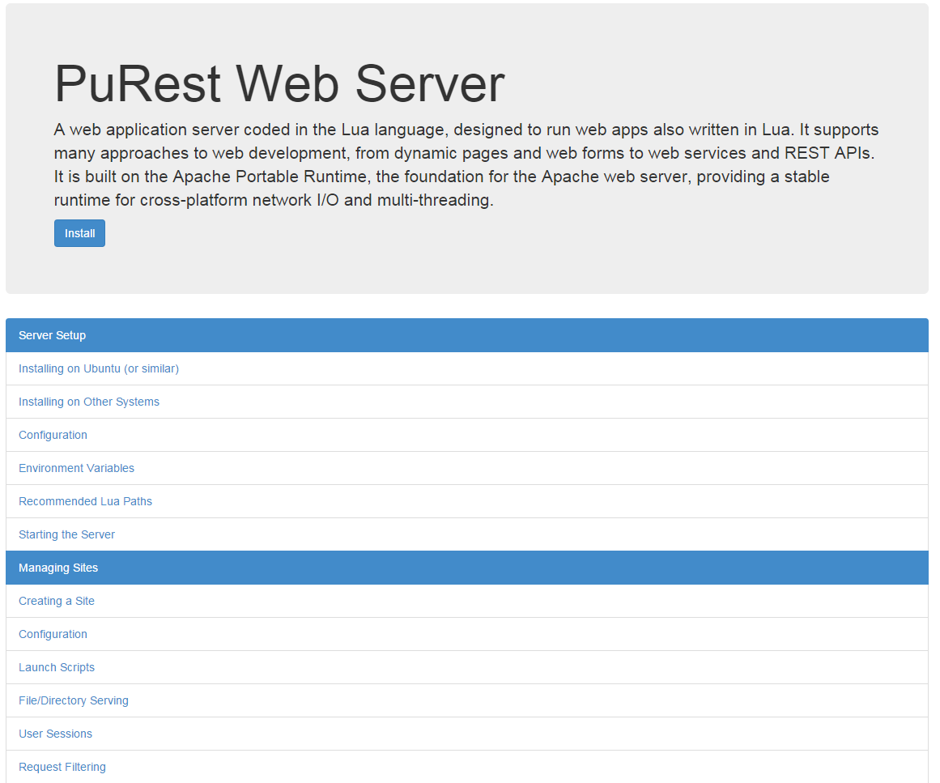

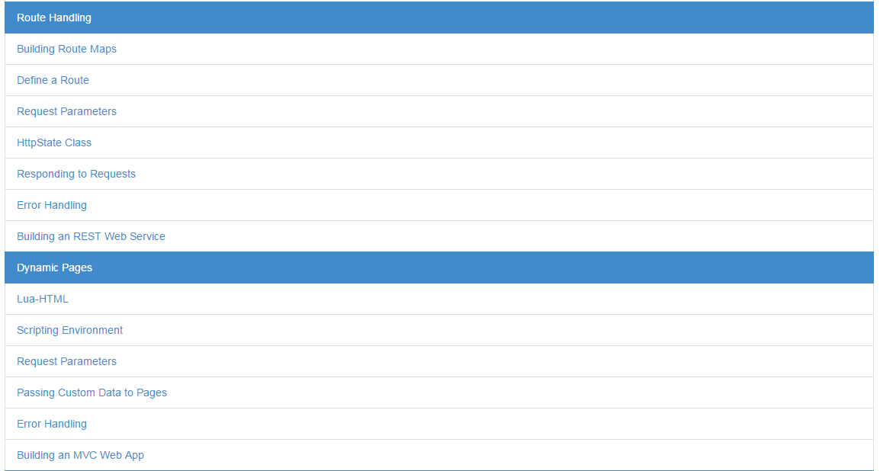

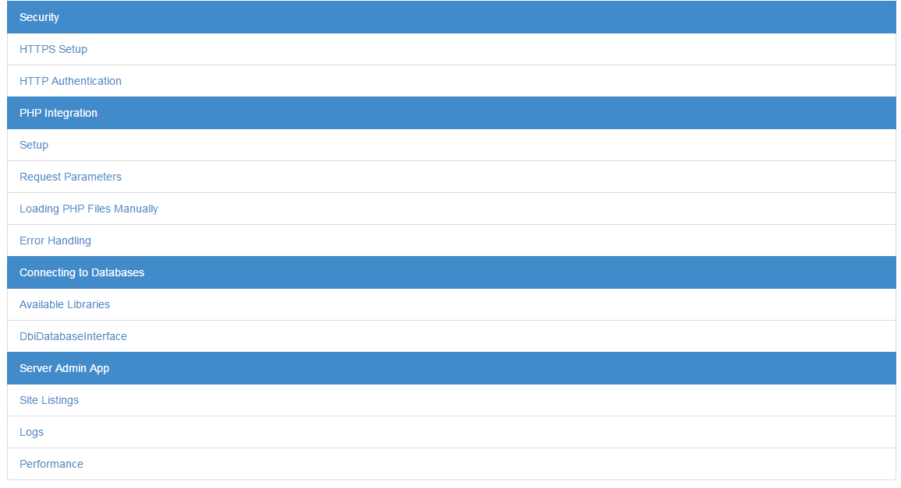

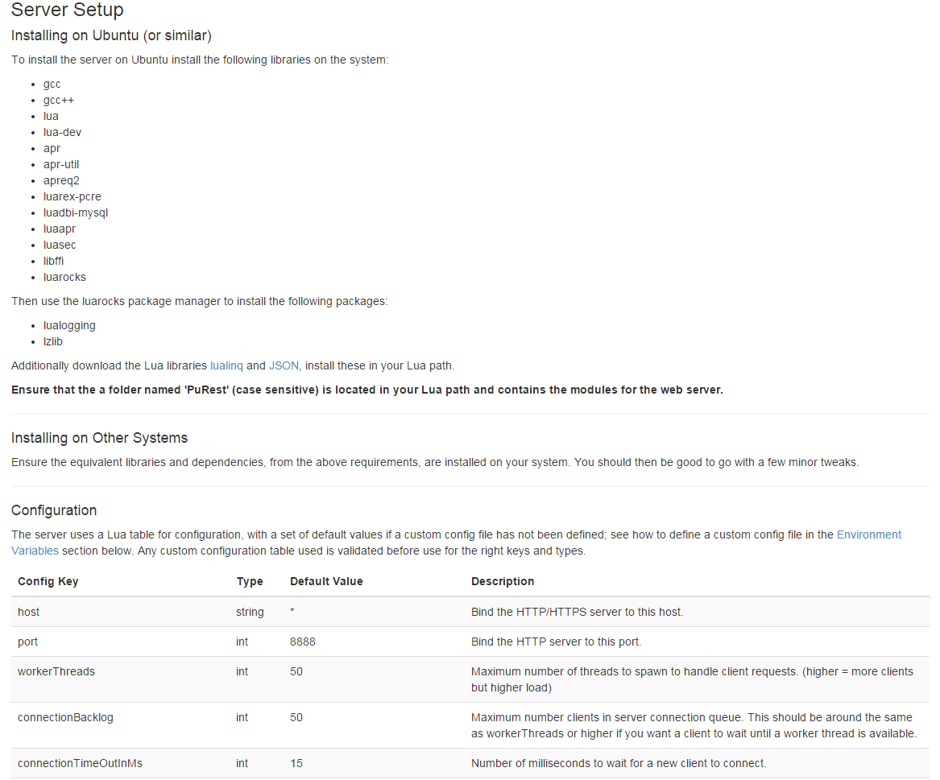

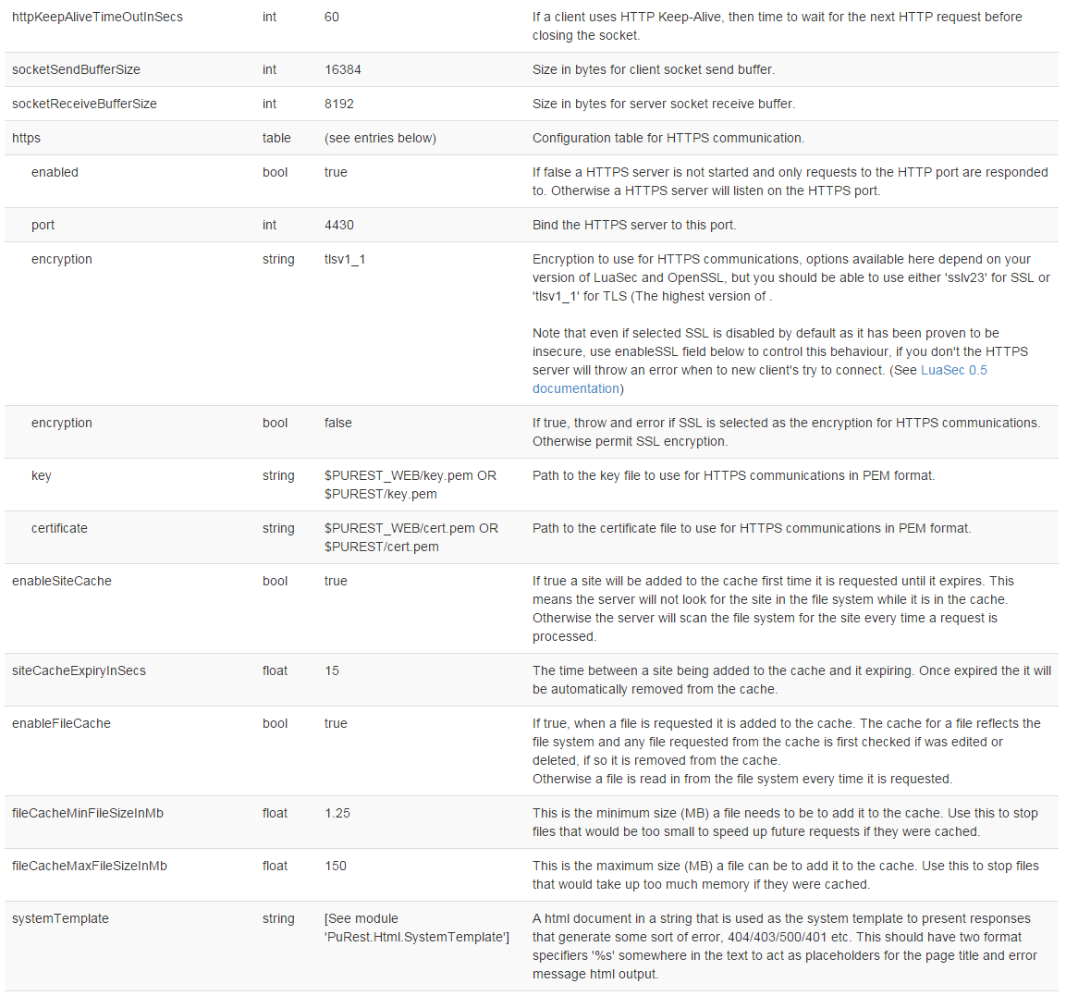

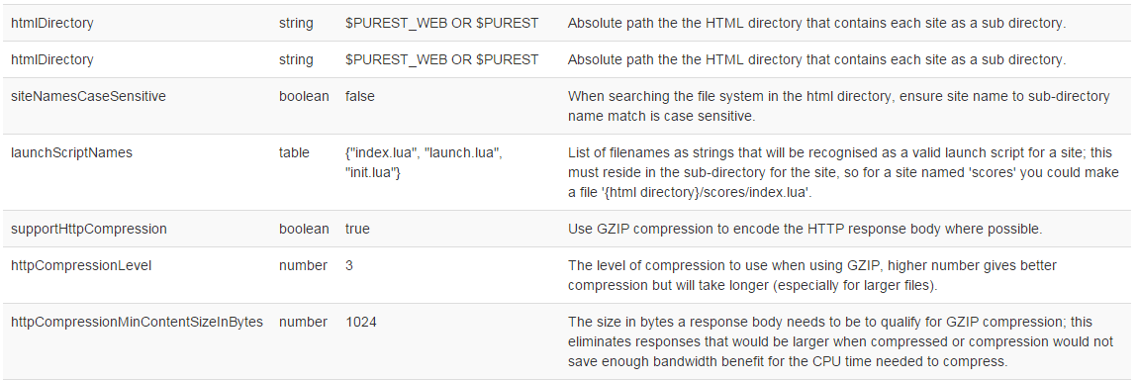

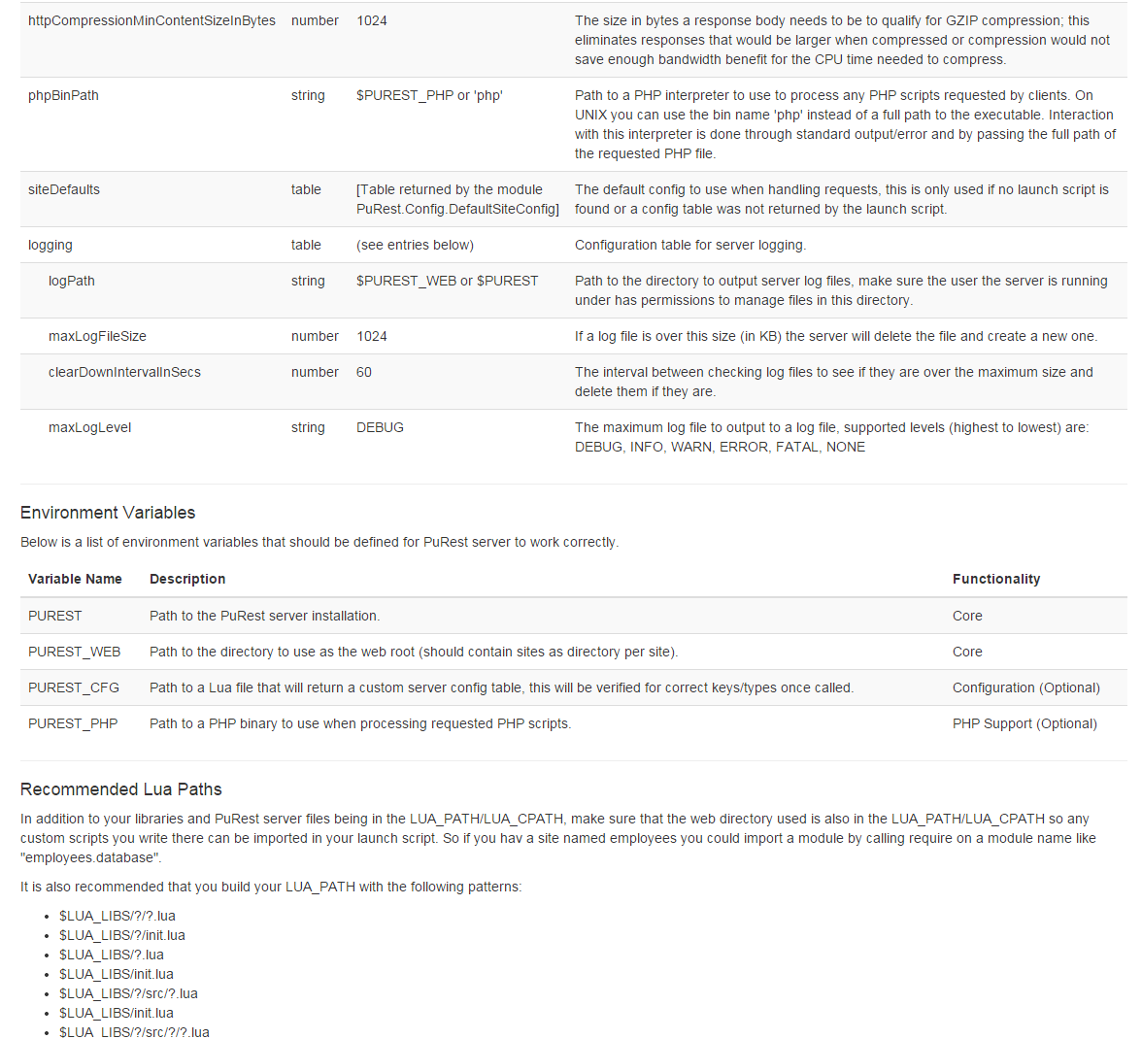

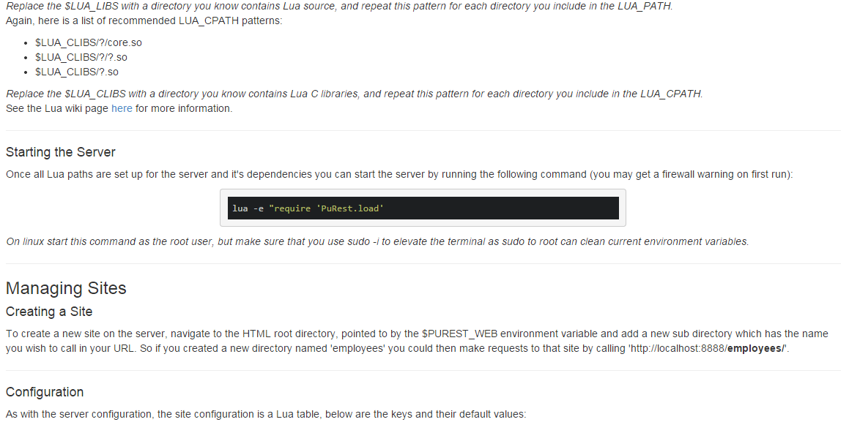

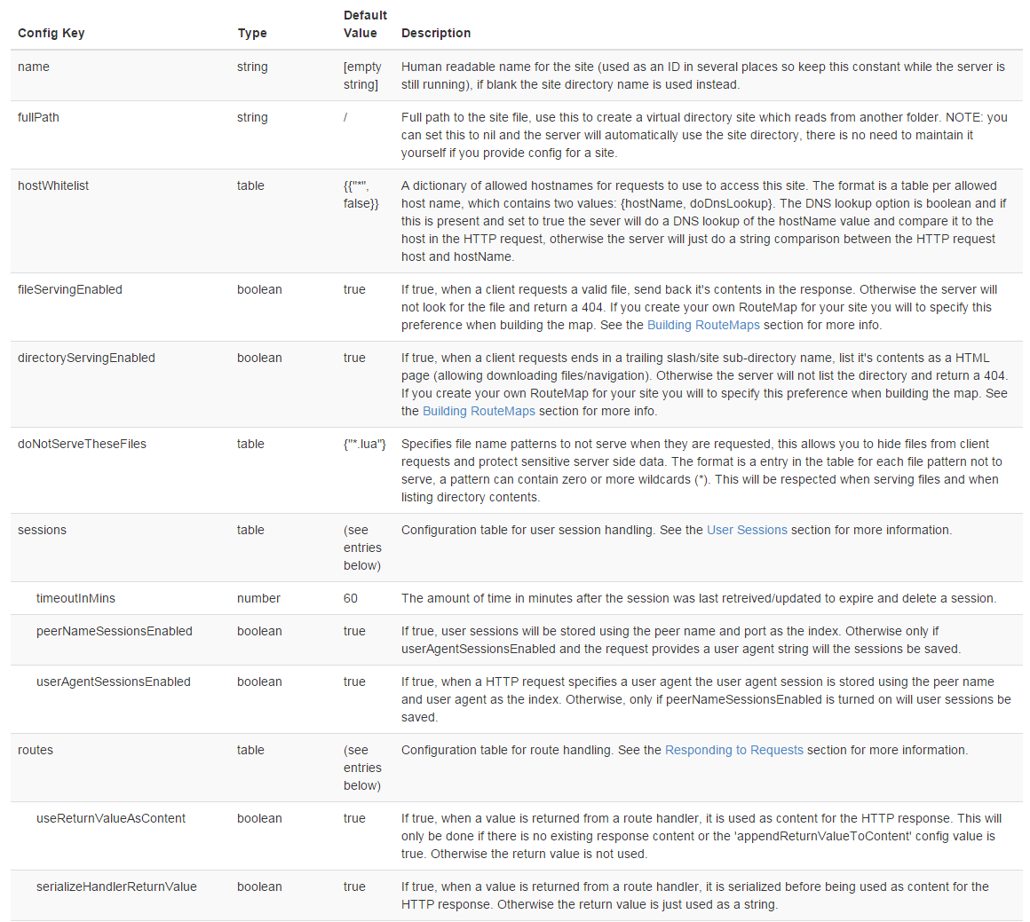

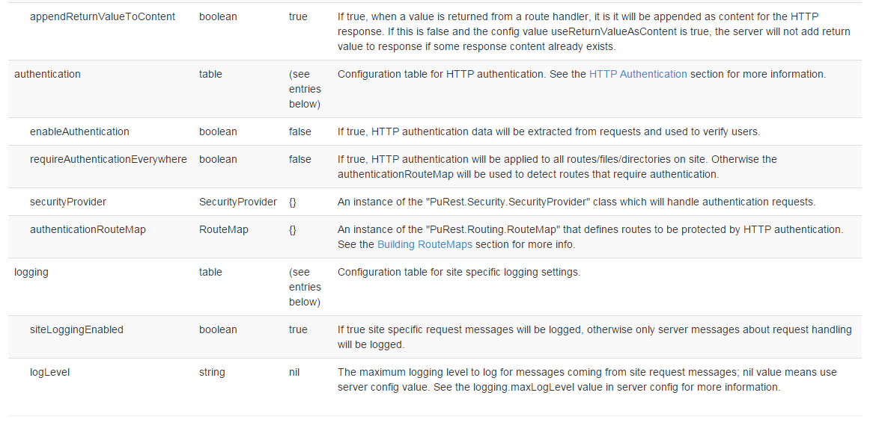

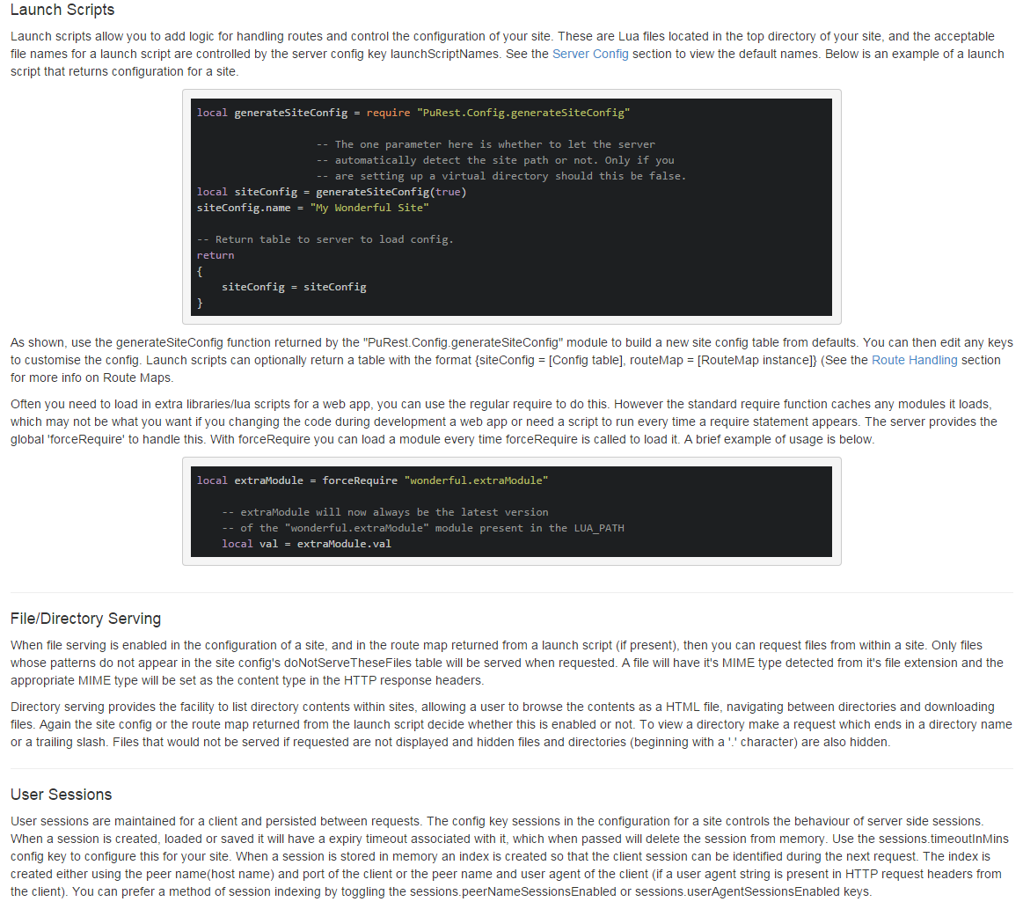

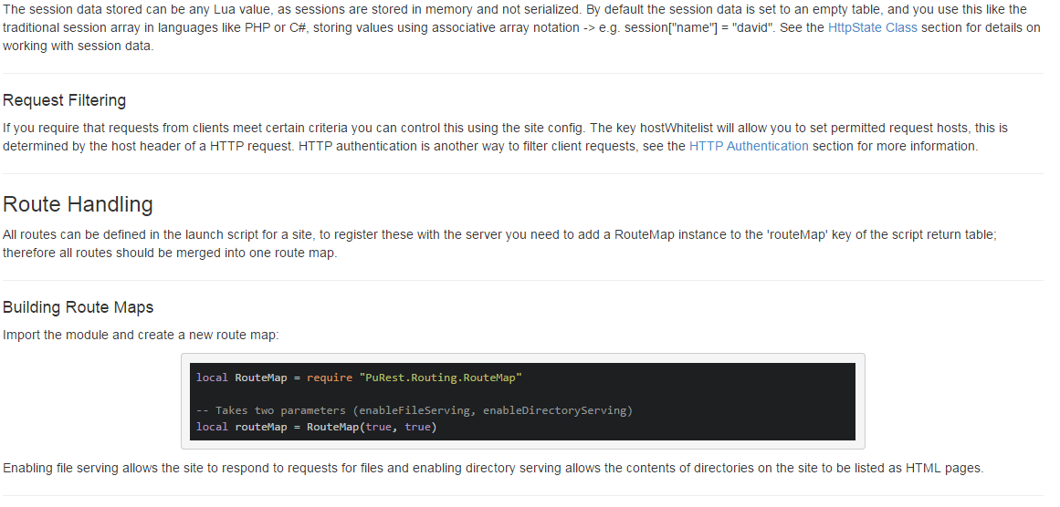

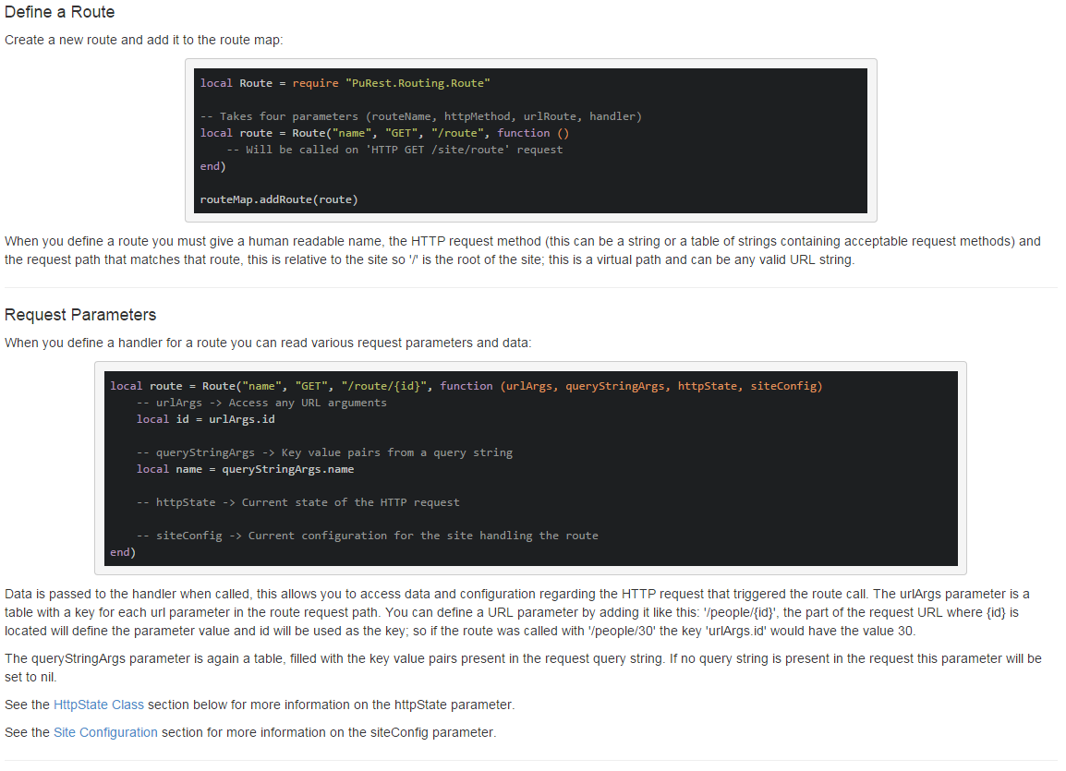

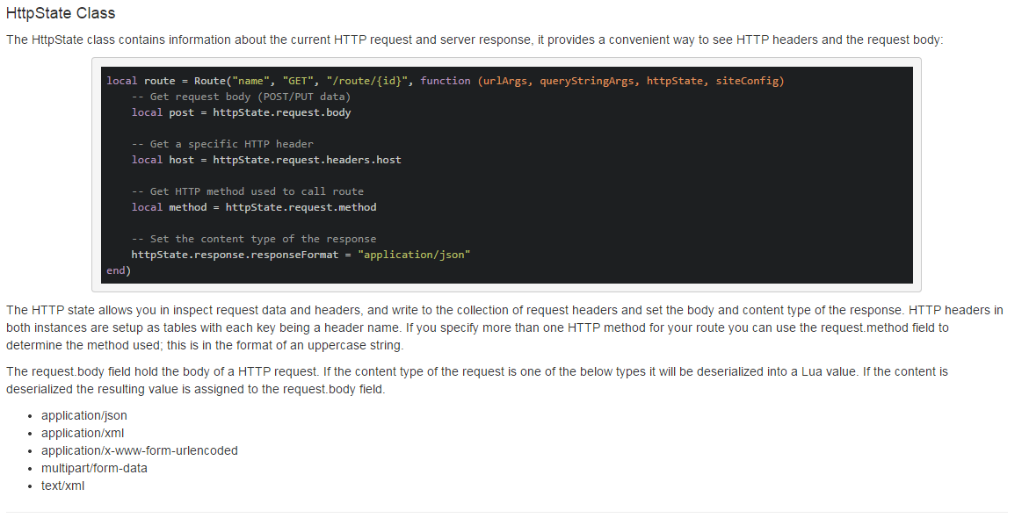

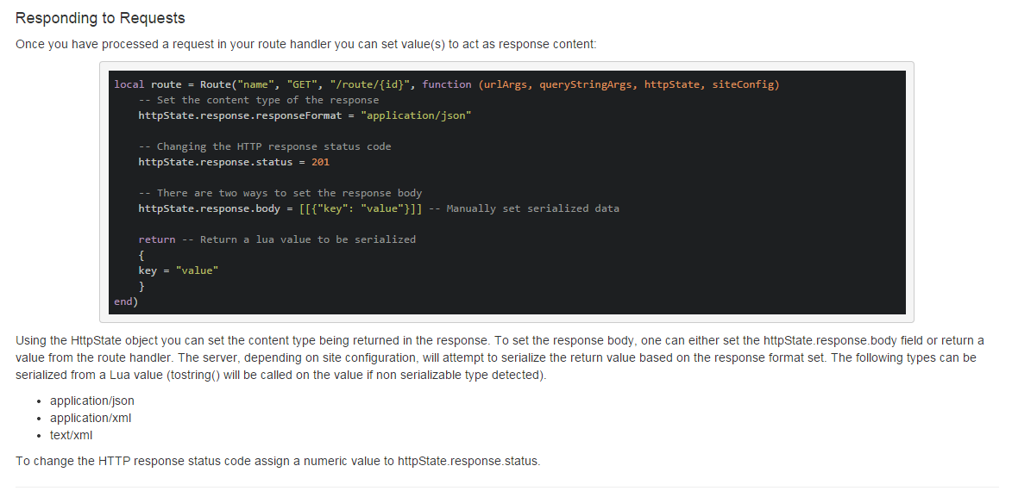

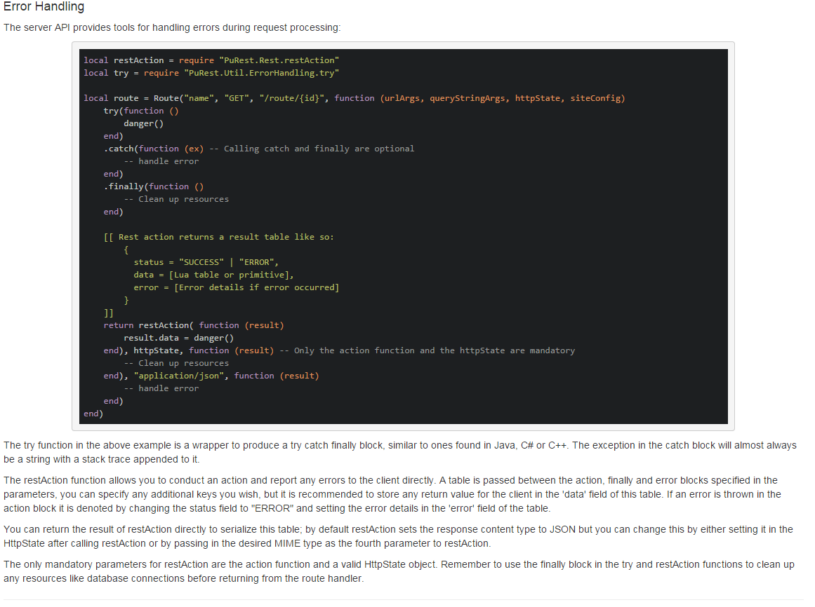

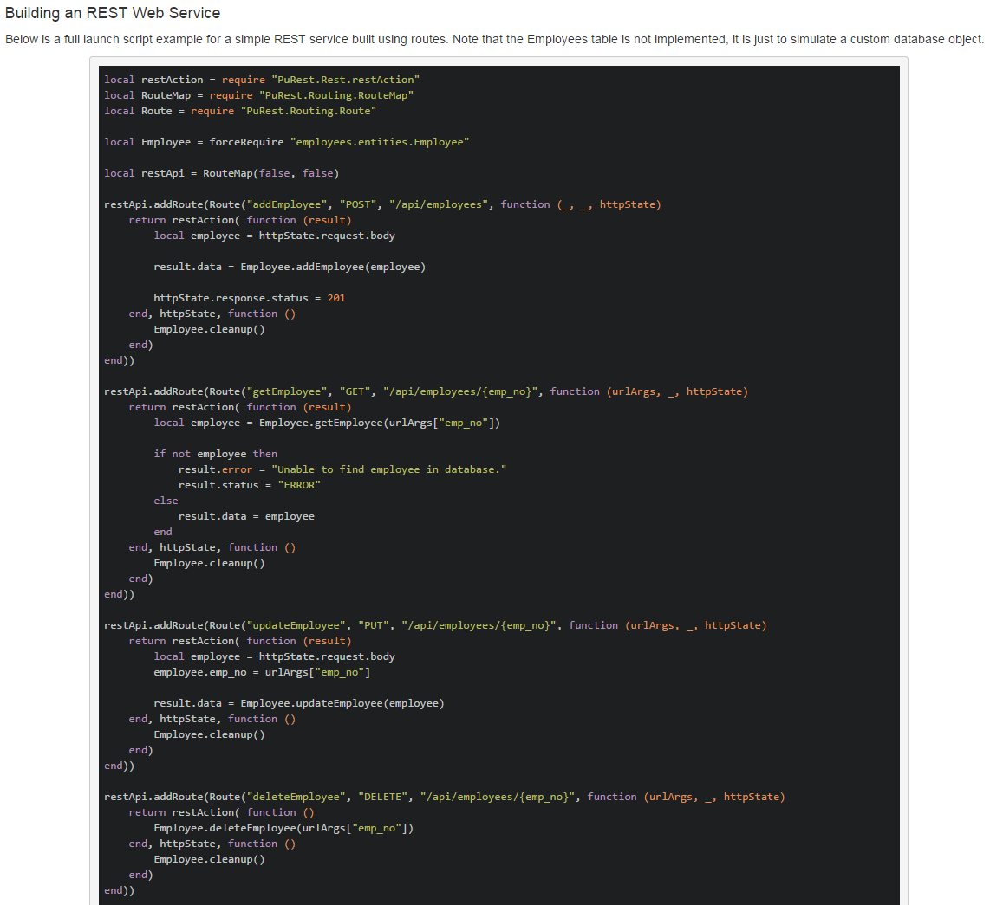

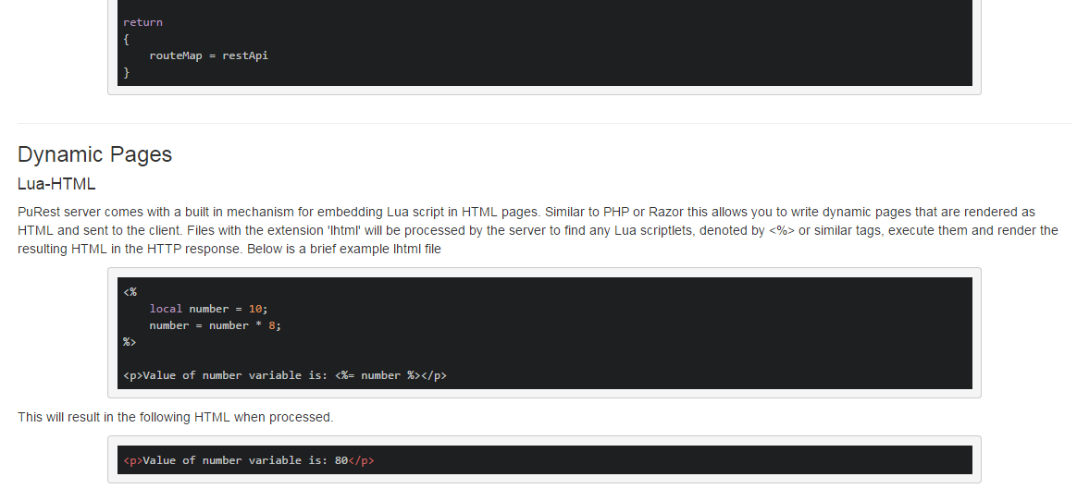

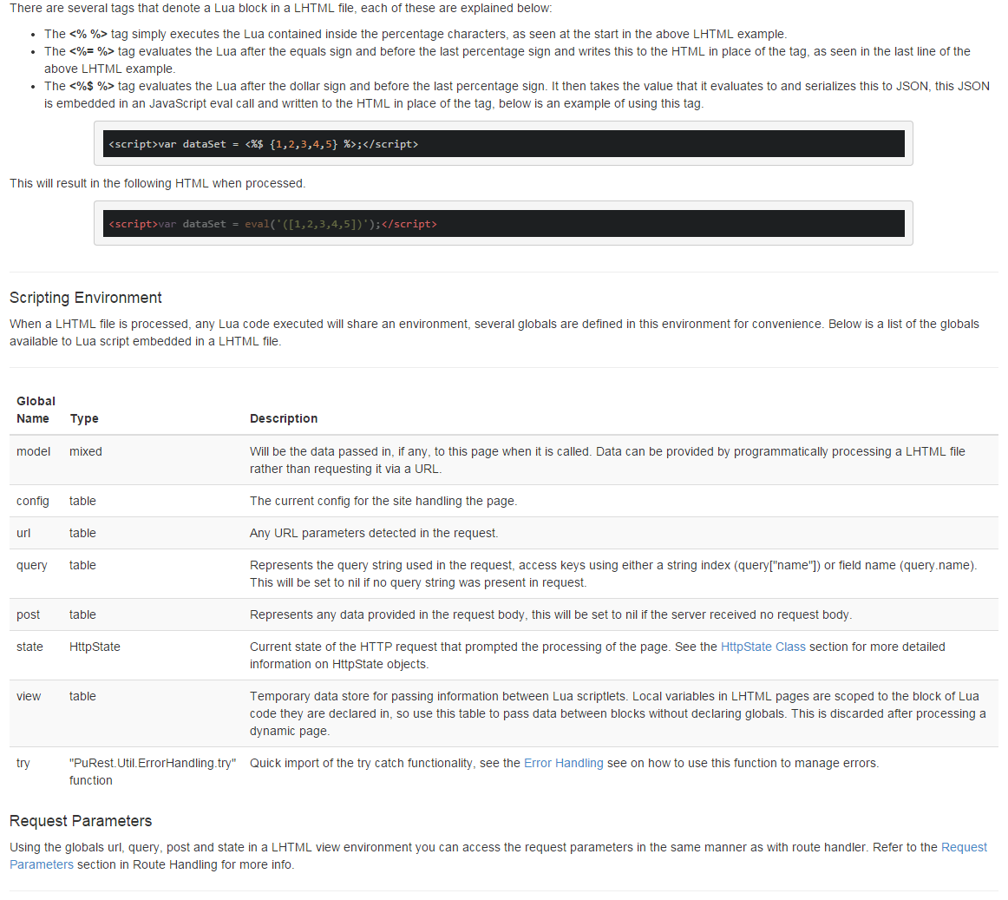

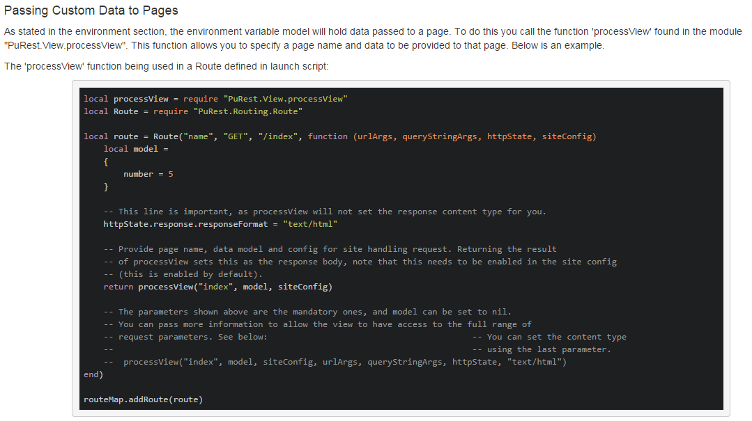

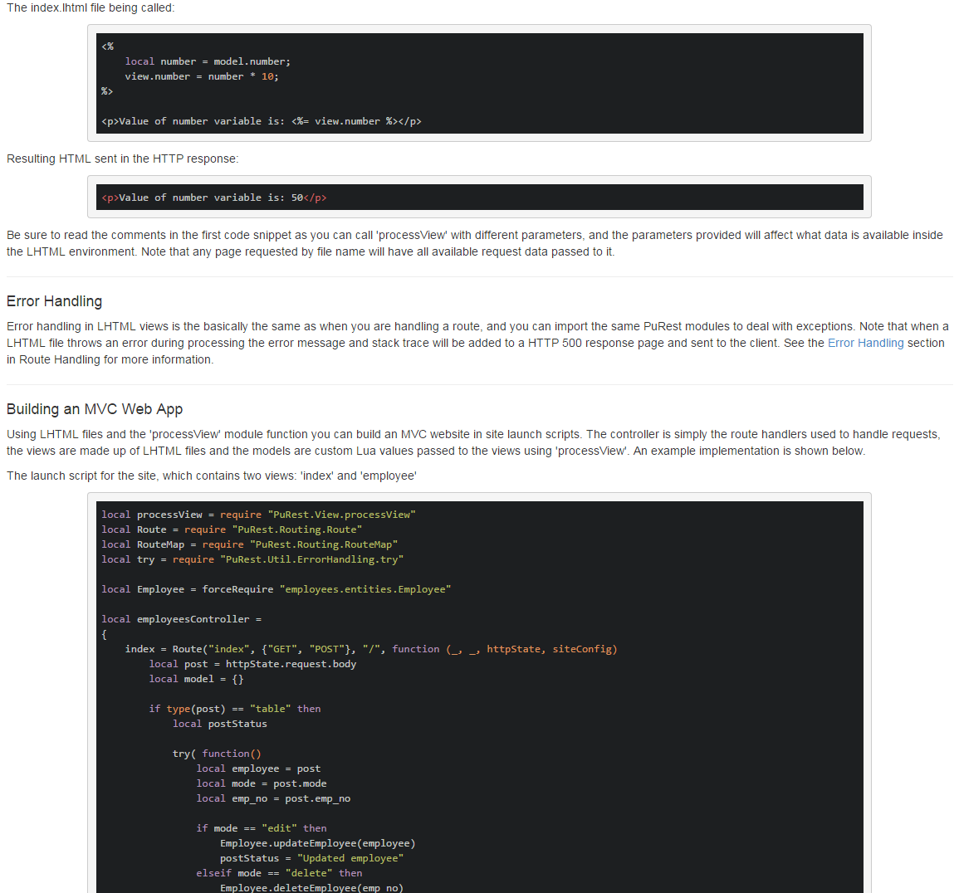

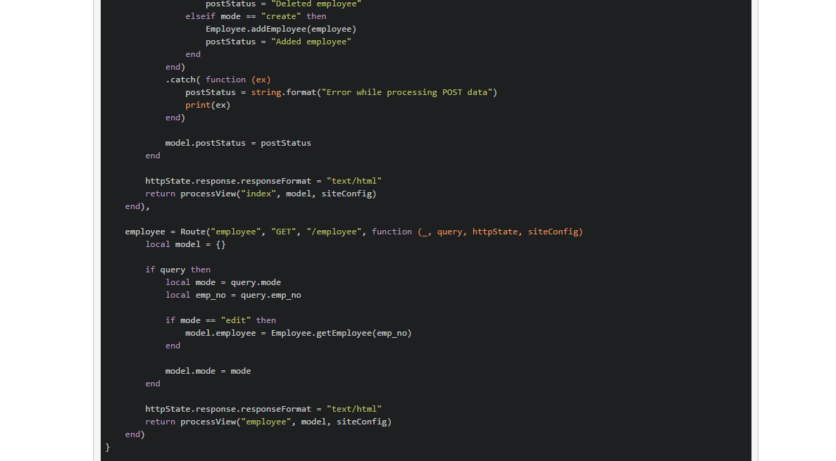

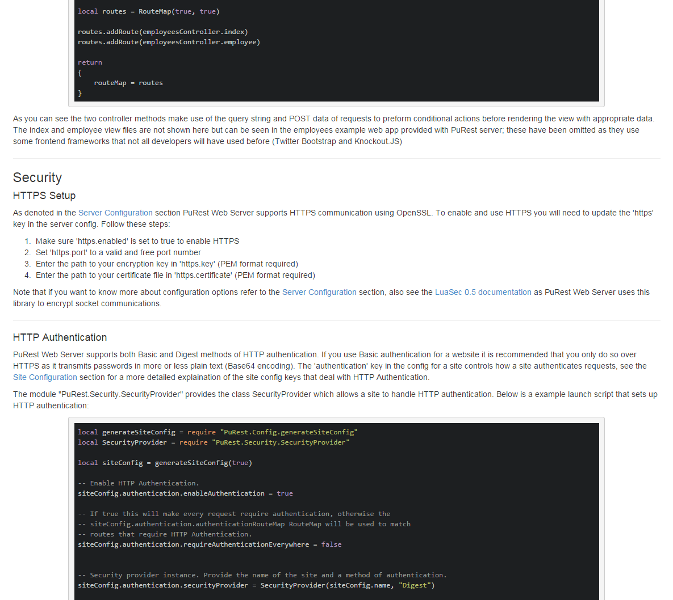

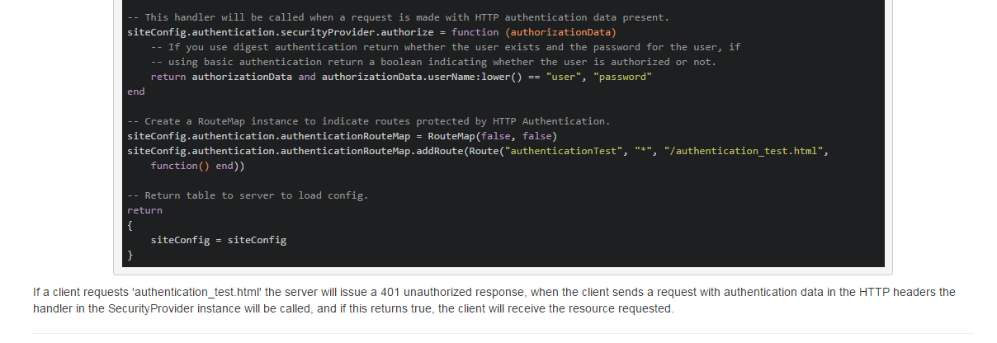



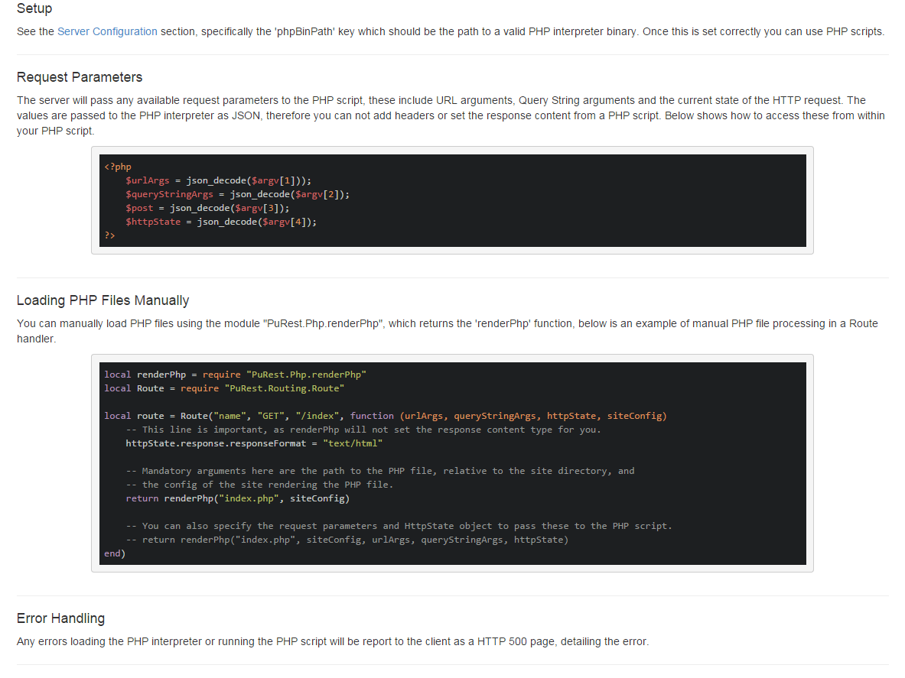

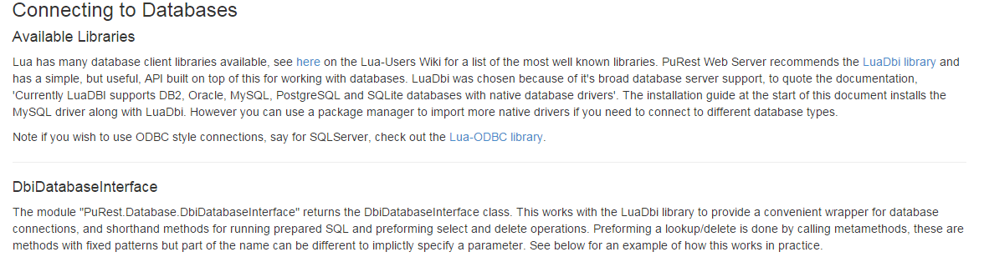

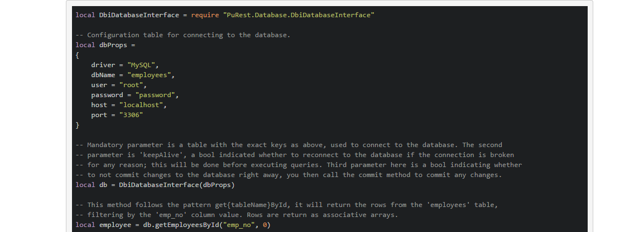

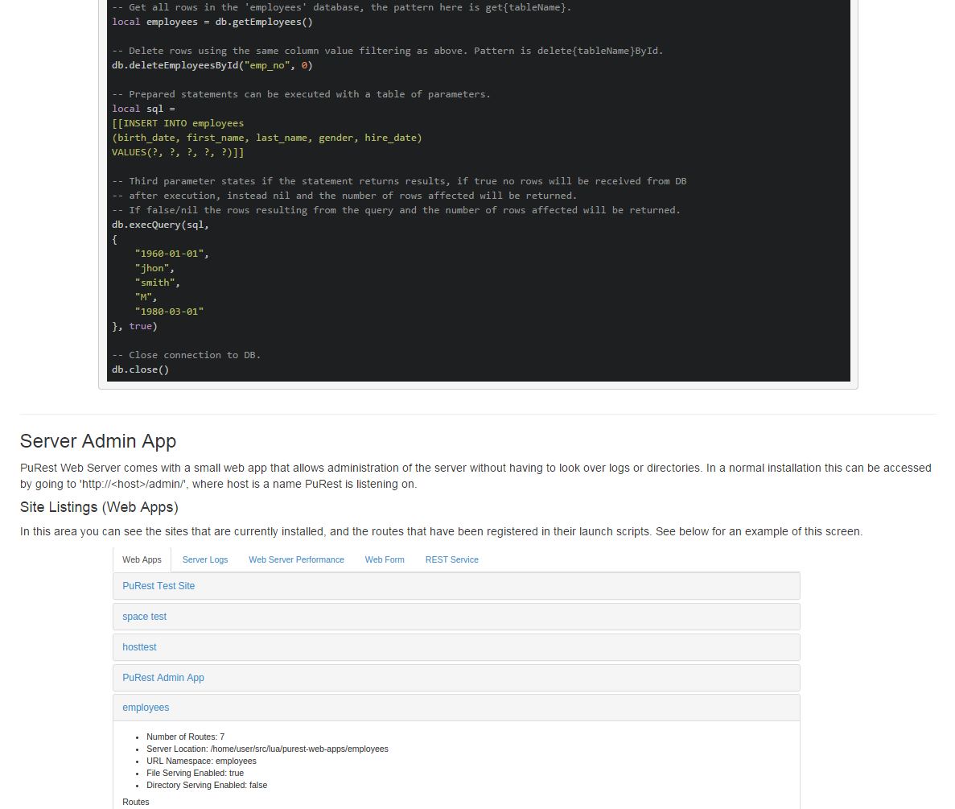

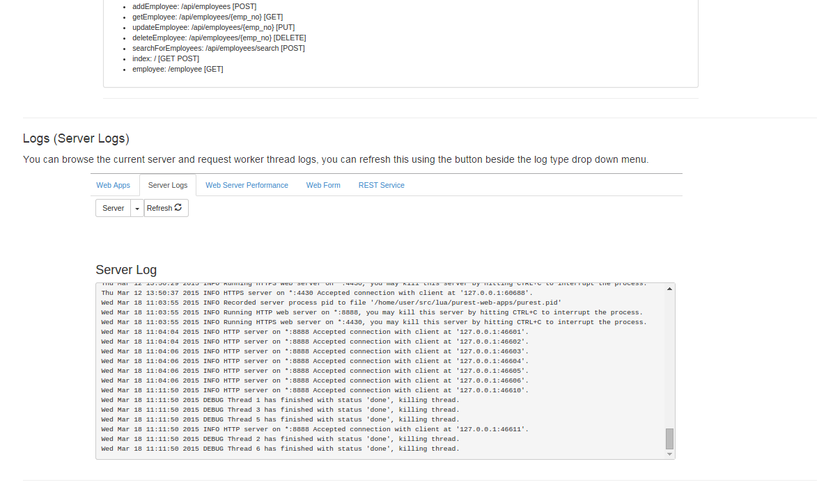

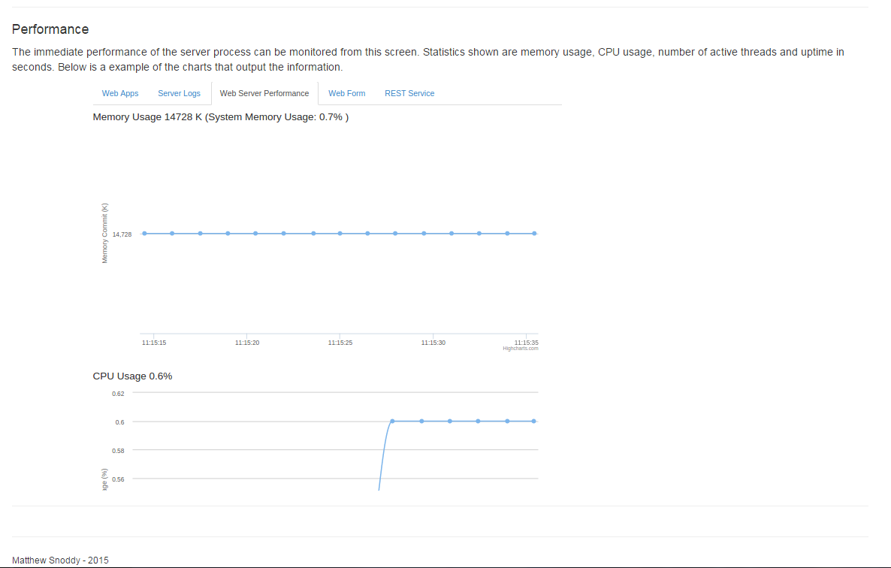

Appendix D: Epics & User Stories

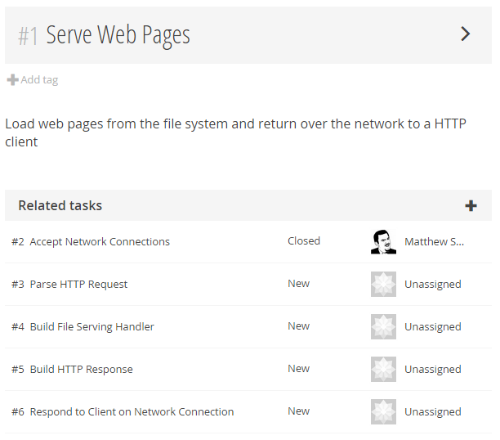

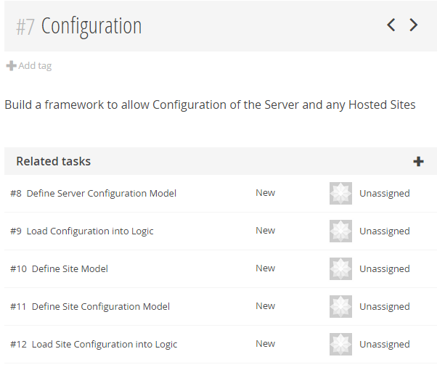

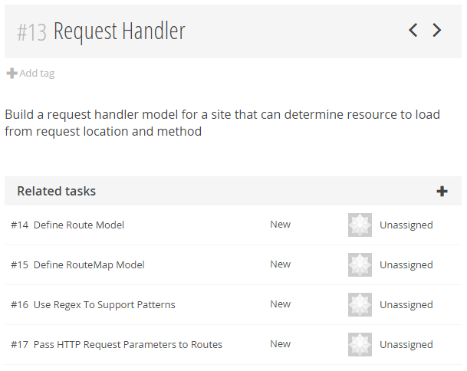

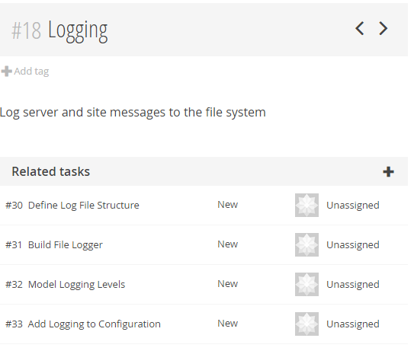

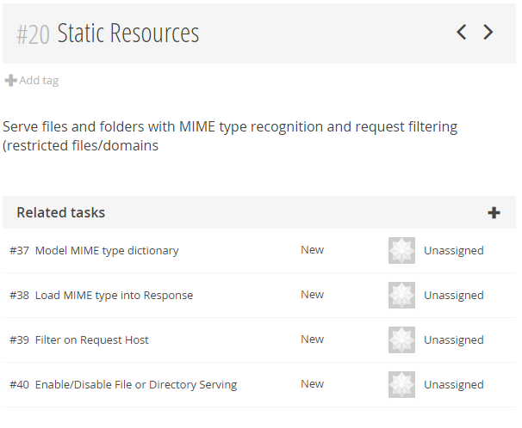

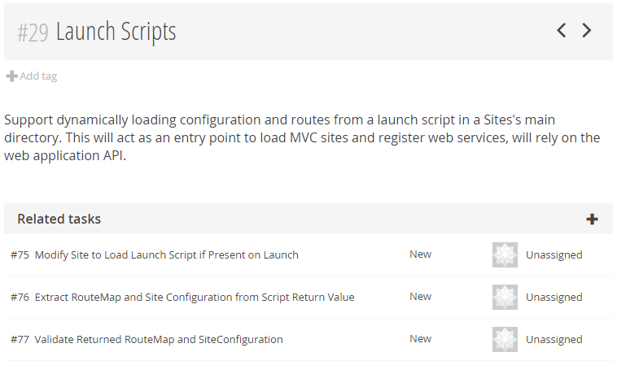

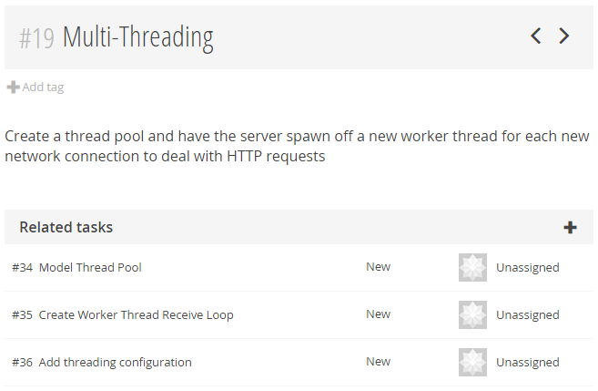

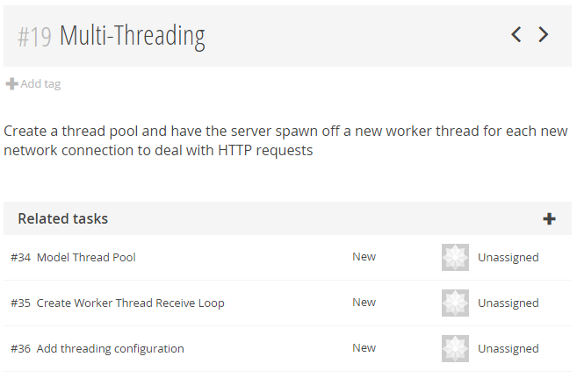

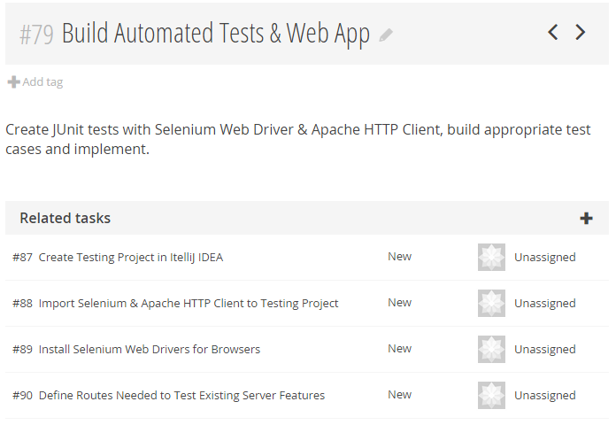

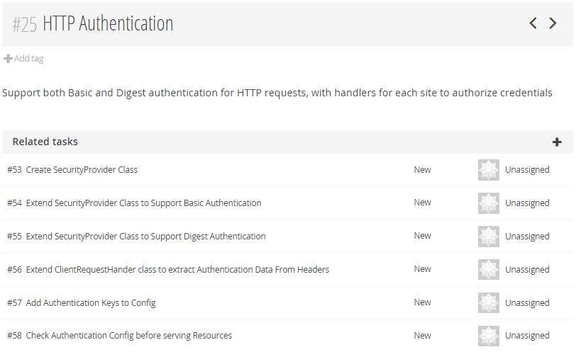

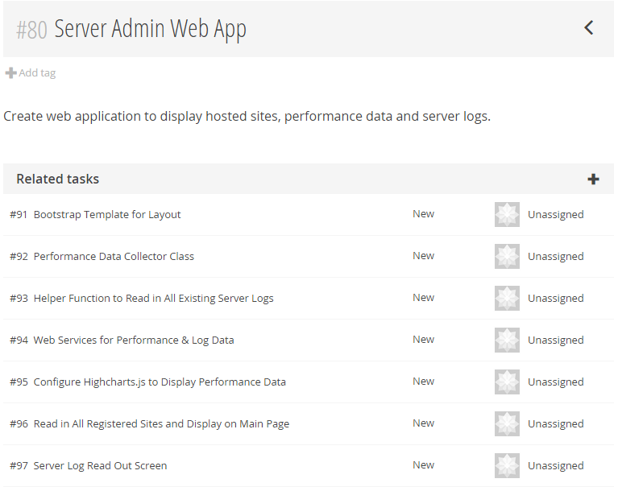

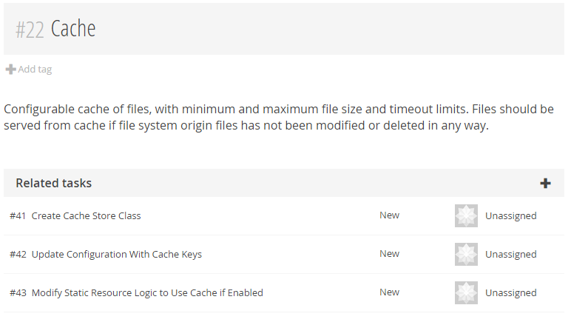

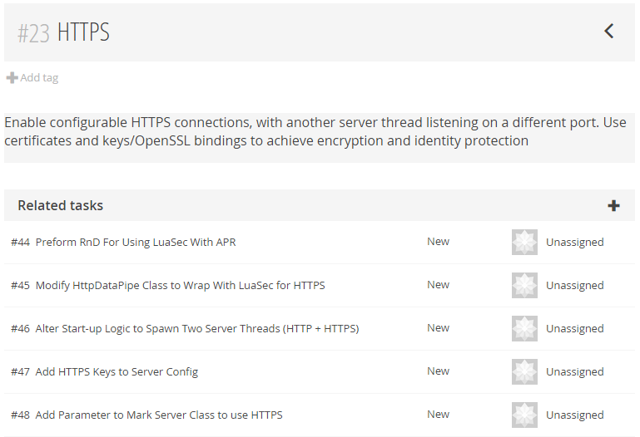

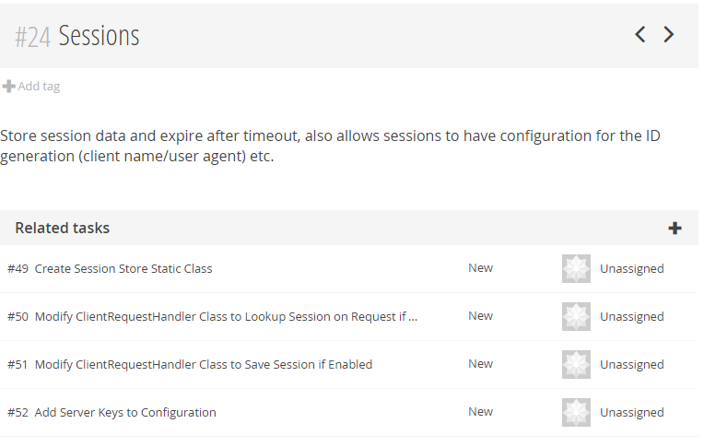

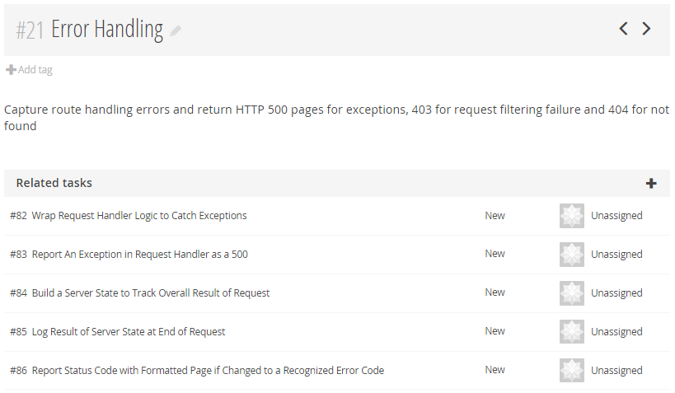

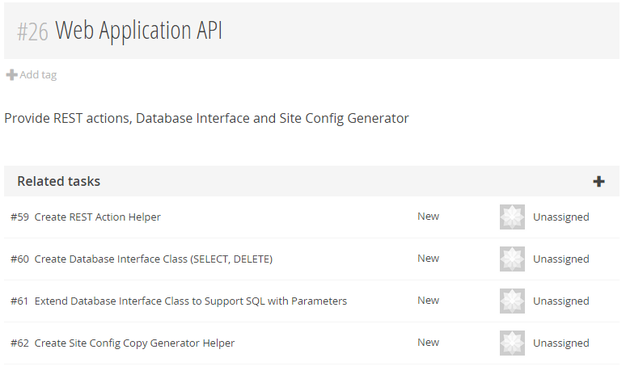

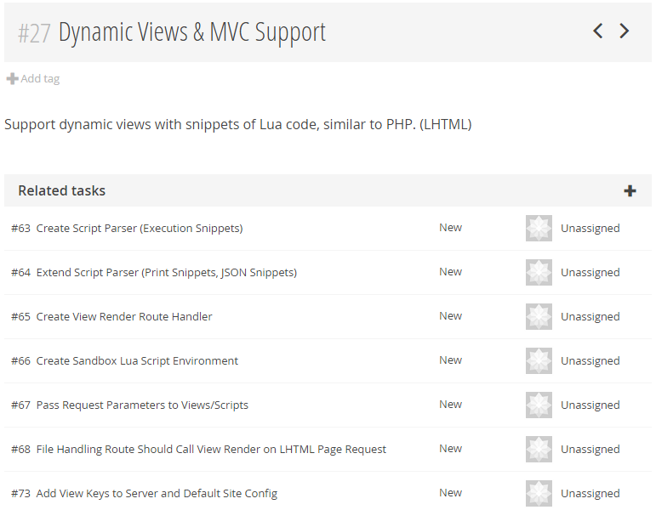

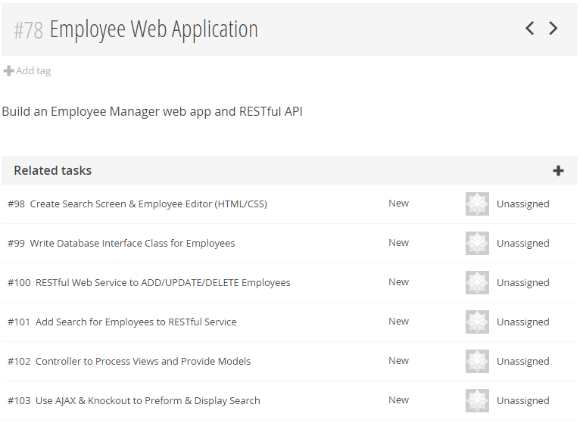

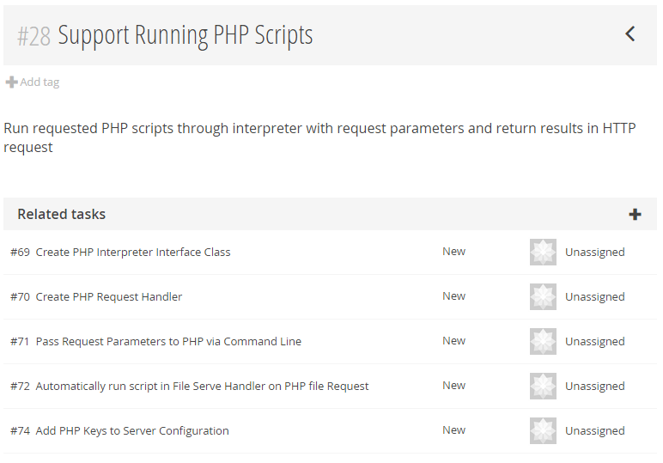

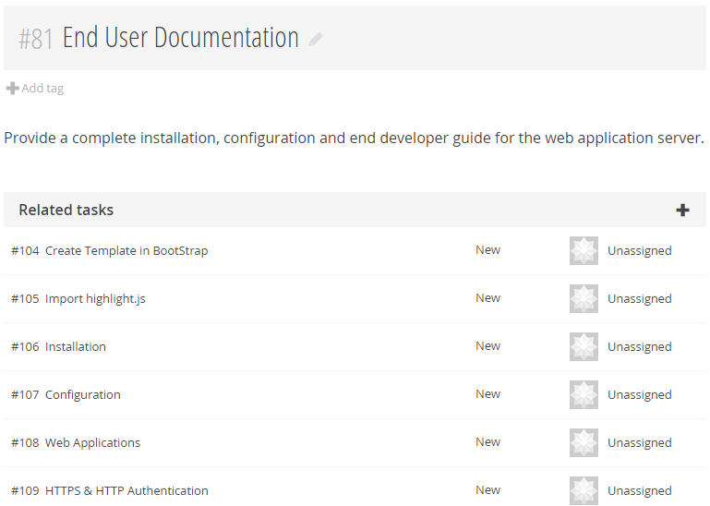

Appendix E: Source Repositories

This appendix list the commits in each source code repository used for the project. Note that the commits in each repository are listed in descending order, with the most recent commits first.

Purest Repository; the main server source code and configuration.

changeset: 271:e4787175b83b

branch: 0.6

tag: tip

user: snoddy-m

date: Mon Apr 06 16:40:20 2015 +0100

summary: Documentation: Fixed small style issue

changeset: 270:4a1deb032010

branch: 0.6

user: snoddy-m

date: Wed Mar 18 15:33:20 2015 +0000

summary: Fixed bug with custom headers not being added correctly

changeset: 269:aa129398e252

branch: 0.6

user: snoddy-m

date: Wed Mar 18 11:32:56 2015 +0000

summary: Added delete info to DbiDatabaseInterface docs

changeset: 268:668809f38e94

branch: 0.6

user: snoddy-m

date: Wed Mar 18 11:32:35 2015 +0000

summary: Documentation: Database section complete, Admin section almost finished

changeset: 267:c2f82641fa87

branch: 0.6

user: snoddy-m

date: Wed Mar 18 01:32:55 2015 +0000

summary: Documentation: PHP edit and started DB section

changeset: 266:b983b409bbd2

branch: 0.6

user: snoddy-m

date: Tue Mar 17 15:30:55 2015 +0000

summary: Documentation: completed PHP section

changeset: 265:e9ff2b152367

branch: 0.6

user: snoddy-m

date: Sun Mar 15 21:51:01 2015 +0000

summary: Documentation: Security section completed

changeset: 264:71eeda88953d

branch: 0.6

user: snoddy-m

date: Sun Mar 15 19:48:58 2015 +0000

summary: Documentation: finished LHTML section

changeset: 263:3ef1f4467de3

branch: 0.6

user: snoddy-m

date: Sun Mar 15 18:28:49 2015 +0000

summary: processView: removing uneccessary local variables

changeset: 262:3baa477c7c4f

branch: 0.6

user: snoddy-m

date: Sun Mar 15 18:28:22 2015 +0000

summary: Documentation: Scripting Environment and Passing data to pages

changeset: 261:4ad507d79a83

branch: 0.6

user: snoddy-m

date: Sat Mar 14 13:46:41 2015 +0000

summary: Documentation: Starting Dynamic Pages

changeset: 260:bed57e98bd12

branch: 0.6

user: snoddy-m

date: Fri Mar 13 15:38:10 2015 +0000

summary: Documentation: file/directory serving, request filtering and user sessions

changeset: 259:5a38b0b95960

branch: 0.6

user: snoddy-m

date: Thu Mar 12 14:29:07 2015 +0000

summary: Documentation: Completing site section, config complete

changeset: 258:08b9b201a0f6

branch: 0.6

user: snoddy-m

date: Thu Mar 12 11:31:20 2015 +0000

summary: Documenatation: Environment Variables and Lua Paths

changeset: 257:25ff3714b696

branch: 0.6

user: snoddy-m

date: Wed Mar 11 17:09:51 2015 +0000

summary: Documentation: route handling section complete

changeset: 256:3873906918cd

branch: 0.6

user: snoddy-m

date: Wed Mar 11 12:55:46 2015 +0000

summary: Documentation: error handling for route handlers

changeset: 255:368ffcd79360

branch: 0.6

user: snoddy-m

date: Wed Mar 11 11:31:53 2015 +0000

summary: Added HttpState and Responding to Requests

changeset: 254:17df42810b42

branch: 0.6

user: snoddy-m

date: Wed Mar 11 00:20:49 2015 +0000

summary: Cleanup of documentation header text

changeset: 253:14c85586d107

branch: 0.6

user: snoddy-m

date: Tue Mar 10 23:58:25 2015 +0000

summary: Working through route handling documentation

changeset: 252:6792aaaec073

branch: 0.6

user: snoddy-m

date: Tue Mar 10 18:08:31 2015 +0000

summary: Server config documentation complete

changeset: 251:249624b61282

branch: 0.6

user: snoddy-m

date: Tue Mar 10 15:47:48 2015 +0000

summary: Documentation rewording

changeset: 250:36bdb943712a

branch: 0.6

user: snoddy-m

date: Fri Mar 06 00:45:21 2015 +0000

summary: Working through documenting server config

changeset: 249:e79dccd22e7b

branch: 0.6

user: snoddy-m

date: Thu Mar 05 15:31:07 2015 +0000

summary: Added a generate function for user doc to create template from headings and

changeset: 248:42286dbd1b3b

branch: 0.6

user: snoddy-m

date: Thu Mar 05 02:35:39 2015 +0000

summary: Started work on end user documentation, first draft of index of topics complete

changeset: 247:ce589ea8ec19

branch: 0.6

user: snoddy-m

date: Tue Mar 03 13:43:37 2015 +0000

summary: Added remainder of comments to code

changeset: 246:1627f486af86

branch: 0.6

user: snoddy-m

date: Tue Mar 03 01:30:59 2015 +0000

summary: More comment refactoring up to getSession.lua

changeset: 245:6426175f6cb3

branch: 0.6

user: snoddy-m

date: Mon Mar 02 16:38:29 2015 +0000

summary: More error checking for Process class

changeset: 244:ed9f7e8e3eb4

branch: 0.6

user: snoddy-m

date: Mon Mar 02 16:38:10 2015 +0000

summary: Issues with 404 for directory browsing being reported as 500

changeset: 243:7819262b5f45

branch: 0.6

user: snoddy-m

date: Mon Mar 02 16:37:46 2015 +0000

summary: More comments

changeset: 242:29f884a34f33

branch: 0.6

user: snoddy-m

date: Mon Mar 02 11:54:50 2015 +0000

summary: Cleaning up more comments

changeset: 241:40b743f79206

branch: 0.6

user: snoddy-m

date: Mon Mar 02 11:41:49 2015 +0000

summary: Document generation bash script to use LuaDoc to build release documentation

changeset: 240:98c0a234f787

branch: 0.6

user: snoddy-m

date: Mon Mar 02 11:40:56 2015 +0000

summary: Refactored @returns to @return in comments (syntax error), added additional

changeset: 239:1a8d4e3d64ad

branch: 0.6

user: snoddy-m

date: Mon Mar 02 02:57:41 2015 +0000

summary: DbiDatabaseInterface now returns nil for execQuery if no rows were returned and

changeset: 238:60f216f6062a

branch: 0.6

user: snoddy-m

date: Mon Mar 02 02:36:04 2015 +0000

summary: Added a Server header to HTTP response, also any headers injected into response

changeset: 237:bb097b10d4f1

branch: 0.6

user: snoddy-m

date: Mon Mar 02 02:11:01 2015 +0000

summary: Cleaning up some comments

changeset: 236:fba336d3c6c1

branch: 0.6

user: snoddy-m

date: Mon Mar 02 02:10:42 2015 +0000

summary: Added version number as static field PUREST_VERSION of the Server class

changeset: 235:026aa06a4ffc

branch: 0.6

user: snoddy-m

date: Sun Mar 01 01:36:10 2015 +0000

summary: Try is now available to views as a global

changeset: 234:725d7da71b64

branch: 0.6

user: snoddy-m

date: Sun Mar 01 01:35:46 2015 +0000

summary: Fixed bug in delete procedure for DbiDatabaseInterface

changeset: 233:a61d62fb18c2

branch: 0.6

user: snoddy-m

date: Sun Mar 01 01:35:24 2015 +0000

summary: Query string returned from route pattern match will now be null if no query

changeset: 232:f688ab22f905

branch: 0.6

user: snoddy-m

date: Fri Feb 27 14:28:39 2015 +0000

summary: Fixed bug with case sensitive names on UNIX

changeset: 231:0bddf9bead0c

branch: 0.6

user: snoddy-m

date: Sun Mar 01 00:15:39 2015 +0000

summary: Added 'view' global to the view environment, can be used as a bin for passing

changeset: 230:5ade7896367f

branch: 0.6

user: snoddy-m

date: Fri Feb 27 02:19:05 2015 +0000

summary: Extending DbiInterface functionality

changeset: 229:9465bf2f955b

branch: 0.6

user: snoddy-m

date: Thu Feb 26 23:30:41 2015 +0000

summary: Bug #: Rolling log file max size not working correcctly

changeset: 228:42e62807eec0

branch: 0.6

user: snoddy-m

date: Thu Feb 26 16:46:24 2015 +0000

summary: Story #99: Enabled reloading of custom libraries in launch scripts

changeset: 227:d0cdb9d791a9

branch: 0.6

user: snoddy-m

date: Thu Feb 26 13:22:31 2015 +0000

summary: Story #88: Refactored site cache

changeset: 226:a1c431f40059

branch: 0.6

user: snoddy-m

date: Thu Feb 26 01:00:49 2015 +0000

summary: Bug #82, vague stacktraces, using xpcall to get full stack trace for any action

changeset: 225:fc67f0c20f20

branch: 0.6

user: snoddy-m

date: Wed Feb 25 23:32:23 2015 +0000

summary: Start of work for bug #82, vague stacktraces

changeset: 224:67881e4006d7

branch: 0.6

user: snoddy-m

date: Tue Feb 24 16:53:43 2015 +0000

summary: Default site gets name dynamically and any site which does not set it's name

changeset: 223:2a739c24a3dc

branch: 0.6

user: snoddy-m

date: Tue Feb 24 16:31:31 2015 +0000

summary: Fixed bug with connection header not being specified causing request to fail

changeset: 222:299baae99002

branch: 0.6

user: snoddy-m

date: Tue Feb 24 16:30:41 2015 +0000

summary: Adding try block to server client connect routine, now reports errors if they

changeset: 221:a59c2ac38df8

branch: 0.6

user: snoddy-m

date: Tue Feb 24 16:29:57 2015 +0000

summary: Changing default connection backlog.

changeset: 220:51829c74200a

branch: 0.6

user: snoddy-m

date: Mon Feb 23 23:04:23 2015 +0000

summary: Removing unecessary print statement

changeset: 219:d16d0410cdbd

branch: 0.6

user: snoddy-m

date: Mon Feb 23 23:04:11 2015 +0000

summary: Bringing back XML after successfully installing on Lubuntu environment

changeset: 218:60cf5855fdc2

branch: 0.6

user: snoddy-m

date: Mon Feb 23 19:27:53 2015 +0000

summary: Fix for URL escaping, to allow sites with illegal characters to be used as well

changeset: 217:c6555dfce598

branch: 0.6

user: snoddy-m

date: Mon Feb 23 19:19:15 2015 +0000

summary: Removed dependency on libapreq2 as the lubuntu build of lua-apr does not seem

changeset: 216:36b9b35711a2

branch: 0.6

user: snoddy-m

date: Mon Feb 23 12:07:32 2015 +0000

summary: Changed uptime reporting to always be in seconds instead of a string

changeset: 215:f666c38dca05

branch: 0.6

user: snoddy-m

date: Mon Feb 23 11:34:06 2015 +0000

summary: Fixed some bugs with new UNIX process manager calls

changeset: 214:4794f694ea48

branch: 0.6

user: matthew <m.snoddy@kainos.com>

date: Mon Feb 23 11:27:06 2015 +0000

summary: Refactoring UNIX ProcessMonitor calls to return memoryUsage percent and uptime,

changeset: 213:2b91e80079b8

branch: 0.6

user: snoddy-m

date: Mon Feb 23 02:43:08 2015 +0000

summary: Added cpu usage monitoring for process monitor under the unix platform

changeset: 212:c861498e7748

branch: 0.6

user: snoddy-m

date: Mon Feb 23 00:18:34 2015 +0000

summary: Fixed bug #95,Script Not Updating. Issue with client request handler caching on

changeset: 211:25fca30f94af

branch: 0.6

user: snoddy-m

date: Sun Feb 22 14:03:54 2015 +0000

summary: Added some additional debugging for site launch script loading and return values

changeset: 210:de78f6d6cdfc

branch: 0.6

user: snoddy-m

date: Sun Feb 22 03:32:21 2015 +0000

summary: Refactored how server pid is recorded to file, only does this once in bootloader

changeset: 209:338da72da40d

branch: 0.6

user: snoddy-m

date: Sun Feb 22 03:09:59 2015 +0000

summary: Incorrect data type in validate parameters for LuaSecToAprSocketWrapper

changeset: 208:c9881655c466

branch: 0.6

user: snoddy-m

date: Sun Feb 22 03:09:43 2015 +0000

summary: Error with calling buildExecuteProxy in DbiDatabaseInterface class, was calling

changeset: 207:d90f5c5ef199

branch: 0.6

user: snoddy-m

date: Sun Feb 22 03:08:44 2015 +0000

summary: Fixed bug with start server erroring with stack overflow, was really a missing

changeset: 206:1be17fde694a

branch: 0.6

user: snoddy-m

date: Sat Feb 21 22:35:57 2015 +0000

summary: Added GZIP support and fixed issues with zlib imports on unix, also added cfg

changeset: 205:8c5686c1303e

branch: 0.6

user: snoddy-m

date: Sat Feb 21 21:14:44 2015 +0000

summary: Added environment set script for /etc/profile.d/lua.sh in unix

changeset: 204:2d08f64f4258

branch: 0.6

user: snoddy-m

date: Fri Feb 20 13:39:05 2015 +0000

summary: Refactoring work to add validation to non optional parameters and add comments

changeset: 203:3646c3b77c9c

branch: 0.6

user: snoddy-m

date: Fri Feb 20 10:52:20 2015 +0000

summary: Refactored and commented the DbiDatabaseInterface class, added option to turn

changeset: 202:24cdce60ac5a

branch: 0.6

user: snoddy-m

date: Fri Feb 20 01:45:56 2015 +0000

summary: Added option to processView to allow setting the contentType for the response

changeset: 201:618ee3257491

branch: 0.6

user: snoddy-m

date: Fri Feb 20 01:45:14 2015 +0000

summary: Added execQuery method to DbiDatabaseInterface class to run SQL with a table of

changeset: 200:6cb4f5f01c53

branch: 0.6

user: snoddy-m

date: Thu Feb 19 17:49:21 2015 +0000

summary: Cleaned up and commented the ProcessMonitor class.

changeset: 199:fd72b9b26251

branch: 0.6

user: snoddy-m

date: Thu Feb 19 15:04:21 2015 +0000

summary: Updating process monitor to pull statistics from UNIX proc file system

changeset: 198:b77484638940

branch: 0.6

user: snoddy-m

date: Thu Feb 19 13:00:54 2015 +0000

summary: Fixed bug with loading JSON library (needs a global called JSON for it to work

changeset: 197:e7f9d712bfde

branch: 0.6

user: snoddy-m

date: Thu Feb 19 13:00:02 2015 +0000

summary: Set up config to point to default PHP binary in path and fixed bugs with

changeset: 196:fd5d4e000003

branch: 0.6

user: snoddy-m

date: Thu Feb 19 01:19:37 2015 +0000

summary: Removed some redundant logic in Server class and refactor signal handlers,

changeset: 195:9dd9773381c9

branch: 0.6

user: snoddy-m

date: Thu Feb 19 01:18:56 2015 +0000

summary: Created simple bootloader to start a server in a new thread, using in load

changeset: 194:b351c9b6628a

branch: 0.6

user: snoddy-m

date: Wed Feb 18 22:14:18 2015 +0000

summary: Switching to tlsv1_1 as the default HTTPS protocol as new dev. env. is using

changeset: 193:7d1ff0c19582

branch: 0.6

user: snoddy-m

date: Wed Feb 18 22:01:40 2015 +0000

summary: Put note in bash server start script around recommending sudo

changeset: 192:b8ef69a855f7

branch: 0.6

user: snoddy-m

date: Wed Feb 18 21:25:50 2015 +0000

summary: Removed unsed local variables in bootloader and edited server start script to

changeset: 191:56c3c20fa1fd

branch: 0.6

user: snoddy-m

date: Wed Feb 18 18:04:59 2015 +0000

summary: Changed start server script to build up Lua paths and launch lua executable

changeset: 190:ce1b3ad62be2

branch: 0.6

user: snoddy-m

date: Wed Feb 18 16:21:55 2015 +0000

summary: Updating project with Lua Library SDK

changeset: 189:7425fc048540

branch: 0.6

user: snoddy-m

date: Wed Feb 18 03:51:15 2015 +0000

summary: Disabling import of alien and use of HTTP compression (zlib deflate not working)

changeset: 188:7a902ff3d012

branch: 0.6

user: snoddy-m

date: Wed Feb 18 02:58:28 2015 +0000

summary: Issues with xml module on Ubuntu, disabling for now.

changeset: 187:5adbe1559cbb

branch: 0.6

user: snoddy-m

date: Wed Feb 18 02:58:10 2015 +0000

summary: Library missing from list

changeset: 186:f70e766f2c74

branch: 0.6

user: snoddy-m

date: Wed Feb 18 02:35:06 2015 +0000

summary: Handling if unable to get PID from system

changeset: 185:1f92464c4a0b

branch: 0.6

user: snoddy-m

date: Wed Feb 18 02:29:58 2015 +0000

summary: Issue with threads joining right away on Ubuntu

changeset: 184:225c034a2e3b

branch: 0.6

user: snoddy-m

date: Tue Feb 17 16:16:06 2015 +0000

summary: First draft of site level log control

changeset: 183:ceb731b29726

branch: 0.6

user: snoddy-m

date: Tue Feb 17 13:33:43 2015 +0000

summary: Added abstract database interface and rest action handler

changeset: 182:da96ff3dbd3c

branch: 0.6

user: snoddy-m

date: Tue Feb 17 03:58:59 2015 +0000

summary: Added extra lua paths and web based paths for stand alone server

changeset: 181:90a5670ae625

branch: 0.6

user: snoddy-m

date: Mon Feb 16 20:03:50 2015 +0000

summary: Added LuaDBI libraries for MySQL, PostgreSQL abd SQLite3 (WIN32)

changeset: 180:e7afc201788c

branch: 0.6

user: matthew <m.snoddy@kainos.com>

date: Mon Feb 16 16:41:54 2015 +0000

summary: Start of work to purge logs for a given site

changeset: 179:51cbc621ede3

branch: 0.6

user: matthew <m.snoddy@kainos.com>

date: Mon Feb 16 11:46:24 2015 +0000

summary: Added the Lubyk Lua library (http://doc.lubyk.org/lub.html) which is a

changeset: 178:1ad6b8ddfafe

branch: 0.6

user: snoddy-m

date: Mon Feb 16 02:18:13 2015 +0000

summary: Updated HTTP state request section port to reflect the port of the client as

changeset: 177:134e67cca393

branch: 0.6

user: snoddy-m

date: Mon Feb 16 02:12:53 2015 +0000

summary: Passing request arguments to PHP script via command line parameters and the

changeset: 176:f67179af173f

branch: 0.6

user: snoddy-m

date: Sun Feb 15 19:22:32 2015 +0000

summary: Fixed library page typo and require directive with try that was incorrectly in

changeset: 175:666d04ed6410

branch: 0.6

user: snoddy-m

date: Sun Feb 15 19:21:26 2015 +0000

summary: Changing session id resolution to do "ip:port" for client peer name and

changeset: 174:cf4bd1c9eec0

branch: 0.6

user: snoddy-m

date: Sun Feb 15 19:13:52 2015 +0000

summary: Fixed bug with responses not rendering in Internet Explorer, error was caused by

changeset: 173:314e7799970e

branch: 0.6

user: snoddy-m

date: Sun Feb 15 01:53:09 2015 +0000

summary: Added logging for HTTPS encryption setup errors and disabled opt_set calls to

changeset: 172:2a5b1609456c

branch: 0.6

user: snoddy-m

date: Fri Feb 13 17:37:20 2015 +0000

summary: Making sessions shared between HTTP and HTTPS server instances

changeset: 171:c930d14cad34

branch: 0.6

user: snoddy-m

date: Fri Feb 13 16:08:25 2015 +0000

summary: HTTPS key and certificate are now relative to purest web directory, or if that

changeset: 170:86fc298e7bcf

branch: 0.6

user: snoddy-m

date: Fri Feb 13 12:01:01 2015 +0000

summary: Fixed issue with openssl where LIBEAY32.dll threw an C0000005.ACCESS_VIOLATION

changeset: 169:37b5f6fc7df8

branch: 0.6

user: snoddy-m

date: Fri Feb 13 11:57:55 2015 +0000

summary: Fixed bug with C0000005.ACCESS_VIOLATION process crash on win32 due to

changeset: 168:93941f84c415

branch: 0.6

user: snoddy-m

date: Fri Feb 13 11:30:48 2015 +0000

summary: Changed priority of log directory from PUREST first to PUREST_WEB first

changeset: 167:998b77f26f24

branch: 0.6

user: snoddy-m

date: Fri Feb 13 10:26:48 2015 +0000

summary: Disabling HTTPS support until bugs are resolved around server crashes

changeset: 166:1ed3225e27fa

branch: 0.6

user: snoddy-m

date: Fri Feb 13 01:57:53 2015 +0000

summary: Changed thread count semaphore to a list of thread slots, mark thread slots to

changeset: 165:6a7a25f4fbba

branch: 0.6

user: snoddy-m

date: Fri Feb 13 00:55:44 2015 +0000

summary: Added HTTPS support through LuaSec interop classes that emulate LuaSocket

changeset: 164:e138dccd226c

branch: 0.6

user: snoddy-m

date: Thu Feb 12 18:23:43 2015 +0000

summary: Added additional socket wrapper to convert a resulting LuaSec socket from a call

changeset: 163:943f388c1d40

branch: 0.6

user: snoddy-m

date: Thu Feb 12 12:48:25 2015 +0000

summary: Added extra call mappings for APR to LuaSocket wrapper

changeset: 162:9d4130832a7a

branch: 0.6

user: snoddy-m

date: Thu Feb 12 09:53:15 2015 +0000

summary: Removing some global variables in favour of private upvalues in static classes

changeset: 161:8087ebd5984a

branch: 0.6

user: snoddy-m

date: Thu Feb 12 00:44:58 2015 +0000

summary: Removed SQLite3 sessions database, sessions are now stored in memory and passed

changeset: 160:f762a1d6652a

branch: 0.6

user: snoddy-m

date: Wed Feb 11 17:33:24 2015 +0000

summary: Semaphore rename and fix

changeset: 159:03e436bee7ed

branch: 0.6

user: snoddy-m

date: Wed Feb 11 14:02:23 2015 +0000

summary: Added mechnaism to hidden the majority of site based logs on a site by site

changeset: 158:35d8e06a2f19

branch: 0.6

user: snoddy-m

date: Wed Feb 11 14:01:15 2015 +0000

summary: Fixed bug with file request handling that caused files other than php or lhtml

changeset: 157:d758ac93f22b

branch: 0.6

user: snoddy-m

date: Wed Feb 11 03:22:43 2015 +0000

summary: Fixing error with content type detection that was causing request bug out and

changeset: 156:b8d86f11b7cd

branch: 0.6

user: snoddy-m

date: Wed Feb 11 03:13:55 2015 +0000

summary: Tidying up serialization imports

changeset: 155:da28ec31aaf6

branch: 0.6

user: snoddy-m

date: Wed Feb 11 03:13:37 2015 +0000

summary: Fixed bug where server side files failed to render for post requests

changeset: 154:66025aaaabe7

branch: 0.6

user: snoddy-m

date: Wed Feb 11 03:12:30 2015 +0000

summary: Fixed bug where content type headers with charsets where being incorrectly

changeset: 153:8bd0eb08ab96

branch: 0.6

user: snoddy-m

date: Wed Feb 11 03:11:57 2015 +0000

summary: Fixed bug where post was not passed to view correctly

changeset: 152:6340535e5687

branch: 0.6

user: snoddy-m

date: Tue Feb 10 20:09:01 2015 +0000

summary: Fixed issue when accessing file with query string

changeset: 151:c412ed9d2afb

branch: 0.6

user: snoddy-m

date: Tue Feb 10 15:01:48 2015 +0000

summary: Fixed bug in PHP rendering and allowed site's to not return routemap from launch

changeset: 150:421629caf468

branch: 0.6

user: snoddy-m

date: Tue Feb 10 10:26:22 2015 +0000

summary: Fixed typo in Site that caused 404's on default site to be reported as 403's

changeset: 149:03fa8a1ce7bd

branch: 0.6

user: snoddy-m

date: Tue Feb 10 00:17:24 2015 +0000

summary: Updated Decoda project to work with a lua runtime in the lua folder of program

changeset: 148:b7560d2dda68

branch: 0.6

user: snoddy-m

date: Mon Feb 09 01:55:42 2015 +0000

summary: Removed redundant parameter signalling a single thread web server, no difference

changeset: 147:0d7ede22665e

branch: 0.6

user: snoddy-m

date: Mon Feb 09 01:52:58 2015 +0000

summary: Fixed bug where the site config and route map for a Site object where references

changeset: 146:0461b88ae265

branch: 0.6

user: snoddy-m

date: Mon Feb 09 01:51:41 2015 +0000

summary: Updated view logic to allow scripts called from serveFile handler to have access

changeset: 145:a33d4b48076f

branch: 0.6

user: snoddy-m

date: Sun Feb 08 20:14:02 2015 +0000

summary: Refactored some config settings and directoryServingEnabled now passes directly

changeset: 144:326888768051

branch: 0.6

user: snoddy-m

date: Sun Feb 08 20:00:38 2015 +0000

summary: Added directory listing via HTML if no route handler is associated with the

changeset: 143:ea5420c11fc7

branch: 0.6

user: snoddy-m

date: Sun Feb 08 02:55:07 2015 +0000

summary: Result of some RnD around making LuaApr sockets work in LuaSec, added class

changeset: 142:d3e22839aaff

branch: 0.6

user: snoddy-m

date: Sun Feb 08 02:53:16 2015 +0000

summary: Added LuaSec and Alien libraries to release template, also added md5 lib but

changeset: 141:2f8c007dad6e

branch: 0.6

user: snoddy-m

date: Sat Feb 07 22:25:49 2015 +0000

summary: Reworked process performance monitoring and log file reading, giving up on

changeset: 140:ae74d3733611

branch: 0.6

user: snoddy-m

date: Fri Feb 06 19:57:58 2015 +0000

summary: Start of work to rework get performance stats to use windows api

changeset: 139:8e513fb142d4

branch: 0.6

user: snoddy-m

date: Thu Feb 05 21:58:57 2015 +0000

summary: Commented getServerStats

changeset: 138:575c00ec3cc2

branch: 0.6

user: snoddy-m

date: Thu Feb 05 18:36:52 2015 +0000

summary: Finished work on getting process performance information for WIN32, unsure if

changeset: 137:f9c90e6abbaa

branch: 0.6

user: snoddy-m

date: Thu Feb 05 01:39:52 2015 +0000

summary: Started work on getting process information from the OS, WIN32 CPU usage works

changeset: 136:6a8cbb8694ce

branch: 0.6

user: snoddy-m

date: Wed Feb 04 20:30:03 2015 +0000

summary: Rejigged loggers and added api function to get server logs

changeset: 135:1fcb32d9928d

branch: 0.6

user: snoddy-m

date: Wed Feb 04 20:07:24 2015 +0000

summary: Fixed bug that caused 500 to be reported as 404

changeset: 134:ca01f61999e3

branch: 0.6

user: snoddy-m

date: Wed Feb 04 18:46:37 2015 +0000

summary: Fixed bug in Scriplet that caused output from one scriptlet to be prepended to

changeset: 133:ec7460638d4e

branch: 0.6

user: snoddy-m

date: Wed Feb 04 16:39:31 2015 +0000

summary: Fixed bug where site would be served incorrectly if no trailing slash was

changeset: 132:fd6af3266d76

branch: 0.6

user: snoddy-m

date: Wed Feb 04 14:57:36 2015 +0000

summary: Added Decoda project and tool runner for IDEA

changeset: 131:abb9c9488edc

branch: 0.6

user: snoddy-m

date: Wed Feb 04 14:56:30 2015 +0000

summary: Removed dependency on lfs

changeset: 130:a58ebd7d4747

branch: 0.6

user: snoddy-m

date: Wed Feb 04 01:19:57 2015 +0000

summary: Fixed some typos and incorrect use of ClientDataPipe in processServerState

changeset: 129:fe31c24d746e

branch: 0.6

user: snoddy-m

date: Tue Feb 03 19:10:12 2015 +0000

summary: Fixed error with firefox, due to CTRL+F5 causes network socket to close and

changeset: 128:491fd7f552b5

branch: 0.6

user: snoddy-m

date: Tue Feb 03 16:57:13 2015 +0000

summary: Fixed some bugs around 404's being reported as 500's

changeset: 127:203f7a49dcda

branch: 0.6

user: snoddy-m

date: Tue Feb 03 16:12:40 2015 +0000

summary: Rejigged ClientRequestHandler serve logic to be more consistent when checking

changeset: 126:115cb20620f1

branch: 0.6

user: snoddy-m

date: Tue Feb 03 12:48:08 2015 +0000

summary: Fixed bug with header formatting, HTTP keep-alive detection and also fixed bug

changeset: 125:6561e5c74983

branch: 0.6

user: snoddy-m

date: Tue Feb 03 01:11:50 2015 +0000

summary: Updated the TextCode and MimeType dictionaries, also ContentTypes now uses APR

changeset: 124:4248322c8e6d

branch: 0.6

user: snoddy-m

date: Mon Feb 02 17:10:00 2015 +0000

summary: Added 'Date' HTTP header and status text (OK, UNAUTHORIZED), plus charset

changeset: 123:e54e7015c6d9

branch: 0.6

user: snoddy-m

date: Mon Feb 02 03:23:31 2015 +0000

summary: Added Semaphore class for easier sharing of resources across threads using a

changeset: 122:8814708d82a7

branch: 0.6

user: snoddy-m

date: Sun Feb 01 15:33:22 2015 +0000

summary: Ensuring socket errors can be reported and checking socket is closed at end of

changeset: 121:67c3901ca270

branch: 0.6

user: snoddy-m

date: Sun Feb 01 15:32:41 2015 +0000

summary: Added more timings for complex code segments.

changeset: 120:4c68eefb8797

branch: 0.6

user: snoddy-m

date: Sun Feb 01 03:12:37 2015 +0000

summary: Logged more timing events and changed file cache min size config to MB and set

changeset: 119:14787a2d5363

branch: 0.6

user: snoddy-m

date: Sun Feb 01 01:47:24 2015 +0000

summary: Fixed but in site config validation and in site config loading from launch

changeset: 118:a02ed6b92b8a

branch: 0.6

user: snoddy-m

date: Sun Feb 01 00:29:19 2015 +0000

summary: Rejigged config to not requrie any serialization to copy for independent use on

changeset: 117:19c9a1f1bc2c

branch: 0.6

user: snoddy-m

date: Sat Jan 31 23:44:00 2015 +0000

summary: Refactored logging to allow the config resolver to use a simple STDOUT logging

changeset: 116:a3e027105446

branch: 0.6

user: snoddy-m

date: Sat Jan 31 16:17:54 2015 +0000

summary: Replace pcallLogged for PHP handler logic with try

changeset: 115:829da483fadc

branch: 0.6

user: snoddy-m

date: Sat Jan 31 16:17:15 2015 +0000

summary: Added more comments and log statements

changeset: 114:c95edaee293d

branch: 0.6

user: snoddy-m

date: Sat Jan 31 15:39:11 2015 +0000

summary: Fixed bug in FileLogger around detecting invalid log level values

changeset: 113:d546dcadc701

branch: 0.6

user: snoddy-m

date: Sat Jan 31 15:38:44 2015 +0000

summary: Added server start script

changeset: 112:96f17fae92e7

branch: 0.6

user: snoddy-m

date: Sat Jan 31 02:43:59 2015 +0000

summary: Updated file cache to monitor stored files for modification/deletion and

changeset: 111:dc4cd6fce2bb

branch: 0.6

user: snoddy-m

date: Fri Jan 30 15:36:31 2015 +0000

summary: Fixed bug in site listing cache which cause the listings to be retrieved from

changeset: 110:a43b941a961b

branch: 0.6

user: snoddy-m

date: Fri Jan 30 14:02:36 2015 +0000

summary: Added timer for benchmarking code, tweaked keep-alive timeout and changed logs

changeset: 109:350c881526e1

branch: 0.6

user: snoddy-m

date: Thu Jan 29 21:59:54 2015 +0000

summary: Adding notes to commented out buggy code and invalid/inert config

changeset: 108:3aa20c9a1dd9

branch: 0.6

user: snoddy-m

date: Thu Jan 29 20:55:16 2015 +0000

summary: Tuned socket config and added fix for empty thread slot null reference

changeset: 107:4b010eaa3347

branch: 0.6

user: snoddy-m

date: Thu Jan 29 17:10:10 2015 +0000

summary: Add socket error detection and passing

changeset: 106:1f4328514f12

branch: 0.6

user: snoddy-m

date: Thu Jan 29 15:09:32 2015 +0000

summary: More work to kill threads and log more keep-alive event

changeset: 105:ccc3663ca304

branch: 0.6

user: snoddy-m

date: Thu Jan 29 02:01:15 2015 +0000

summary: Added inital support for keep-alive HTTP requests, need to fix bug in Connection

changeset: 104:fd7c4b42c6c9

branch: 0.6

user: snoddy-m

date: Wed Jan 28 23:11:20 2015 +0000

summary: Changing some comments in server config

changeset: 103:713efe2abb5d

branch: 0.6

user: snoddy-m

date: Wed Jan 28 21:53:12 2015 +0000

summary: Added more logging to ClientRequestHandler HTTP authentication routines and

changeset: 102:982b44236066

branch: 0.6

user: snoddy-m

date: Wed Jan 28 12:13:57 2015 +0000

summary: Added default tasks to gradle build script; removed batch file to run gradle as

changeset: 101:31377576452a

branch: 0.6

user: snoddy-m

date: Tue Jan 27 16:26:39 2015 +0000

summary: added gradle task runner

changeset: 100:0926e37347d7

branch: 0.6

user: snoddy-m

date: Tue Jan 27 15:51:22 2015 +0000

summary: Changed powershell build script to a Gradle one, now embedded as run action for

changeset: 99:aea89a5afaa6

branch: 0.6

user: snoddy-m

date: Mon Jan 26 23:20:48 2015 +0000

summary: Removed examples from build and added security module to build

changeset: 98:c3e5a000663d

branch: 0.6

user: snoddy-m

date: Mon Jan 26 02:17:45 2015 +0000

summary: Fixed bug in SecurityProvider that forced Digest authentication logic if a

changeset: 97:dfcf712e36c1

branch: 0.6

user: snoddy-m

date: Thu Jan 22 17:23:19 2015 +0000

summary: Commented SecurityProvider class

changeset: 96:e8135220916d

branch: 0.6

user: snoddy-m

date: Thu Jan 22 15:51:12 2015 +0000

summary: Added reporting of final HTTP status code in logs

changeset: 95:cd2879a7edf3

branch: 0.6

user: snoddy-m

date: Thu Jan 22 15:12:46 2015 +0000

summary: Fixed bug around mimetype metamethod lookup

changeset: 94:ebd2b6d23398

branch: 0.6

user: snoddy-m

date: Thu Jan 22 14:59:13 2015 +0000

summary: Error handling around end user HTTP authentication handlers

changeset: 93:15eaaf178d49

branch: 0.6

user: snoddy-m

date: Thu Jan 22 12:12:30 2015 +0000

summary: Digest finally working, single call only, tested with chrome

changeset: 92:062e7479e3ee

branch: 0.6

user: snoddy-m

date: Thu Jan 22 01:35:14 2015 +0000

summary: More Digest hacking

changeset: 91:167dbdf9ab46

branch: 0.6

user: snoddy-m

date: Wed Jan 21 22:54:40 2015 +0000

summary: More Digest Authentication work

changeset: 90:12316224570b

branch: 0.6

user: snoddy-m

date: Tue Jan 20 13:55:13 2015 +0000

summary: Added convenience function to generate a copy of the site config defaults.

changeset: 89:0281f02458fd

branch: 0.6

user: snoddy-m

date: Tue Jan 20 13:05:04 2015 +0000

summary: Fixed some bugs in HTTP authentication and added more logging.

changeset: 88:e0b4bd18fd98

branch: 0.6

user: snoddy-m

date: Tue Jan 20 02:04:44 2015 +0000

summary: Start of Digest authentication work

changeset: 87:8933a3cf30e9

branch: 0.6

user: snoddy-m

date: Sun Jan 18 04:19:42 2015 +0000

summary: Basic HTTP Authentication

changeset: 86:20a471ef238a

branch: 0.6

user: snoddy-m

date: Mon Dec 08 14:48:40 2014 +0000

summary: Added example of try catch, to be adopte more later on. Fixed bug with site

changeset: 85:e492fd29662e

branch: 0.6

user: snoddy-m

date: Wed Dec 03 11:39:31 2014 +0000

summary: Added custom try catch finally mechanism

changeset: 84:95194bbeade6

branch: 0.6

user: snoddy-m

date: Tue Dec 02 00:30:48 2014 +0000

summary: Fixed several bugs and exposed some properties from server objects for debugging

changeset: 83:6475ff6466a1

branch: 0.6

user: snoddy-m

date: Mon Dec 01 11:17:39 2014 +0000

summary: Updated favicon

changeset: 82:5a36f6790400

branch: 0.6

user: snoddy-m

date: Thu Nov 27 18:37:37 2014 +0000

summary: Added ODBC libraries

changeset: 81:3a86e1f9fc9a

branch: 0.6

user: snoddy-m

date: Thu Nov 27 01:57:11 2014 +0000

summary: Updated MVC logic to allow multi line scriptlets and added ability to print

changeset: 80:7c13c6667fce

branch: 0.6

user: snoddy-m

date: Thu Nov 27 01:54:21 2014 +0000

summary: Fixing some bugs

changeset: 79:45cfe446d837

branch: 0.6

user: djfdyuruiry

date: Wed Nov 12 18:12:10 2014 +0000

summary: Annotated functions/methods with validateParameters where appropriate and also

changeset: 78:fc5ebf738abd

branch: 0.6

user: djfdyuruiry

date: Wed Nov 12 11:17:35 2014 +0000

summary: Fixed log level reporting and started to introduce appropriate levels

changeset: 77:958fe1eb5534

branch: 0.6

user: snoddy-m

date: Tue Nov 11 23:57:42 2014 +0000

summary: File handler code centralised at FileSystemUtils, also fixed error where binary

changeset: 76:2e6124775841

branch: 0.6

user: snoddy-m

date: Tue Nov 11 15:44:17 2014 +0000

summary: Copy Php folder in build script

changeset: 75:9b886a86bff4

branch: 0.6

user: snoddy-m

date: Tue Nov 11 15:12:39 2014 +0000

summary: Updating runtime to use the PUREST environment variable not the old PUREST_DIR

changeset: 74:aa2f2b983ff2

branch: 0.6

user: snoddy-m

date: Tue Nov 11 15:04:21 2014 +0000

summary: Changing port not to conflict with teamcity

changeset: 73:e4ca3d655f3a

branch: 0.6

user: snoddy-m

date: Tue Nov 11 14:41:55 2014 +0000

summary: Preventing deleting release folder from throwing error to help build process

changeset: 72:97296a0d556c

branch: 0.6

user: djfdyuruiry <djfdyuruiry@hotmail.com>

date: Mon Nov 10 23:54:35 2014 +0000

summary: Added minimum file size for content caching and made receive and send buffers

changeset: 71:760f1d697a0e

branch: 0.6

user: djfdyuruiry <djfdyuruiry@hotmail.com>

date: Mon Nov 10 23:53:10 2014 +0000

summary: Fixed error with content length calculation cause incomplete files

changeset: 70:624dc0fbdf73

branch: 0.6

user: djfdyuruiry <djfdyuruiry@hotmail.com>

date: Mon Nov 10 23:07:24 2014 +0000

summary: Some preformance tuning (TCP socket parameters)

changeset: 69:6ec44fb2539e

branch: 0.6

user: djfdyuruiry

date: Mon Nov 10 10:35:02 2014 +0000

summary: Added simple file and site cache mechanism on a thread level plus enable flags.

changeset: 68:e0bbf6d082a0

branch: 0.6

user: djfdyuruiry <djfdyuruiry@hotmail.com>

date: Sun Nov 09 01:33:07 2014 +0000

summary: Tweaking config

changeset: 67:037eef3de032

branch: 0.6

user: djfdyuruiry <djfdyuruiry@hotmail.com>

date: Sun Nov 09 01:29:31 2014 +0000

summary: Added extra config for HTTP compression, enabling and setting level of

changeset: 66:b98bc1d269c6

branch: 0.6

user: djfdyuruiry <djfdyuruiry@hotmail.com>

date: Sat Nov 08 22:17:42 2014 +0000

summary: Refactored the PHP logic and added comments to the FileHandler and renderPhp

changeset: 65:bd78d01b987c

branch: 0.6

user: djfdyuruiry <djfdyuruiry@hotmail.com>

date: Sat Nov 08 16:17:51 2014 +0000

summary: Small fix for PHP support

changeset: 64:b54d03315b5c

branch: 0.6

user: djfdyuruiry <djfdyuruiry@hotmail.com>

date: Sat Nov 08 16:16:56 2014 +0000

summary: Using Lua APR to pipe PHP interpreter, PHP support functional with no obvious

changeset: 63:0e72bf738799

branch: 0.6

user: djfdyuruiry <djfdyuruiry@hotmail.com>

date: Sat Nov 08 14:15:09 2014 +0000

summary: Removed 'PUREST_DIR' environment variable in favour of 'PUREST'

changeset: 62:9770230ac6a4

branch: 0.6

user: djfdyuruiry

date: Sat Nov 08 14:11:13 2014 +0000

summary: PHP support work beginning, built command string to execute script and added

changeset: 61:045c34bca556

branch: 0.6

user: djfdyuruiry

date: Fri Nov 07 00:10:01 2014 +0000

summary: Added missing zlib library to build bin package

changeset: 60:77437d80f311

branch: 0.6

user: djfdyuruiry <djfdyuruiry@hotmail.com>

date: Thu Nov 06 23:55:30 2014 +0000

summary: Added support to compress the response body unsing 'deflate' encoding, provided

changeset: 59:a799efe90a19

branch: 0.6

user: djfdyuruiry <djfdyuruiry@hotmail.com>

date: Tue Nov 04 23:26:23 2014 +0000

summary: Backed out changeset: 41377e9570d5 (async pollset was slower than multithreaded)

changeset: 58:5d1cde940c19

branch: 0.6

user: djfdyuruiry <djfdyuruiry@hotmail.com>

date: Tue Nov 04 23:25:45 2014 +0000

summary: Added Collection utility class

changeset: 57:41377e9570d5

branch: 0.6

user: djfdyuruiry <djfdyuruiry@hotmail.com>

date: Tue Nov 04 23:25:18 2014 +0000

summary: Changed network logic to async pollset instead of multithreaded

changeset: 56:723bce85a742

branch: 0.6

user: djfdyuruiry

date: Wed Oct 29 14:30:35 2014 +0000

summary: Cut down lua socket lib files to minimum

changeset: 55:b0fe01390fcb

branch: 0.6

user: djfdyuruiry

date: Wed Oct 29 13:55:19 2014 +0000

summary: Updated load script to assert that either PUREST_WEB or PUREST_DIR environment

changeset: 54:84ba51af78ce

branch: 0.6

user: djfdyuruiry

date: Wed Oct 29 13:54:17 2014 +0000

summary: Changed file logging to use lualogging framework, now outputs to web directory

changeset: 53:58ca5f24da0d

branch: 0.6

user: djfdyuruiry

date: Wed Oct 29 00:22:35 2014 +0000

summary: Added file logging by default as well as std out

changeset: 52:86c7a75c9187

branch: 0.6

user: djfdyuruiry <djfdyuruiry@hotmail.com>

date: Sat Oct 25 23:54:57 2014 +0100

summary: Removed relative paths in build script, all paths are now relative to the build script itself

changeset: 51:99a804668955

branch: 0.6

user: djfdyuruiry

date: Mon Oct 20 20:10:07 2014 +0100

summary: Updating rest example to work out of the box

changeset: 50:2761072487c1

branch: 0.6

user: djfdyuruiry

date: Mon Oct 20 19:58:52 2014 +0100

summary: Fixing some bugs in win32 build script

changeset: 49:ae388574ac57

branch: 0.6

user: djfdyuruiry

date: Mon Oct 20 19:30:28 2014 +0100

summary: Build template and script for win32

changeset: 48:1a12ac0db3c1

branch: 0.6

user: djfdyuruiry

date: Mon Oct 20 19:20:06 2014 +0100

summary: repo fix one

changeset: 47:3d36c0b73f86

branch: 0.6

user: djfdyuruiry <djfdyuruiry@hotmail.com>

date: Sat Oct 18 00:33:06 2014 +0100

summary: Fixed logic bug which caused a 404 to be reported as a 500

changeset: 46:3231097a45a4

branch: 0.6

user: djfdyuruiry <djfdyuruiry@hotmail.com>

date: Sat Oct 18 00:28:21 2014 +0100

summary: Refactored file handler to use file exists and only read file at end of

changeset: 45:6ad7c86b00b2

branch: 0.6

user: djfdyuruiry <djfdyuruiry@hotmail.com>

date: Fri Oct 17 23:53:43 2014 +0100

summary: Editing build notes for new example and lua lib zip files

changeset: 44:6be413f80178

branch: 0.6

parent: 42:c6b68d195c50

parent: 43:8a4a1875612e

user: djfdyuruiry <djfdyuruiry@hotmail.com>

date: Fri Oct 17 23:51:06 2014 +0100

summary: Merge

changeset: 43:8a4a1875612e

branch: 0.6

parent: 41:3ccaa768db44

user: djfdyuruiry <djfdyuruiry@hotmail.com>

date: Fri Oct 17 23:46:36 2014 +0100

summary: Cleaning up library code and example JS files to rectify issue with BlackDuck

changeset: 42:c6b68d195c50

branch: 0.6

user: djfdyuruiry

date: Thu Sep 25 22:54:05 2014 +0100

summary: Inital Commit

Purest Web Apps Repository; web applications and test sites.

changeset: 69:74bcd9b8e542

tag: tip

user: snoddy-m

date: Fri Apr 10 13:11:18 2015 +0100

summary: Fixed issue with query not being passed into employee editor page

changeset: 68:03fc4046d31e

user: snoddy-m

date: Thu Mar 05 11:27:39 2015 +0000

summary: Employees Web App now follows a more MVC like pattern

changeset: 67:1e499733cb26

user: snoddy-m

date: Mon Mar 02 14:03:51 2015 +0000

summary: Admin app: fixed issues with URLs for scripts and HTML

changeset: 66:d5fccc0652fe

user: snoddy-m

date: Mon Mar 02 02:59:06 2015 +0000

summary: Added some extra data checks and error messages to employee app

changeset: 65:5e25b565a761

user: snoddy-m

date: Sun Mar 01 01:33:53 2015 +0000

summary: Changing some tests to reflect the fact query parameter to route handler can

changeset: 64:4c77d70681eb

user: snoddy-m

date: Sun Mar 01 01:33:23 2015 +0000

summary: Tested out create/edit/delete in employee web app, all works ok, POST status is

changeset: 63:704c8c55b9b0

user: snoddy-m

date: Sat Feb 28 23:24:19 2015 +0000

summary: Add employee REST call now returns the new employee from the database

changeset: 62:67b1e138ba80

user: snoddy-m

date: Sat Feb 28 19:21:40 2015 +0000

summary: Working on dynamic pages version of employee app

changeset: 61:ddce5158aac2

user: snoddy-m

date: Fri Feb 27 02:17:23 2015 +0000

summary: Updated employees app REST API, one can now create, get, update, delete and

changeset: 60:5963f282bd86

user: snoddy-m

date: Thu Feb 26 23:29:49 2015 +0000

summary: Updates to employee app

changeset: 59:3d8bdd9246da

user: snoddy-m

date: Tue Feb 24 16:58:30 2015 +0000

summary: Not displaying default site in admin and also showing if file/directory serving

changeset: 58:2e3b604e16cc

user: snoddy-m

date: Tue Feb 24 16:32:45 2015 +0000

summary: Employee App: ixed typo in route and disabled directory browsing

changeset: 57:ac5852d73fe7

user: snoddy-m

date: Mon Feb 23 23:04:53 2015 +0000

summary: Changing hosttest to Lubuntu host name

changeset: 56:e23203fc4151

user: snoddy-m

date: Mon Feb 23 19:28:23 2015 +0000

summary: Added test for URL Encoded site names in request

changeset: 55:8716c0d38e36

user: snoddy-m

date: Mon Feb 23 15:35:49 2015 +0000

summary: Changed log viewer to refresh every time the tab is clicked into and a refresh

changeset: 54:0782f4c96cfd

user: snoddy-m

date: Mon Feb 23 14:34:31 2015 +0000

summary: Added extra charts for displaying performance information and filtering for

changeset: 53:2191a2197b88

user: snoddy-m

date: Mon Feb 23 02:44:41 2015 +0000

summary: Pulling down and displaying new CPU usage stat in admin adpp. Added hiding of

changeset: 52:f93e045f6d89

user: snoddy-m

date: Sun Feb 22 03:31:17 2015 +0000

summary: Tweaked admin app IDs and Javascript

changeset: 51:5d83dd4e3dc8

user: snoddy-m

date: Sun Feb 22 03:10:44 2015 +0000

summary: Added postman collections for employees API endpoints so far

changeset: 50:8bc420065658

user: snoddy-m

date: Fri Feb 20 01:48:26 2015 +0000

summary: Updating employees rest api with get employees post method to search for

changeset: 49:51e810679290

user: snoddy-m

date: Thu Feb 19 17:55:17 2015 +0000

summary: Used rest actions in admin server script

changeset: 48:a70927b3137d

user: snoddy-m

date: Thu Feb 19 17:32:16 2015 +0000

summary: Add thread count out to performance display in admin

changeset: 47:cd6795fbe3f4

user: snoddy-m

date: Thu Feb 19 13:03:12 2015 +0000

summary: Updating test PHP file to also print out POST data

changeset: 46:4b384c8ed73f

user: snoddy-m

date: Thu Feb 19 01:20:12 2015 +0000

summary: Updated db props for employees app

changeset: 45:dd82297dd225

user: snoddy-m

date: Wed Feb 18 22:02:29 2015 +0000

summary: Updating ssl RnD tests

changeset: 44:d0a3923e9b65

user: snoddy-m

date: Wed Feb 18 18:16:23 2015 +0000

summary: Adding HTTPS key/cert back

changeset: 43:7054f0d9abda

user: snoddy-m

date: Wed Feb 18 03:54:44 2015 +0000

summary: Bringing back in Admin and Tests sites after file case fix

changeset: 42:e7ad7f6164f4

user: snoddy-m

date: Wed Feb 18 03:54:05 2015 +0000

summary: file case fix

changeset: 41:819ce2189909

user: snoddy-m

date: Tue Feb 17 13:36:20 2015 +0000

summary: Using new API for rest action and database interface

changeset: 40:aaf8cc82ee3c

user: snoddy-m

date: Tue Feb 17 04:05:41 2015 +0000

summary: Some SQL script for the employee site

changeset: 39:905c6978862c

user: snoddy-m

date: Tue Feb 17 04:00:32 2015 +0000

summary: Create new employees app, this will be the showcase of mvc and rest abilities

changeset: 38:74217920568b

user: snoddy-m

date: Mon Feb 16 02:13:55 2015 +0000

summary: Added code in test PHP file to render passed in request arguments.

changeset: 37:8775f34674e1

user: snoddy-m

date: Mon Feb 16 02:13:32 2015 +0000

summary: Updated HTTPS cert with more info and longer expiry time

changeset: 36:b67d6f8167b0

user: snoddy-m

date: Fri Feb 13 16:09:37 2015 +0000

summary: Hiding HTTPS key/cert that is in use from mecurial

changeset: 35:e2a21999157a

user: snoddy-m

date: Thu Feb 12 15:45:16 2015 +0000

summary: Changed server example to use TLS as SSL is inherently insecure

changeset: 34:8396f0b3cc25

user: snoddy-m

date: Thu Feb 12 13:41:57 2015 +0000

summary: Simple server tester

changeset: 33:199203c20618

user: snoddy-m

date: Thu Feb 12 12:47:45 2015 +0000

summary: Added working example of APR sockets using SSL

changeset: 32:7be9c47fdee9

user: snoddy-m

date: Thu Feb 12 09:54:23 2015 +0000

summary: Adding some padding to the log viewer controls

changeset: 31:52f64b42e224

user: snoddy-m

date: Thu Feb 12 00:45:57 2015 +0000

summary: Turned off site logging for Admin app and switch debug route in tests to use a

changeset: 30:da5265ef9664

user: snoddy-m

date: Wed Feb 11 10:51:55 2015 +0000

summary: MVC test update

changeset: 29:c2dfb3ba41e0

user: snoddy-m

date: Wed Feb 11 03:23:15 2015 +0000

summary: More test endpoints

changeset: 28:e7249af57a2e

user: snoddy-m

date: Tue Feb 10 20:09:46 2015 +0000

summary: Added more test pages for automated tests

changeset: 27:d88678474196

user: snoddy-m

date: Tue Feb 10 15:00:58 2015 +0000

summary: Changed web apps to suit automated tests and added site to test host filtering

changeset: 26:411ca5f835e2

user: snoddy-m

date: Mon Feb 09 01:57:00 2015 +0000

summary: Fixed 'helpful' (lol) bug in restexample which exposed bug in site launch

changeset: 25:07508d3183aa

user: snoddy-m

date: Sun Feb 08 20:14:45 2015 +0000

summary: Updated examples to adhere to new RouteMap constructor parameters

changeset: 24:98cfc29bf9dd

user: snoddy-m

date: Sun Feb 08 02:56:35 2015 +0000

summary: Adding modified version of the https library for LuaSec with uses the wrapper

changeset: 23:579cae80225a

user: snoddy-m

date: Sat Feb 07 22:29:14 2015 +0000

summary: Added new chart library for performance data, cleaned up performance screen as

changeset: 22:c005eb85326d

user: snoddy-m

date: Fri Feb 06 19:58:58 2015 +0000

summary: Start of performance charts - need to add external chart library

changeset: 21:eba0069f7ac4

user: snoddy-m

date: Thu Feb 05 21:58:17 2015 +0000

summary: Using server performance stats in admin app, refreshes well and interesting to

changeset: 20:d5c355cf54b1

user: snoddy-m

date: Wed Feb 04 20:32:29 2015 +0000

summary: Started work on adding log reader screen to admin app, commented out, MVC

changeset: 19:03daf1e11dad

user: snoddy-m

date: Sun Feb 01 00:30:02 2015 +0000

summary: Reflecting changes in server config api

changeset: 18:d5cfcd260a16

user: snoddy-m

date: Fri Jan 30 22:38:33 2015 +0000

summary: Added more timing data for rev.110 of the server

changeset: 17:660870d25b9a

user: snoddy-m

date: Fri Jan 30 14:04:21 2015 +0000

summary: Adding some preformance data (timings) and script to read logs and find

changeset: 16:b501c705f7ef

user: snoddy-m

date: Wed Jan 28 23:10:25 2015 +0000

summary: Fixed bug in test site index script and typo in authentication_test.html

changeset: 15:be2fe975f039

user: snoddy-m

date: Wed Jan 28 21:52:28 2015 +0000

summary: Remade/moved tests from Admin to Tests site, to be used for integration testing.

changeset: 14:7955abc9d8d6

user: snoddy-m

date: Mon Jan 26 02:16:24 2015 +0000

summary: Updated HTTP authentication test in Admin site to be isolated to a single html

changeset: 13:bc50628f3f67

user: snoddy-m

date: Mon Jan 26 01:42:46 2015 +0000

summary: Renaming the Test site to Admin

changeset: 12:b1d6490044dd

user: snoddy-m

date: Thu Jan 22 15:26:11 2015 +0000

summary: Added quotes generator for test web app

changeset: 11:1f9c04193231

user: snoddy-m

date: Tue Jan 20 13:58:41 2015 +0000

summary: Fixed site config issues

changeset: 10:86924bfc7fb5

user: snoddy-m

date: Sun Jan 18 04:20:03 2015 +0000

summary: Added Basic Authentication Test

changeset: 9:6c098ce6ec12

user: snoddy-m

date: Mon Dec 08 14:49:16 2014 +0000

summary: Fixed accordion being open on load of test web app

changeset: 8:552cf1240464

user: snoddy-m

date: Tue Dec 02 00:28:08 2014 +0000

summary: Beefed up test site to show all current apps and provide simple tests for web

changeset: 7:7a1b8ed44ba2

user: snoddy-m

date: Thu Nov 27 18:36:38 2014 +0000

summary: Database example view as well

changeset: 6:10a892cadc3e

user: snoddy-m

date: Thu Nov 27 01:53:06 2014 +0000

summary: Added simple MVC example app

changeset: 5:cffe2bba03a4

user: snoddy-m

date: Wed Nov 26 22:23:04 2014 +0000

summary: Adding IntelliJ IDEA project files

changeset: 4:1e54961e7a17

user: snoddy-m

date: Tue Nov 11 21:26:19 2014 +0000

summary: Fixed library require directives in test app

changeset: 3:cd2c96ff7650

user: snoddy-m

date: Sat Nov 08 16:20:13 2014 +0000

summary: Moving debug test site over to this repo (also 'Pu(R)est' library name changed

changeset: 2:da8d4c84a81e

user: snoddy-m

date: Tue Nov 04 23:28:13 2014 +0000

summary: Updated ignore filter

changeset: 1:a633998ecaa6

user: snoddy-m

date: Wed Oct 29 14:06:48 2014 +0000

summary: Removed full path from rest example which was messing up file paths for serving

changeset: 0:695068af4638

user: snoddy-m

date: Sun Oct 26 13:23:00 2014 +0000

summary: Added existing rest example

Purest Tests Repository; automated Junit tests.

changeset: 13:b09438db7949

tag: tip

user: snoddy-m

date: Sun Mar 01 18:34:58 2015 +0000

summary: Embedding JDK setting into IntelliJ project file

changeset: 12:2bb8909ee28b

user: snoddy-m

date: Mon Feb 23 23:05:46 2015 +0000

summary: Changing test config to Lubuntu host name

changeset: 11:d15c63c023b6

user: snoddy-m

date: Mon Feb 23 23:05:34 2015 +0000

summary: Fixing typos in test ASSERTS

changeset: 10:69f4b03de5ee

user: snoddy-m

date: Wed Feb 11 14:03:00 2015 +0000

summary: Typos in some test names

changeset: 9:277c6564a8a7

user: snoddy-m

date: Wed Feb 11 10:52:43 2015 +0000

summary: Added MVC test

changeset: 8:c2b0fd4db938

user: snoddy-m

date: Wed Feb 11 03:25:43 2015 +0000

summary: Refactored naming conventions, allowed response body to be read for HTTP

changeset: 7:f727ca15ff03

user: snoddy-m

date: Tue Feb 10 20:10:27 2015 +0000

summary: Fleshing out the server side script,sessions and content

changeset: 6:7dc59c019f63

user: snoddy-m

date: Tue Feb 10 15:02:54 2015 +0000

summary: Added WebApp test suite and templates for the rest of thr tests (following the

changeset: 5:9289b1047add

user: snoddy-m

date: Wed Jan 28 23:09:43 2015 +0000

summary: Refactoring test method naming convention

changeset: 4:1f71ad255acf

user: djfdyuruiry <djfdyuruiry@hotmail.com>

date: Wed Jan 28 23:05:01 2015 +0000

summary: Typo in HTTP tests

changeset: 3:1673bbd77606

user: snoddy-m

date: Wed Jan 28 22:02:10 2015 +0000

summary: Added apache HttpClient library and refactored Http test class

changeset: 2:277a17f07916

user: snoddy-m

date: Mon Jan 26 22:28:18 2015 +0000

summary: Changed from NUnit to JUnit, you know...for reasons...

changeset: 1:bfbff0ecf6ef

user: djfdyuruiry

date: Mon Jan 26 02:23:19 2015 +0000

summary: Removed chrome driver reference in proj

changeset: 0:a569575c415b

user: djfdyuruiry

date: Mon Jan 26 02:22:40 2015 +0000

summary: Inital commit

Appendix F: Integration Tests

Below is a listing of the automated tests developed to test elements of functionality provided by the web application server and the standard HTTP communications. As you can see, test method names are extremely descriptive in nature to clearly highlight their area of concern.

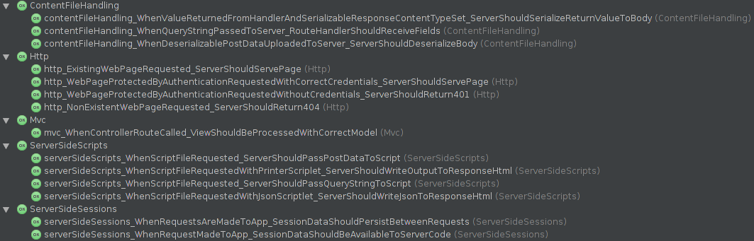

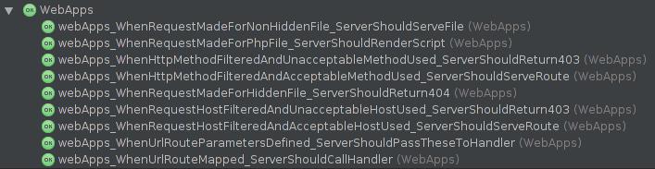

Appendix G: Employees Sample MySQL Database Schema

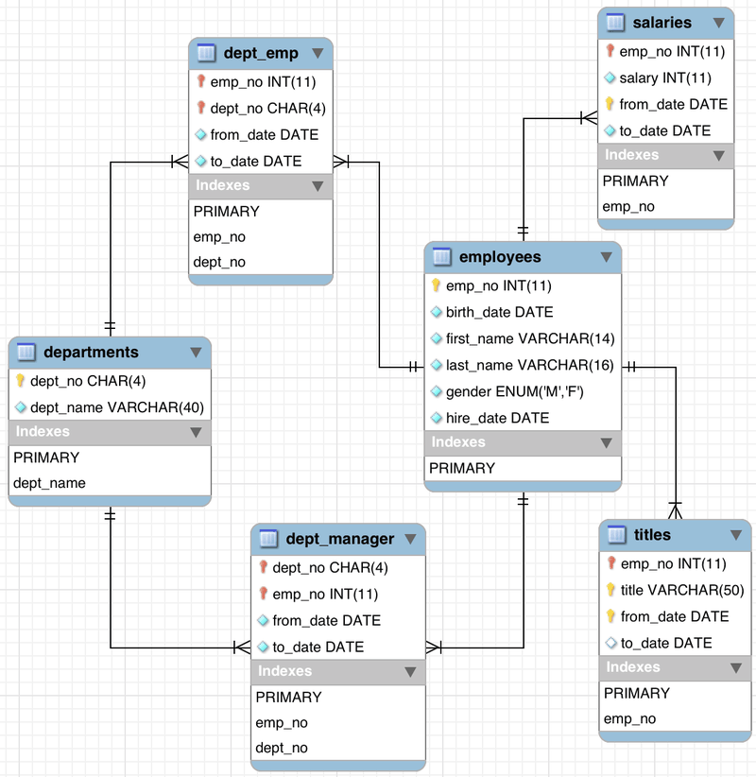

Figure - Schema for the MySQL Sample Employees Database. (Employees Structure, 2008)

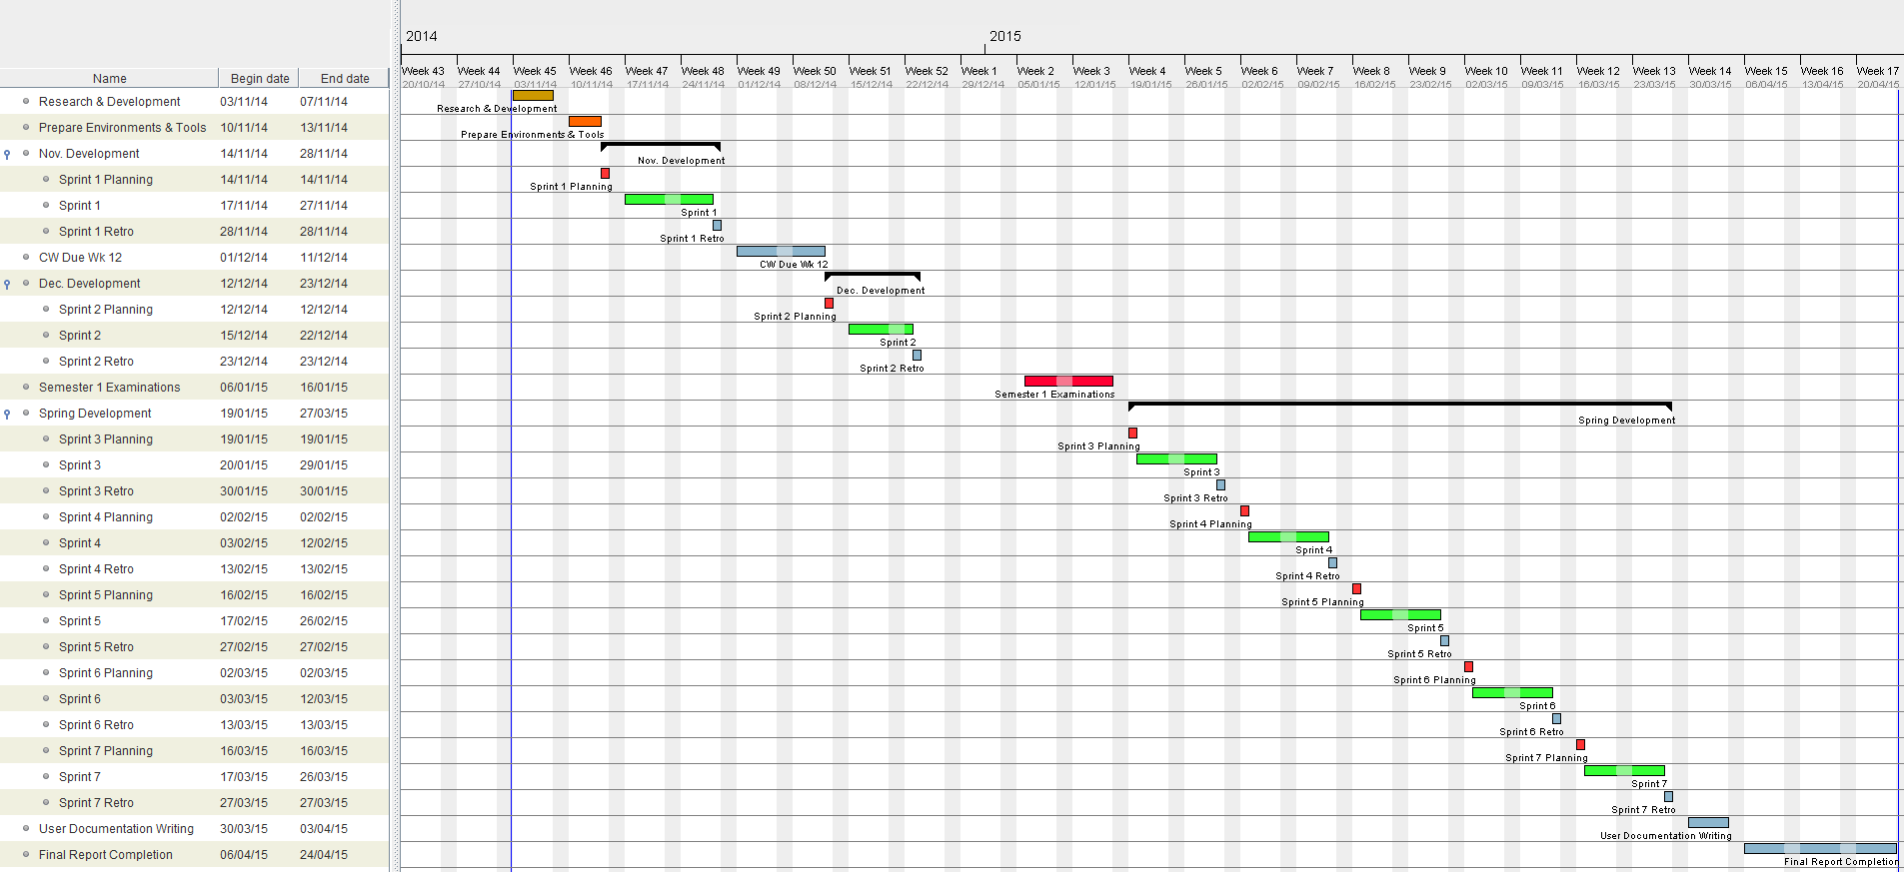Appendix H: Project Gantt Chart

Appendix I: Design – Activity Diagrams

Session Retrieve/Update

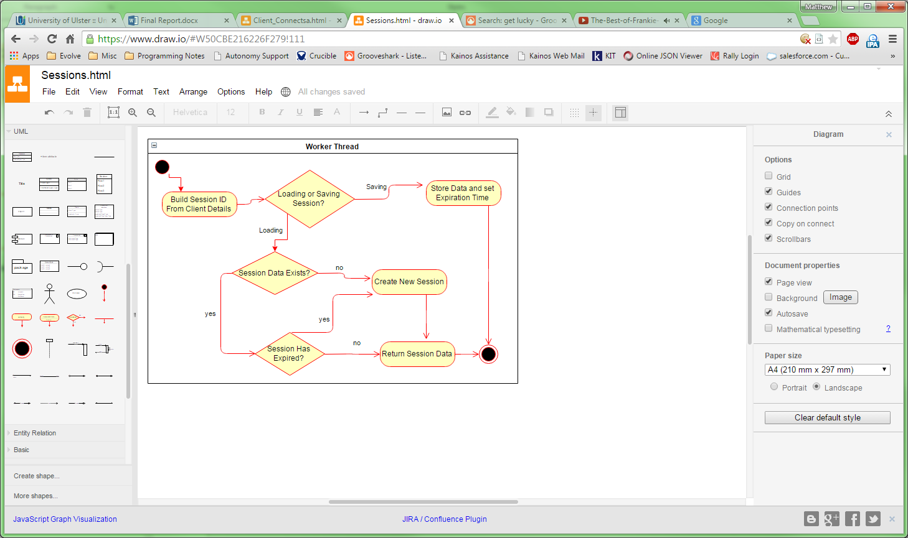

Figure - Activity Diagram: Loading/Saving Sessions

Route Protected by HTTP Authentication

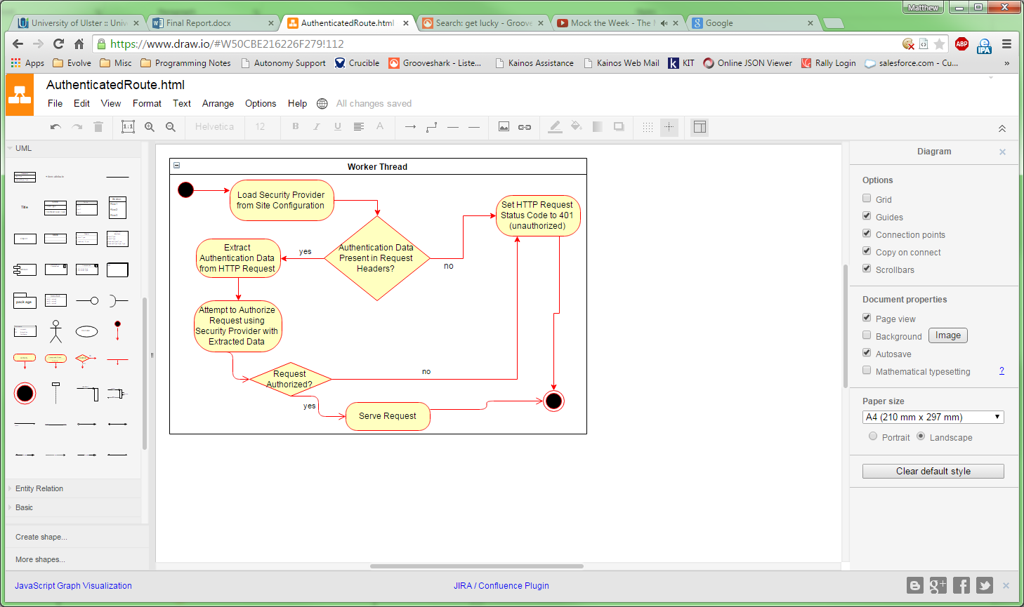

Figure - Activity Diagram: Route Protected by HTTP Authentication

Launch Script Loading

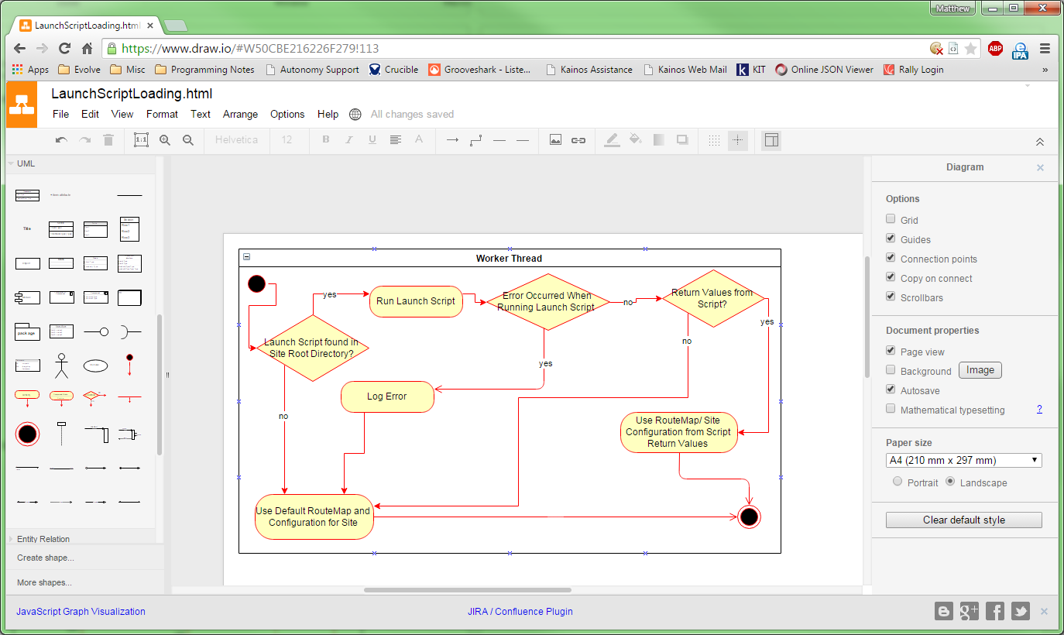

Figure - Activity Diagram: Launch Script loading

Run PHP File

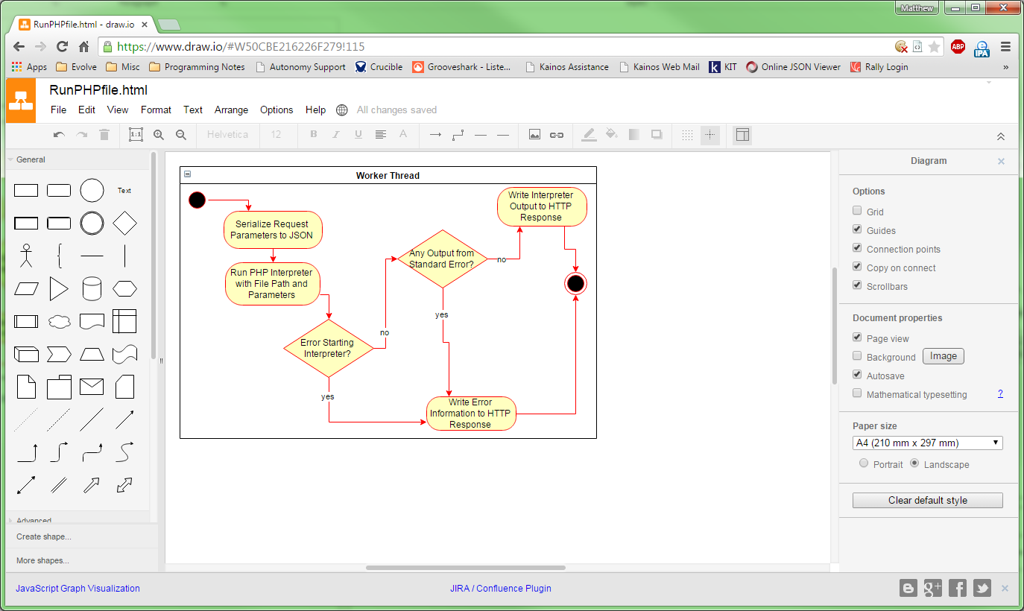

Figure - Activity Diagram: Run PHP File

List Directory

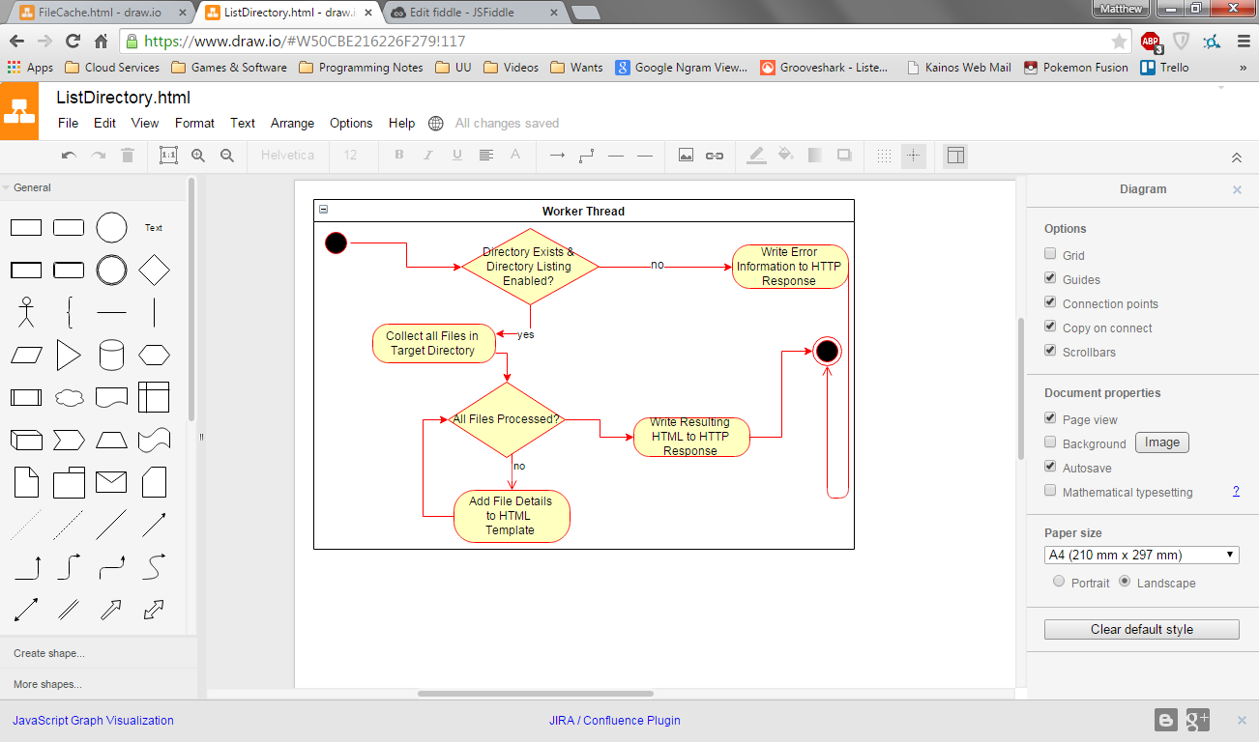

Figure - Activity Diagram: List Directory

File Cache

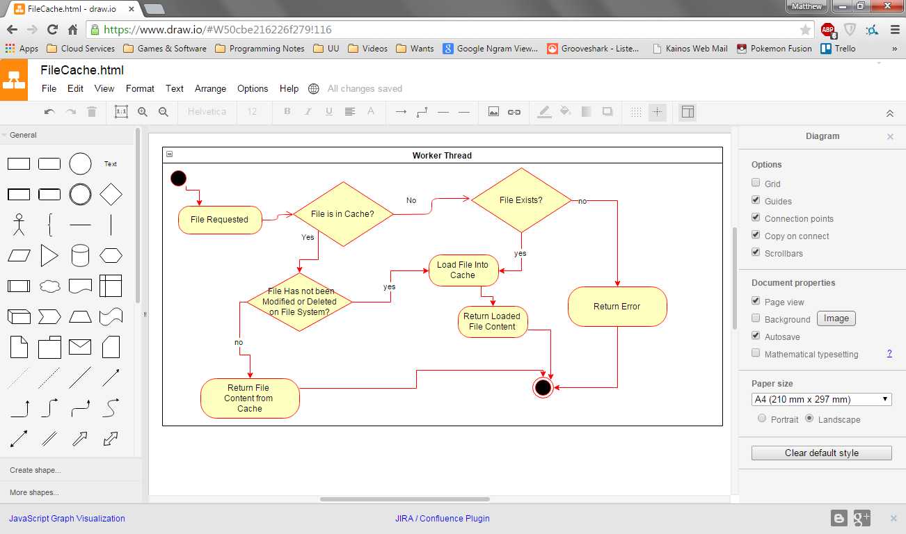

Figure - Activity Diagram: File Cache

Appendix J: Requirements Engineering – Volere Shells

**Requirement #**: FR01 **Requirement Type**: Functional

**Description**: The server should be cross platform, running on Windows, OSX and Linux.

**Rationale**: To allow end users to host the server on the operating system of their choice.

**Originator**: Matthew Snoddy – Senior Requirements Engineer.

**Fit Criterion**: The server runtime should run on the operating systems listed in the description.

**Customer Satisfaction**: 4 **Customer Dissatisfaction**: 4

**Dependencies**: None.

**Conflicts**: 0

**Supporting Materials**: Project Activity Diagrams.

**History**: Created 15th October 2014

**Requirement #**: FR02 **Requirement Type**: Functional

**Description**: The server should be able to parse HTTP requests and author HTTP responses.

**Rationale**: To allow the server to understand requests and provide the requested resource correctly.

**Originator**: Matthew Snoddy – Senior Requirements Engineer.

**Fit Criterion**: The server should hold a model in memory for each HTTP request received and a similar model for each response.

**Customer Satisfaction**: 5 **Customer Dissatisfaction**: 5

**Dependencies**: None.

**Conflicts**: 0

**Supporting Materials**: Project Activity Diagrams.

**History**: Created 15th October 2014

**Requirement #**: FR04 **Requirement Type**: Functional

**Description**: The web application API should be available from Lua scripts. (as importable modules)

**Rationale**: To allow developers to use the web application API in applications.

**Originator**: Matthew Snoddy – Senior Requirements Engineer.

**Fit Criterion**: The server should make the web application API modules available to web applications.

**Customer Satisfaction**: 3 **Customer Dissatisfaction**: 3

**Dependencies**: None.

**Conflicts**: 0

**Supporting Materials**: Project Activity Diagrams.

**History**: Created 15th October 2014

**Requirement #**: FR03 **Requirement Type**: Functional

**Description**: The server should provide a web application API (Application Programming Interface)

**Rationale**: To allow developers to write web applications using a simple and documented programming interface.

**Originator**: Matthew Snoddy – Senior Requirements Engineer.

**Fit Criterion**: The server should come with Lua modules that aid in the development of web applications.

**Customer Satisfaction**: 3 **Customer Dissatisfaction**: 3

**Dependencies**: None.

**Conflicts**: 0

**Supporting Materials**: Project Activity Diagrams.

**History**: Created 15th October 2014

**Requirement #**: FR06 **Requirement Type**: Functional

**Description**: The web application API should allow a user to customise the configuration for a website hosted on the server.

**Rationale**: To allow developers to configure filtering rules for requests and HTTP authentication.

**Originator**: Matthew Snoddy – Senior Requirements Engineer.

**Fit Criterion**: The server should provide modules to the web applications to manage site configuration.

**Customer Satisfaction**: 4 **Customer Dissatisfaction**: 4

**Dependencies**: None.

**Conflicts**: 0

**Supporting Materials**: Project Activity Diagrams.

**History**: Created 15th October 2014

**Requirement #**: FR05 **Requirement Type**: Functional

**Description**: The web application API should allow a user to create web services.

**Rationale**: To web application should provide data structures and procedures to facilitate the developer in creating simple web services.

**Originator**: Matthew Snoddy – Senior Requirements Engineer.

**Fit Criterion**: The server allows creation of web services by the developer.

**Customer Satisfaction**: 4 **Customer Dissatisfaction**: 4

**Dependencies**: None.

**Conflicts**: 0

**Supporting Materials**: Project Activity Diagrams.

**History**: Created 15th October 2014

**Requirement #**: FR10 **Requirement Type**: Functional

**Description**: The server should serve files from the file system by matching them with request resource paths.

**Rationale**: To allow clients to request web pages and other resources hosted on the server.

**Originator**: Matthew Snoddy – Senior Requirements Engineer.

**Fit Criterion**: The server should load file content from requests resource paths and return these in a HTTP response.

**Customer Satisfaction**: 4 **Customer Dissatisfaction**: 4

**Dependencies**: None.

**Conflicts**: 0

**Supporting Materials**: Project Activity Diagrams.

**History**: Created 15th October 2014

**Requirement #**: FR09 **Requirement Type**: Functional

**Description**: The server should handle errors by responding with an appropriate HTTP status code in a response, such as 500 for an error and 404 for resource not found.

**Rationale**: To enable the server to respond in an expected manner to client requests.

**Originator**: Matthew Snoddy – Senior Requirements Engineer.

**Fit Criterion**: The server should automatically respond to error conditions with an appropriate HTTP response.

**Customer Satisfaction**: 4 **Customer Dissatisfaction**: 4

**Dependencies**: None.

**Conflicts**: 0

**Supporting Materials**: Project Activity Diagrams.

**History**: Created 15th October 2014

**Requirement #**: FR11 **Requirement Type**: Functional

**Description**: Sites hosted on the server should allow loading of application logic and site configuration from a Lua source code file located in the root directory for the site.

**Rationale**: To allow sites to have an entry point to load custom application logic and configuration.

**Originator**: Matthew Snoddy – Senior Requirements Engineer.

**Fit Criterion**: The server should look for and load lua source code stored in a site directory, loading the logic and configuration into memory.

**Customer Satisfaction**: 4 **Customer Dissatisfaction**: 4

**Dependencies**: None.

**Conflicts**: 0

**Supporting Materials**: Project Activity Diagrams.

**History**: Created 15th October 2014

**Requirement #**: FR12 **Requirement Type**: Functional

**Description**: The server should provide and manage server side sessions.

**Rationale**: To allow data to be associated with a client between multiple HTTP requests.

**Originator**: Matthew Snoddy – Senior Requirements Engineer.

**Fit Criterion**: The server should automatically hold a memory store for a client between HTTP requests that is available to web application logic.

**Customer Satisfaction**: 4 **Customer Dissatisfaction**: 4

**Dependencies**: None.

**Conflicts**: 0

**Supporting Materials**: Project Activity Diagrams.

**History**: Created 15th October 2014

**Requirement #**: FR13 **Requirement Type**: Functional

**Description**: The server should provide configuration and adhere to this for server behaviour.

**Rationale**: To allow server administrators to tune a web server and customise its behaviour to their needs.

**Originator**: Matthew Snoddy – Senior Requirements Engineer.

**Fit Criterion**: The server should provide a configuration file and use this for controlling feature behaviour.

**Customer Satisfaction**: 4 **Customer Dissatisfaction**: 4

**Dependencies**: None.

**Conflicts**: 0

**Supporting Materials**: Project Activity Diagrams.

**History**: Created 15th October 2014

**Requirement #**: FR14 **Requirement Type**: Functional

**Description**: The server should log messages about events, requests, errors and warning in log files.

**Rationale**: To assist in the monitoring, debugging and configuration of the web application server.

**Originator**: Matthew Snoddy – Senior Requirements Engineer.

**Fit Criterion**: The server should produce files on the server file system that hold system messages for inspection.

**Customer Satisfaction**: 5 **Customer Dissatisfaction**: 5

**Dependencies**: None.

**Conflicts**: 0

**Supporting Materials**: Project Activity Diagrams.

**History**: Created 15th October 2014

**Requirement #**: FR15 **Requirement Type**: Functional

**Description**: The server should automatically de-serialize data contained in HTTP requests and serialize data to be used in HTTP responses. Specifically JSON, XML and web form data should be convertible from text to Lua values and back to text.

**Rationale**: To allow web service authors to work with data formats seamlessly using Lua values.

**Originator**: Matthew Snoddy – Senior Requirements Engineer.

**Fit Criterion**: The server should automatically convert to and from data types in HTTP requests and responses respectively.

**Customer Satisfaction**: 4 **Customer Dissatisfaction**: 4

**Dependencies**: None.

**Conflicts**: 0

**Supporting Materials**: Project Activity Diagrams.

**History**: Created 15th October 2014

Appendix K: SonicAgile Software

In this appendix is detailed the use of the online software SonicAgile, this was used to manage the agile elements of the project. As stated in project management this service ended abruptly and this section serves to evidence its use and shutdown.

Firstly is the evidence of the first encounter with the service shutdown, this occurred during sprint five when the lead developer after a period of business with external work attempted to log on to the online service. He was greeted with a blank page and no suggestion that anything was wrong, after some digging a post was found on the SonicAgile Facebook page; the page has since been taken down and is unable for viewing.

This post read that the service had been shut down and that an e-mail had been sent warning of the termination of the program; this e-mail had not been received on the registered e-mail address by the team in any case. The next step taken was to contact the individual who ran the service and request some data from the application if available; this initial e-mail is shown below.

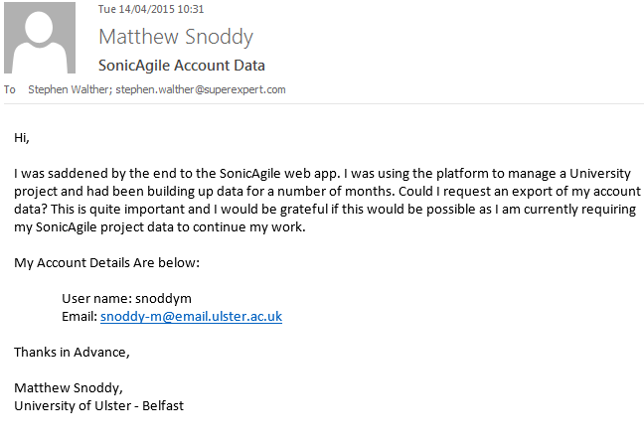

Lucky a reply was received with an offer to export any existing data, see below.

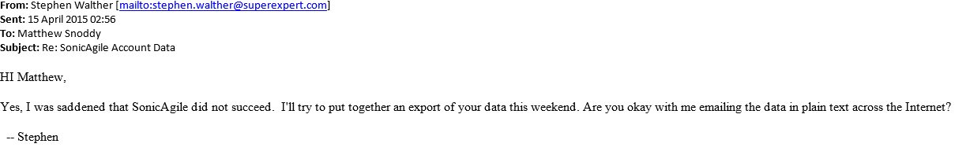

Following this message the lead developer promptly replied to authorised the export from the system backup, see below.

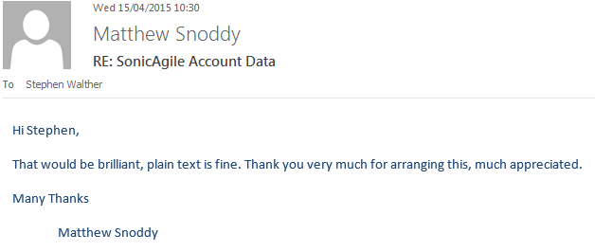

Before the end of the weekend the owner had replied with the raw data requested, shown in the email below.

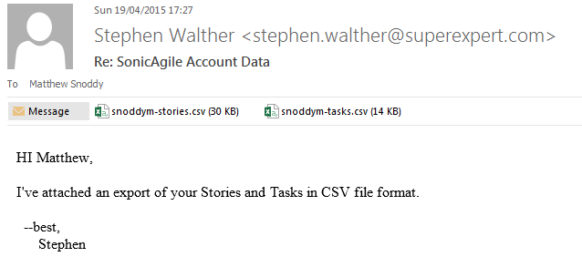

To evidence that the system was used throughout development I have included the data table below, which show the user stories that were recorded and managed on the system.

|  |  |  |  |
| --- | --- | --- | --- |
| User Story ID | User Story Title | User Story Points | User Story Time Estimate |
| 78 | Server Breaks After Requests from Firefox | 8 | 8 |
| 73 | Install & Configure TeamCity | 6 | 6 |
| 105 | When case match fails for site: 500 instead of 404 | 2 | 2 |
| 82 | Logged Error Stack Trace Vague | 2 | 2 |
| 92 | Pass Request Parameters to PHP | 4 | 4 |
| 76 | Time Key Sections of Code | 8 | 8 |
| 53 | Add Performance Data | 4 | 8 |
| 33 | Construct HTTP Response | 5 | 4 |
| 64 | Current Session Should be available in HTTP State | 1 | 1 |
| 43 | Routemap | 2 | 2 |
| 45 | Extend route model to support URL params | 4 | 4 |
| 80 | Directory Listing (HTML/HTTP) | 5 | 8 |
| 65 | IE Requests Fail (Client Side Error) | 4 | 4 |
| 38 | Config Validation | 2 | 2 |
| 81 | Rolling Log Files Size | 2 | 2 |
| 31 | Read in HTTP Request Body | 2 | 2 |
| 47 | Get Driver Binaries & Lua Libs | 5 | 5 |
| 39 | Add & Use config for Web Dir | 2 | 2 |
| 91 | HTTPS Support | 8 | 8 |
| 50 | Define Site Model | 2 | 2 |
| 59 | Provide Log Resolver | 2 | 2 |
| 54 | Log Reading Screen | 4 | 4 |
| 30 | Consume HTTP Headers | 4 | 3 |
| 90 | Build LuaSec Interface for APR | 8 | 8 |
| 74 | Add support for HTTP Keep-Alive | 8 | 10 |
| 71 | Make Gradle Build Script for Server | 4 | 8 |
| 99 | Load/Unload Web App Lua Packages Automatically | 4 | 4 |
| 89 | Refresh Button - Log Screen | 2 | 2 |
| 100 | Older Internet Explorer GZIP Support | 4 | 4 |
| 79 | HTTP Keep-Alive is always on | 4 | 4 |
| 104 | Server Silently Exits on Javascript Redirect | 2 | 2 |
| 70 | Issue when requesting pages | 2 | 4 |
| 37 | Use Config Values for Host and Port | 1 | 1 |
| 93 | Support Running PHP files | 6 | 6 |
| 68 | Basic HTTP Authentication | 8 | 5 |
| 29 | Accept Network Connections | 10 | 8 |
| 97 | Create a LuaRocks build/rockspec using Gradle | 8 | 0 |
| 106 | MIME Type Dictionary Incorrect | 2 | 2 |
| 77 | Investigate Issues with Timeouts not working | 4 | 8 |
| 62 | Create SQLite DB to hold sessions | 4 | 4 |
| 88 | Refactor Site Cache | 6 | 6 |
| 32 | Get Resource from Directory | 8 | 6 |
| 103 | Server Silently Exists After Closed Connections | 8 | 8 |
| 55 | Use sessions DB to store performance/log data | 4 | 4 |
| 96 | Crash after database select | 8 | 8 |
| 95 | Script Not Updating | 4 | 4 |
| 57 | Make Screens Auto-Update | 6 | 5 |
| 58 | Use Lua APR to introduce Mutlithreading | 4 | 4 |
| 84 | Make Web Directory In Lua Path | 4 | 4 |
| 83 | Server Fails to send 500 Response | 2 | 2 |
| 52 | Design Layout | 5 | 5 |
| 98 | Create Lubuntu Complete install script | 8 | 8 |
| 102 | Fix XML support under UNIX | 2 | 2 |
| 94 | HTTP Method not Reported in 403 | 2 | 2 |
| 86 | In Memory Cross-Thread Sessions | 8 | 8 |
| 56 | Session screen | 8 | 8 |
| 41 | Use model to consume & present | 4 | 3 |
| 49 | Provide Site Configuration | 4 | 4 |
| 63 | Connector Class & Resolver | 6 | 6 |
| 44 | Provide Default FileHandling Route | 3 | 3 |
| 101 | HTTP Compression | 8 | 8 |
| 40 | Design Model | 2 | 2 |
| 72 | Create JUNit Integration Test Project | 6 | 8 |
| 51 | Site Model: Load Routes from Launch Script | 4 | 4 |
| 85 | Allow Site to Generate no Logs | 4 | 4 |
| 42 | Provide Route Model | 1 | 1 |
| 61 | Sprinkle Appropriate Log Statements | 6 | 6 |
| 60 | Add File Logging | 4 | 4 |
| 75 | SQLite Database Errors | 4 | 8 |
| 66 | Preform Type Checking | 3 | 3 |
| 46 | Link up captures to HTTP model | 4 | 4 |
| 48 | Test by extracting table from database | 4 | 4 |
| 87 | HTTPS Client Crashes Server | 6 | 6 |
| 67 | Log Levels | 4 | 4 |
| 69 | Digest Authentication | 6 | 8 |
| 34 | Respond to HTTP request | 2 | 2 |
| 36 | Put Server Port & Host in Config | 2 | 2 |
| 35 | Define Config File Location & Structure | 3 | 3 |

Once the removal of the service had been discovered the team made the decision to use a separate online service, Taiga, to create new Epics and User Stories, as the existing ones were only stored on SonicAgile and unavailable to them at the time. Taiga was not actively used in development but instead used as an example of the benefits of using an agile management system.